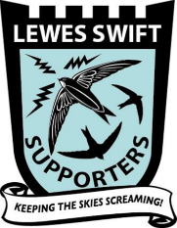

Lewes Swift Supporters Annual Report for 2021

Based upon contributions from members of the LSS Committee and surveyors: -
Mike Ramsey (Chair, Acting Treasurer to September 2021and Surveyor)
Audrey Jarvis (Secretary, Communications Officer and Surveyor)
Kevin Murphy (Recorder and Surveyor)
Sharon Hall (Treasurer from September 2021 and Surveyor)
Crispin Holloway (Founder Member of LSS)
Talitha Bromwich (from September 2021, Surveyor)
Emma Allen (from September 2021, Surveyor)
And the additional surveyors:-
Gill and Chris Garratt, Mary Hempshall, Nick Jarvis, Julie McNamee, Leonie Mercer, Carina Morrisey, Moya Tomlinson.
And swift sightings reported by 64 of our members via social media

Summary

This report summarises the key achievements of Lewes Swift Supporters (LSS) during the third year of operation, since our relaunch in May 2019. It reports the results of the survey that were primarily used to estimate the current numbers of swifts nesting in Lewes, for a larger portion of the town than covered in 2020, including Cliffe, the Neville, Eastern Malling, and the area around School Hill. The total number of 76 active swift nest entrance holes were recorded, from a total number of 2038 swift sightings. Rigorous comparison of this total number of ‘nests’ with earlier years is constrained by differences in the survey area and the methodology, and by a lack of systematic survey results prior to 2019. However, for the six swift colonies where we do have results from 2000, the number of nesting pairs was down in total by 37% (from 54 to 34) on the numbers reported in 2000, which is broadly consistent with the reported national decline of 57% between 1995 and 2017. Lewes residents participated extensively in their contributions to the LSS survey via our new website and social media (e.g. 210 contributions, mainly via Facebook). Supporters were also kept informed of LSS activities via four LSS Newsletters, and through social media interactions, rather than in real-world meetings, due to the ongoing limitations imposed to control the Covid-19 pandemic.

Brief introduction to LSS

The Lewes Swift Supporters (LSS) is an organisation of volunteers that was formed in 2015 with support from Sussex Ornithological Society (SOS) and Sussex Wildlife Trust (SWT). It was relaunched in May 2019, with the following aims and objectives:

  - To increase the number of Swifts nesting in Lewes and the surrounding area through providing and encouraging more swift nesting.
  - To increase people’s awareness and knowledge of swifts through education and engagement.
  - To provide opportunities for local people to get actively involved in, appreciate and be educated about their local swifts.

Annual Swift Survey
In order to pursue our first objective, LSS has conducted a survey of the swift population in Lewes in 2021, as it did in both 2019 and 2020. The results of these two earlier years’ surveys were reported in previous LSS Annual Reports. The most robust and useful indicator is the number of entrance holes in buildings seen to be used repeatedly by swifts, sometimes loosely referred to here as the number of ‘nests’.

  - Methods employed
The survey methods employed in 2021 used sightings from both systematic and casual surveys, but were modified from those used in both 2020 and 2019 in order to improve the accuracy of the estimated number of nests. All of the results were logged by the LSS Recorder, and have now been entered into the national and international database BirdTrack, which is hosted by the British Trust for Ornithology (BTO).

2.2. Systematic Survey
The area covered by the systematic survey of swifts was redesigned in 2021 to be bounded by roads, rather than as rectangles of equal size, for ease of use. The total area surveyed was extended beyond the four areas in the central region of the old part of Lewes originally covered in 2019, and the two additional areas of Wallands and Western Malling added in 2020 (See Fig 1b), to also include four new areas. The four new areas for 2021 (shown and numbered on Fig 1a), were in Cliffe (6), the Neville (7), Eastern Malling (10) and the area around School Hill west of Cliffe (3). These new areas were identified as potentially interesting by casual swift sightings reported in the 2020 survey.
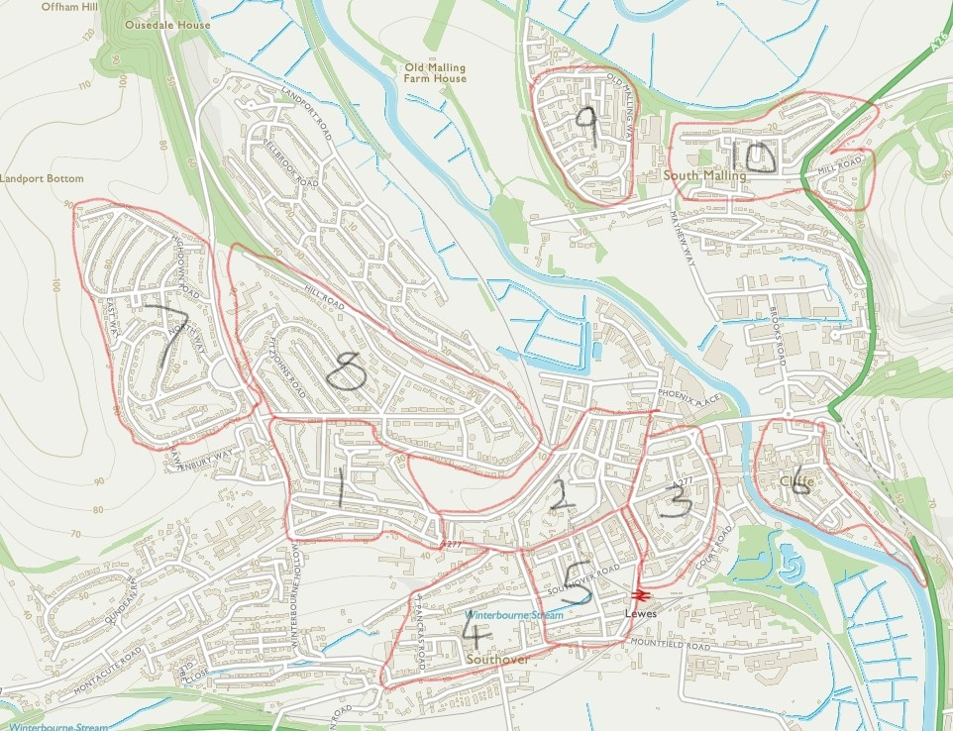
(a)
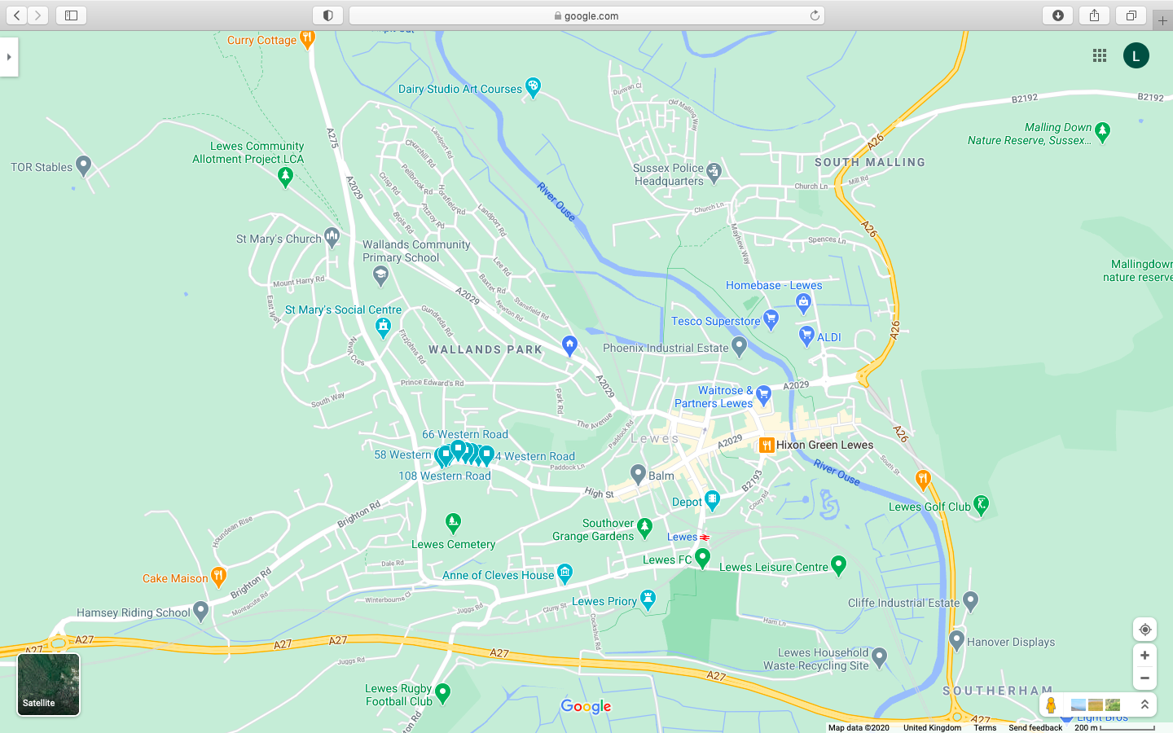
(b)

Figure 1. Design of systematic survey of swifts in Lewes used in (a) 2021, organised into ten areas. This has been extended and reorganised from (b) the six survey areas that were used in 2020, by the addition of Cliffe (6), the Neville estate (7), Eastern Malling (10) and the area around School Hill west of Cliffe (3)

Implementation of the new survey design was enabled by the welcome addition of seven new surveyors. The surveyors were each allocated to an area and asked to survey that area at least twice a month when possible, for the three-month period from May to July, while the swifts are in Lewes. The timing of each survey was still for a period between approximately 7.30pm and 9.30pm or dusk. The general survey design, surveyor instructions (identical to those used in 2020, Appendix Aa), map of each area (Appendix Ab, Fig 1a for Area 4 &5), and reporting forms (Appendix B) used by each surveyor, were slightly modified from those used in 2020. The instructions contain a description of the types of swift activity that were to be reported (e.g., low-flying party or banging), and those to be excluded (i.e., high-flying swifts above twice house height, as these are not necessarily local birds).

2.3. Casual sightings
Casual sightings of swifts were made across with whole of Lewes, including extra visits to the areas covered by the systematic survey, and to other areas. These reports were partially made by the surveyors, using LSS Reporting forms. Substantial numbers of further casual reports were also made by other Supporters and the general public, as part of Lewes Swift Watch project, through Facebook (122 reports), our LSS webpage, Twitter and email. LSS are very gratefully to all of those people who submitted sighting, and all the reports with sufficient detail have been included in the main database (Appendix C).

2.4. Key findings
A total number of 2038 sighting of swifts and their active nest entrances, made both in the systematic and casual observations, were reported to LSS in 2021 (Appendix C, sheet 1). A total of 76 active swift nest hole entrances was reported in 27 buildings (summarised in Table 1, with details and photos of key sites in Appendix C, sheets 2-4).

Address | 'Nests'*
 | 2019 | 2020 | 2021
St Anne’s Church, High Street | 8 | 19 | 12
98 Western Road | 5 | 8 | 6
The Maltings, Castle Precincts | 1 | 4 | 8
Flea Market, Market Street |  |  | 7
80b High Street | 2 | 3 | 5
Marchand Son, 30-31 Station Street | 2 | 3 | 5
6 St Martin’s Lane | 2 | 3 | 3
22 King Henry’s Road | 2 | 3 | 3
Swift House, Market Lane | 1 | 2 | 4
28 Valence Road | 3 | 2 | 4
169 Old Malling Way |  | 2
The Pigeon House, 51 Potters Lane |  |  | 2
52 Southover High Street (Anne of Cleves House) | 2 | 1 | 2
58 Southover High Street |  |  | 1
59 Southover High Street |  | 1 | 1
Westfield House, Western Road |  |  | 1
77 High Street |  |  | 1
144 High Street | 2 | 1 | 1
2b Gallows Bank, Abinger Place | 1 | 1 | 1
32 Grange Road | 1 | 1 | 1
24 De Montford Road | 1 | 1 | 1
5 De Montfort Road |  | 1 | 1
47 The Avenue |  |  | 1
51 The Avenue | 1 | 1
57 The Avenue |  |  | 1
59 The Avenue |  | 1 | 1
1 Bridgewick Close |  | 1
4 Bridgewick Close |  | 1
6 Bridgewick Close |  | 1 | 1
7 Bridgewick Close |  | 1 | 1
8 Bridgewick Close |  | 2 | 1
Total | 34 | 64 | 76

Table 1. Buildings in Lewes with active nest hole entrances, or ‘nests’* found in the 2021 swift survey, with the 2020 and 2019 results for comparison. (* it was not possible to ascertain whether successful breeding took place at these locations).

The distribution of breeding swifts, especially the larger colonies, is concentrated in the older areas of Lewes (Fig 2).

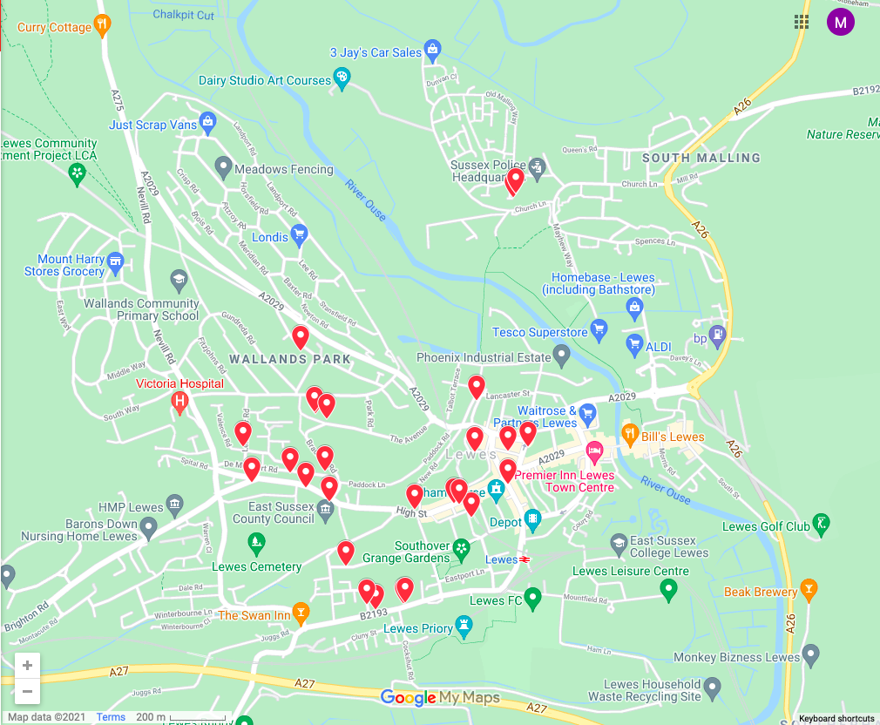
Figure 2. Locations within Lewes of the 27 locations () that were estimated to have the 76 active swift ‘nests’.

Comparisons between the numbers of nests reported in different years are problematic for several reasons. The obvious comparison between the 76 nests found in 2021 against the 64 found in 2020, and 34 found in 2019 (Table 1), apparently suggests more than a doubling in the swift population. However, this conclusion is not reliable due to two changes in the survey methodology across these three years. Firstly, extra areas were added, 2 in 2020 and a further 4 in 2021. The new colony discovered at the Flea Market had 7 nests, but was detected only as the result of setting up a new survey area (3 on Fig 1a). It is possible that this colony existed in 2019 and 2020 but remained undetected. The second change was in the much-increased number of sightings recorded in 2021 (2038, compared to 1843 in 2020 and 150 in 2019). A consequence of these changes has undoubtably led to an increase in the number of sites identified, and the number of nests detected at some of these sites. The extra information gained from the increased survey effort in 2021 has made a very valuable contribution to our understanding of these swift colonies. However, it has had the unintended consequence of making the detection of changes in population size more challenging.

Overall, therefore, the results of the systematic surveys made over just three years (2019, 2020 and 2021) are not sufficient to draw and reliable conclusions about any possible changes in the size of the swift population in Lewes over this period. The application of the same survey methodology over the same area for the whole breeding season, for a much longer period (e.g. in excess of ten years) will be required to clarify the longer-term trend in the swift population of Lewes. This trend is currently also obscured by the year-to-year variations that are common in such small populations, and partially caused by uncertainty arising from the inevitable limitations in the survey methodology.

Comparison of the 2021 results against a survey that was recorded prior to 2019 are also problematic. This is because the few earlier surveys did not aim to survey the whole of Lewes, but only focussed on a small number of colonies. However, a comparison for a limited number of locations can be attempted. One focussed and non-systematic survey of swift in Lewes was made in 2000 by Mike Helps.

Swift colony location | Nests in 2000 | Nests in 2019 | Nests in 2020 | Nests in 2021
St Anne’s Church | 30 | 8 | 19 | 12
Old Stable in Market Lane | 5 | 1 | 2 | 4
The Maltings | 4 | 1 | 4 | 8
Bottom of St Martin’s Lane | 3 | 2 | 3 | 3
Chapel in Market Street (now Flea Market) | 10 |  |  | 7
Bottom of St Andrew’s Lane | 2
Total | 54 | 12 | 28 | 34
Apparent decline since 2000 |  | -78% | -48% | -37%
Table 2. Comparison of number of swift nests at six colonies reported in the three LSS surveys (2019-2021) against those reported by Helps (2004)³ for the year 2000.

Helps reported the number of pairs of swifts nesting in six of the colonies that existed in Lewes in the year 2000 (Table 2). The discovery by LSS in 2021 of the colony in the Flea Market, was partially enabled by this report by Helps in 2000 of 10 pairs nesting in the then Chapel in Market Street. The comparison (Table 2), shows that five of these six colonies reported by Helps still exist in 2021, but the one at the bottom of St Andrew’s Lane has apparently not survived. The original total of 54 nests in these six colonies has reduced to 34 nests in 2021, suggesting a 37% decline (Table 2). This compares with an apparent decline of 78% at these same colonies found in 2019. All three of these estimates of decline give a very approximate indication of the scale of the general decline in the breeding population in Lewes, and are in rough agreement with the national picture of a 57% decline between 1995 and 2017. However, all of these survey values suffer from the same limitations that were discussed above, about differences in the effectiveness and comparability of the survey techniques across the years, and how representative this small number of colonies might be.

  - Review of alteration to the survey design used in 2021 for consideration in 2022
The alterations made to the survey design between years have the potential advantage of improving the way that LSS can achieve some of its objectives. However, the alterations have the disadvantage of making the findings of the survey less comparable from year to year. It is therefore prudent to review the effects of the alterations, and decide whether to retain them and to decide whether further changes are justified. Each survey design alteration made in 2021 will be reviewed in turn.
2.5.1 Changing from rectangular survey areas to ones bounded by roads.
Advantages: Easier for surveyors to identify the limits of their survey areas, and to make each area of a suitable size for surveyors to survey effectively in the time available.
Disadvantages: Survey areas are not of the same size (making them less comparable), and are not contiguous (leaving more gaps between them).
Recommendation: Retain
2.5.2 Adding new survey areas in general:
Advantage: Can help to locate previously unsuspected swift nests and colonies
Disadvantages: Makes statistically rigorous comparison of number of swift nests between years ineffective and potentially misleading.
2.5.2.1 Area 3 (Around School Hill): New swift colony detected in the Flea Market (maybe rediscovering the colony previously described as being in the ‘Chapel in Market Street’ by Helps in 2000).
Recommendation: Retain and maybe use for ‘stake out’ observations.
2.5.2.2 Area 6 (Cliffe): Successfully implemented but no swifts observed.
2.5.2.3 Area 7 (Neville): Successfully implemented but no swifts observed.
2.5.2.4 Area 10 (Eastern Malling): Successfully implemented but no swifts observed.
Recommendation: (Areas 6,7 &10): After discussion by the LSS committee, it was provisionally decided to discontinue systematic surveying of areas where the lack of observations was considered to be probably due to the current absence of swift nests in that area (i.e. Cliffe). Surveys of other areas will probably be either maintained (e.g. Neville) or combined (e.g. Eastern and Western Malling) in 2022.
2.5.2.5 Areas 4 & 5 (Eastern and Western Southover):
Recommendation: Combine Eastern and Western Southover in 2022

It was also considered probable that undiscovered swift nests may still exist in Lewes, for example at the rear of buildings where systematic surveyors cannot detect them. It was therefore considered essential to continue with the Swift Watch where Supporters and members of the public can report sightings that may reveal these previously undetected nests, as happened this year at 77 High Street.

Other LSS activities in 2021
LSS conducted a number of other activities in support of our objectives.

3.1 Site visits.
Members of LSS made 69 visits to sites where occupiers or developers requested advice on the feasibility and optimal location for installing swift accommodation. This included fitting swift boxes to existing buildings and planning to locate swift bricks within new buildings or extensions.

3.2 Swift boxes and swift bricks
64 new swift boxes (36 single, 27 doubles and 1 triple) were installed on 56 buildings around Lewes in 2021, mainly with advice from LSS (Appendix D, and shown on Fig. 2). Twenty of these properties are known to have swift callers that can be used to increase the probability that the boxes will successfully attract swift more quickly. Within this total number of boxes was a focused project, to install 15 swift boxes on houses around De Montford Road where swifts from the existing colony in Western Road regularly explore and ‘banged’ potential nest sites. LSS wish to thank and acknowledge the Friends of Lewes, Chalk Cliff Trust and Sussex Police for funding for this project, and Dave Boddington for his excellent work on the installation of these boxes mainly in June and July 2021.

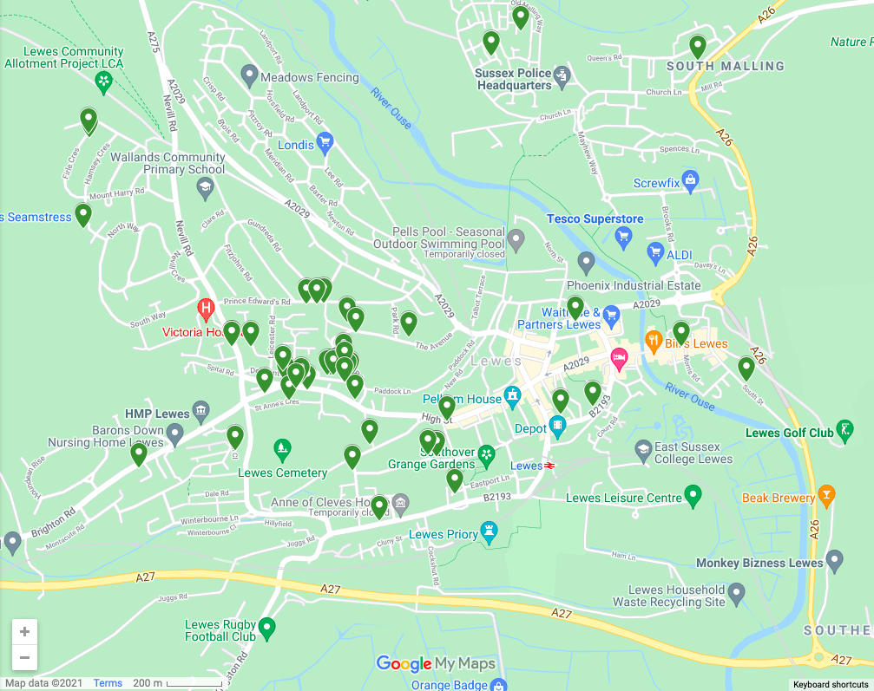
Fig 2. Locations of 64 swift nest boxes () installed on 56 buildings in 2021.

3.3 Interaction with Supporters and General Public
Wider interaction between LSS, supporters and the general public were enabled by organisation of activities such as:
- Set up and frequent updated new LSS website
- Held the LSS-AGM via Zoom on 2nd March
- Held a talk by Edward Mayer from Swift Conservation on 20th April entitled "Swifts and Supporting and Enhancing Urban Biodiversity"
- Held a Surveyors' Get-Together and swift walk on 6th July
- Expanded the LSS membership: 199 people have now given their contact details and asked to receive LSS communications (e.g., newsletters, reports)
- Published and disseminated four editions of LSS Newsletter in April, June, July and August 2021.
- Updated LSS social media outlets:
  - Facebook page, currently with 199 followers
  - Twitter, with 724 followers
- Made numerous posts of LSS information on Facebook and Twitter, including 210 reports of Swift sightings from our Facebook group members within the Lewes Swift Watch project
- Produced a new batch of LSS badges to raise funds to buy and install more nest boxes
- Distributed LSS information postcards or letters to 100 selected houses
- Participated in the Planet Party on 19th September and in the Biodiversity Day on 9th November as part of the COP @Depot season, through our affiliation with Lewes Climate Hub (Section 3.4)
- Ran the first LSS Swift Poster competition, and presented a prize to the winner.

3.4. Interactions with external bodies
LSS has been has been maintaining active links with Lewes Town Council (LTC), Lewes and Eastbourne District Council (L&EDC), and the South Downs National Park (SDNP) in order to embed advice on providing swift accommodation into the consideration of suitable Planning Applications. The leaflet has been written by LSS on this subject by LSS, and adopted by LTC and submitted to L&EDC and SDNP, continues to be used. LSS has also contributed recommendations for the inclusion of swift accommodation on individual planning applications. LSS maintains its interactions with related external bodies such as Sussex Ornithological Society, Sussex Wildlife Trust, British Trust for Ornithology, Royal Society for the Protection of Birds, and Swift Conservation.
LSS became affiliated with Lewes Climate Hub, and participated in some events organised by them (as noted in section 3.3)
Funding for the purchase and installation of multiple swift boxes at strategically important locations, was applied for and secured for LSS from: Friends of Lewes and the Chalk Cliff Trust.
Funding has also been received through residents choosing LSS as their "good cause" in the LDC Local Lottery, (https://www.leweslocallottery.co.uk/support/lewes-swift-supporters), and residents giving us generous donations.

Recommendations for future work
The experience and findings from the operation of LSS in 2021 are being used to plan improvements for 2022. These included:
- Review the optimal design for the Swift Survey for 2022, and long-term surveying strategy. Decide whether to survey any new areas, identified from casual sightings, or possibly discontinue the survey of areas with little or no evident swift activity.
- Review the number and training of new surveyors required to cover the systematic survey areas.
- Maybe plan ‘stake outs’ around existing colonies to (a) increase number of hours of recording improve detection of existence of nests and whether they have had successful breeding (b) give new surveyors, who sometimes have not observed many active nests, the experience (and enjoyment) of observing a colony.
- Implement a further project to install multiple swift boxes around a different existing colony in Lewes. Out of a shortlist of six potential areas for this project, the LSS Committee have provisionally identified The Avenue as the most promising focus. The Avenue current has three active nests, evidence of banging by young swifts, and is also on the flight path to and from the nearby colonies at St. Anne’s Church and Western Road. .

Conclusions
In 2021 Lewes Swift Supporters successful conducted the third systematic survey of the swift population of Lewes, whilst complying with the continuing regulations arising from the Covid-19 pandemic. From a total of 2038 reported sightings, LSS has estimated that there are 76 active ‘nests’ (i.e., hole entrances recorded as being used repeatedly by swifts). This is an apparent increase on the 64 nests located in the 2020 survey, but this is not considered to be conclusive evidence of an increase in the size of the swift population in Lewes, but is probably due to changes in the survey methodology since 2020. Comparison with a limited survey of six swift colonies recorded in 2000, suggests around a 40 % decrease in swifts nesting in Lewes since that time, which is not significantly different from the estimated national decline over a similar period.

6. Appendices
Copies of this report and the LSS Annual Reports for 2019 and 2020 are published on the LSS Website. The following appendices are available by request from the LSS Secretary, contacted via lewesswifts@gmail.com

A. Survey Instructions for LSS Surveyors 2021
a. Lewes Swift Survey 2020 and 2021– methodology (Annual Report).pdf
b. Maps of individual swift survey areas within Lewes
B. Survey Reporting Forms for LSS Surveyors 2021
a. Lewes Swift Survey 2021- recording form (Annual Report).pdf
b. Lewes Nest Activity Log 2021 (Annual Report).pdf
C. List of all swift sightings reported in 2021
LSS Survey 2021-locked +pictures (Annual Report).xlsx
D. New Swift Boxes
New Lewes Swift Boxes_2021 (Annual Report).xlsx

https://app.bto.org/birdtrends/species.jsp?year=2019&s=swift
https://e-voice.org.uk/lewesswiftsupporters/
https://e-voice.org.uk/lewesswiftsupporters/newsletters/
https://e-voice.org.uk/lewesswiftsupporters/lss-annual-reports/
Mike Helps (2004) ' Lewes Landscapes and Bird’ (Private Publication, copies in Lewes Library)
https://app.bto.org/birdtrends/species.jsp?year=2019&s=swift
https://e-voice.org.uk/lewesswiftsupporters/
https://e-voice.org.uk/lewesswiftsupporters/newsletters/
LSS leaflet for LTC: Consideration of Swift Accommodation when Considering a Planning Application. Available at https://protect-eu.mimecast.com/s/GnrOC9gLlTZRBx2so7owp?domain=e-voice.org.uk/
https://www.swift-conservation.org
Six potential locations for new swift-box project [Current Nests No]: High Street & St Martin’s Lane [10], The Maltings [8], Flea Market [7], Southover High Street & Potter’s Lane [6], The Avenue [3], Bridgewick Close [3]
https://e-voice.org.uk/lewesswiftsupporters/lss-annual-reports/

