# **Consideration of Swift Accommodation when Considering a Planning Application**

# **Adopted as primary advice by Lewes Town Council Planning Committee November 2020**

Produced by **Lewes Swift Supporters** (LSS) for the assistance of Lewes Town Council (LTC).

**Swifts** are an Amber listed species. In England, the swift population declined by 57% between 1995 and 2017. Retaining and increasing the number of nesting swifts in Lewes can form part of the biodiversity net gain that is required by legislation.

# **Planning context**

Environment Bill 2020 (DEFRA forthcoming)

When the 25 year Environment Bill comes into effect, it will be mandatory for new developments to demonstrate a net gain in biodiversity of at least 10% in order for planning to be permitted. Very minor changes, such as extensions to houses, and national infrastructure projects are to be excluded. Biodiversity net gain is ‘*an approach to development that aims to leave the natural environment is a measurably better state than beforehand*. *This means protecting existing habitats and ensuring that lost or degraded environmental features are compensated for by restoring or creating environmental features that are of greater value to wildlife and people.’*

National Planning Policy Framework (MHCLG 2019)

Para 174b *“promote the conservation, restoration and enhancement of priority habitats, ecological networks and the protection and recovery of priority species; and identify and pursue opportunities for securing measurable net gains for biodiversity”*

South Downs Local Plan - Adopted 2 July 2019 (2014 - 33) (SDNPA 2019)

Strategic Policy SD9 Biodiversity and Geodiversity (p. 59): ‘*Development proposals will be permitted where they conserve and enhance biodiversity and geodiversity, giving particular regard to ecological networks and areas with high potential for priority habitat restoration or creation….*’

Lewes Neighbourhood Plan 2015 - 2033 (LTC 2019)

Policy LE2 Biodiversity (p. 36): ‘*1) Development proposals will be expected to demonstrate how they will provide a net gain in biodiversity, habitats and species on the site, over and above the existing biodiversity situation….*’

# **Why local planning is essential to Swift recovery**

In England, Swifts only nest in buildings and an ever-increasing shortage of nest sites is one significant factor driving their population decline. Swifts nest at over 4.5m (15 feet) above the ground and usually in small colonies near where other Swifts are already established.

Lewes Town Council have a statutory right to observe and comment upon adherence to the planning policies detailed above, and to thereby help increase biodiversity, when considering planning applications – such as supporting Swifts.

# **Objective**

To aid the recovery of this declining species by ensuring that Swift accommodation or ‘nest places’, (i.e., bricks, boxes or cabinets), are incorporated into any suitable new development or significant redevelopment / extension, within the parts of Lewes shown in the map below.

This may be achieved through the planning process by LTC’s comments including a recommendation that a condition be attached to approval of any suitable application by Lewes District Council or the South Downs National Park Authority. These will state whether any bespoke conditions being put forward have been agreed as a result of either (a) specific discussions with LSS, or (b) just following LSS guidelines without consultation.

# **Questions to consider when reviewing a planning application**

1. Is the proposed development located within the Red Zone of the Town on Map 1 (Appendix 1)?
2. Is the proposed development to be over 4.5m (15 feet) high i.e., two stories or above?
3. Can Swift accommodation (i.e., brick, box or cabinet) be located so that the nest entrance would face preferably north, northwest or northeast, or west or east if well shaded? A south facing aspect should be avoided unless Swift bricks are to be used. Lewes Swift Supporters can advise. See Figure 1.
4. Can Swift accommodation be located so that the Swifts have an unobstructed flight path into the nest from 10m away? Avoiding trees, cables, etc. See Figure 1.

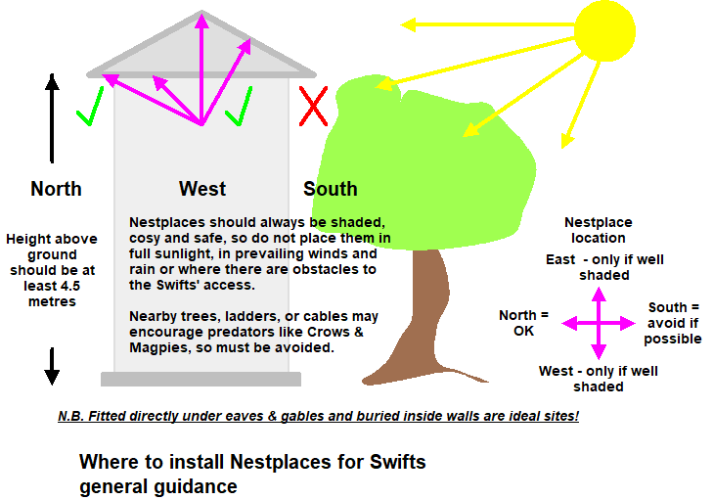

**Figure 1.** Where to install ‘nest places’ for Swifts (Source: Swift Conservation)

**Types of Swift Accommodation**

Swift nests come in different shapes and sizes. They can be externally mounted nest boxes fitted under the eaves [e.g., 38 x 20 x 21cm], externally mounted triangular cabinets on a gable end, typically with three nests [e.g., 75 x 40cm, 45O apex] or swift bricks which can be incorporated in a new wall of a building. If externally mounted nest boxes or cabinets are made of “Woodcrete” rather than wood, they will last much longer.

Swift bricks are typically a hollowed out set of six ‘bricks’ with a small nest entrance, that allow the swifts to nest without entering the cavity wall.

**Further Support**

If in doubt during the review process, Councillors may consult **Lewes Swift Supporters** (lewesswifts@gmail.com). The group will visit the proposed development site, if necessary, to confirm suitability of the site and to recommend the type of swift accommodation and its preferred location. LSS can also provide more information on the importance of Swifts in Lewes, if required.

This guidance will be reviewed periodically as more information becomes available, in order to better support a thriving Swift population in Lewes.

Appendix 1.

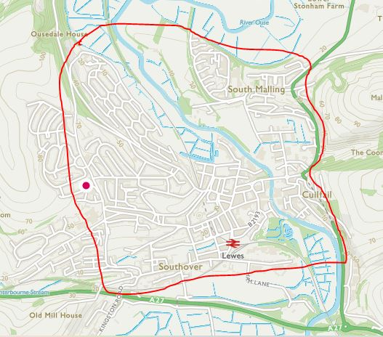

Map 1. The Red Zone of Lewes within which consideration of swift accommodation is required