"The Afghan goatherds" – a real life moral dilemma
from Michael Sandel's Justice
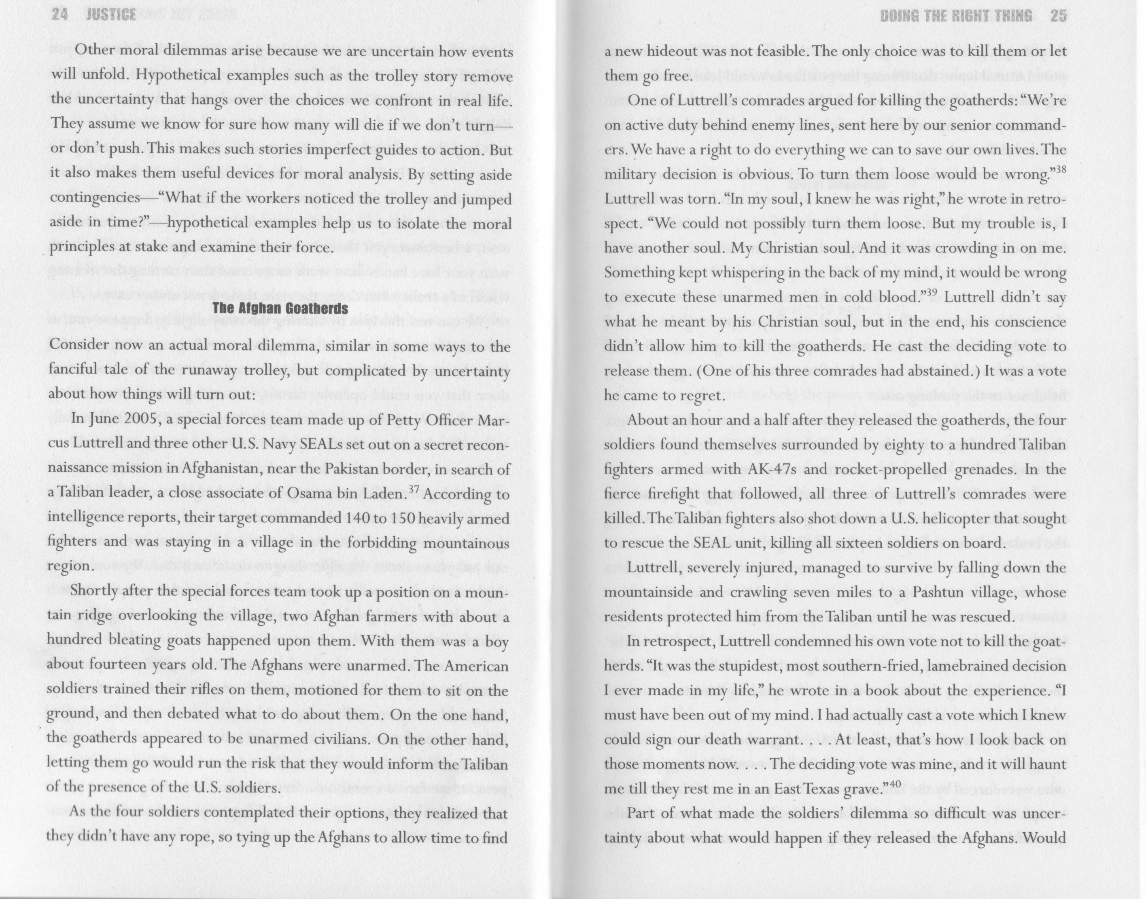

Do we "have a right to do everything we can to save our own lives"?

Do moral debates have to be couched in terms of "Christian souls" v self-interest? Are there other moral principles that could help here and in other moral dilemmas?

Is it always wrong to execute unarmed men in cold blood? Would "hot blood" make it any better?
Was this the right moral decision? What do you think they should they have done?

