
KINGSTON PHILOSOPHY CAFÉ UPDATE
June 2009
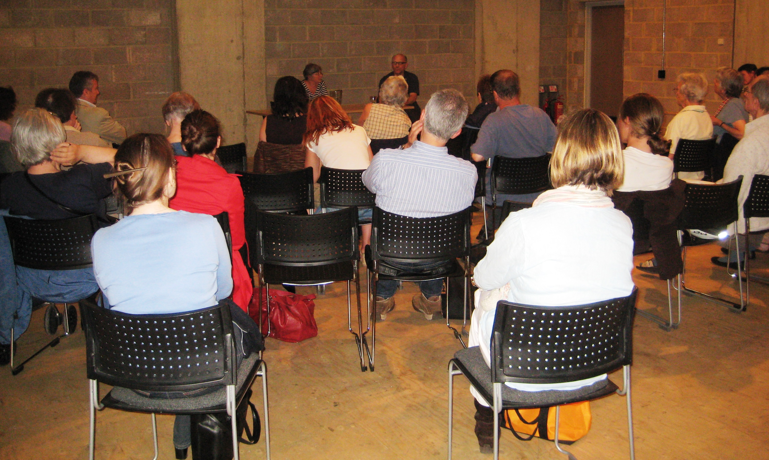
Drama in the Studio
Billed as “a philosophical conversation about theatre and drama with Stephen Unwin, Artistic Director of the Rose Theatre”, our June 4th discussion did manage to stay more or less philosophical and even, despite the numbers, to achieve something close to a genuine conversation between Stephen and those present. Well informed and enthusiastic participants supported Stephen in defending theatre from some of the more provocative challenges – indeed some were more robustly pro-theatre than Stephen, who admitted to reading more plays than he sees and to finding some audience responses “sentimental”. There were arguments about the relative roles of action, language and the more visual aspects of theatre, the merits of Pinter and of farce, the value of cinema, and much else, but the consensus seemed to be that live theatre does have a distinctive and important aesthetic function, and that plays can be both philosophical and theatrical (with Beckett and Shakespeare cited as examples) – and also powerfully subversive, as in the example offered by a Russian participant of fleeting gestures in the theatre that could criticise the Communist state but go unrecorded and unpunished. It was also suggested that just enjoying the story and empathising with the characters are legitimate responses, and that analysis could be deadening (so much for literary and theatre studies, and philosophy!).
A rapt group of Philosophy
Café participants in the Studio

We are very grateful to Stephen for making time in his super-humanly demanding schedule to come and talk to us so engagingly, and for his ongoing support and encouragement of Kingston Philosophy Café (despite his initial reservations about the idea). And, as always, a big thank you to the Rose staff who do much of the background work.

Philosophical book exchange
Do you have philosophy books or periodicals that you will never read again (or perhaps never read in the first place) that other KPC participants might like? Why not dust them off and bring them along to a KPC evening to find a good home? The Rose will put any books left at the end of the evening into their free book exchange programme.

KPC Thursdays coming up (the next few are all on the first Thursday of the month)

 Thursday 2nd July, 6.00, Kingston Philosophy Café in the Rose Theatre Gallery
Environmentalist and writer Shaun Chamberlin on contemporary environmental challenges:
unusually for Kingston Philosophy Café, we are going to consider facts and evidence with the help of an expert before moving on to the ethical issues next month. Free. If you already know all about the environment, you might want to skip straight to –

 Thursday 6 August, 6.00 - 7.30pm, Kingston Philosophy Café in the Rose Culture Cafe
“It might cost the Earth – but why should we care?”: an informal follow-up discussion of some of the ethical issues raised by our relations with nature and environmental concerns. Free.

 Thursday 27 August, 6.00 - 7.30pm, Kingston Philosophy Café in the Rose Culture Cafe
Bob Churchill on “Whatever you think about rationalism is probably wrong.” Free.

 September: Kingston Philosophy Café will probably take a short break, returning on October 1.

Keep an eye on www.kingstonphilosophycafe.org.uk for the most up-to-date information including changes of time, venue or topic and whether events need to be booked in advance or paid for.
Marilyn Mason www.kingstonphilosophycafe.org.uk

