# Towards a comprehensive account of Subject-Object Relationship

## Kant ,Merleau-Ponty and Lacan

Kant’s concept of Self as internalized manifold of impressions and Jacques Lacan’s concept of Mirror image as externalized symmetry of gestalt of opposing actions of Self  
  
1. Kant’s concept of Self as internalized manifold of impressions of object

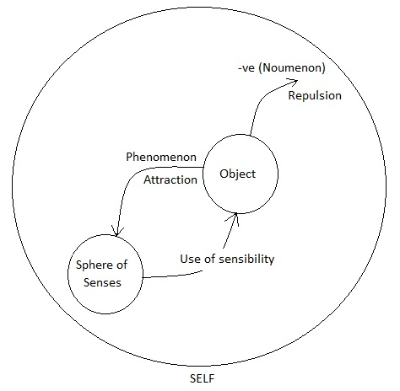

Self – A constitutive whole of manifold of impressions (or representations)  
Phenomenon – An impression resulting from positive use of sensibility   
-ve Noumenon – An impression signifying a negative use of sensibility; an unknown phenomenon  
Sphere of senses – A certain space active by attractive and repulsive forces

2. Kant and Lacan’s account of Self and other (mirror image) respectively

(Source:  
1. Ecrits, The Mirror Stage as Formative of the I function, Jacques Lacan  
2. Phenomenology of Perception, Merleau Ponty  
3. Sketch for a Theory of the Emotions, Sartre  
4. The social contract or principles of Political Right, Jean Jacques Rousseau

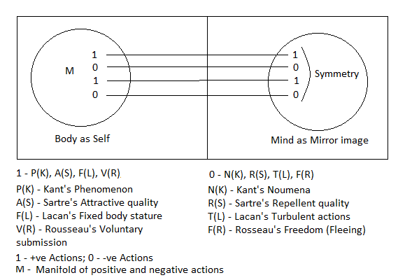

1. “The concept of a noumenon is therefore merely limitative, and intended to keep the claims of sensibility within proper bounds, therefore of negative use only. But it is not a mere arbitrary fiction, but closely connected with the limitation of sensibility, though incapable of adding anything positive to the sphere of the senses” – 151  
   (Noumena is negative use of sensibility; adds something negative to the sphere of the senses; does not represent an object of senses)   
   “In doing this, it immediately proceeds to prescribe limits to itself, by admitting that it cannot know these noumena by means of the categories, but can only think of them under the name of something unknown” – 152 (Noumena are something unknown)
2. “If by noumenon we mean a thing so far as it is not an object of our sensuous intuition, and make abstraction of our mode of intuition, it may be called a noumenon in a negative sense. If, however, we mean by it an object of a non-sensuous intuition, we admit thereby a peculiar mode of intuition, namely, the intellectual, which, however, is not our own, nor one of which we can understand even the possibility. This would be the noumenon in a positive sense. The doctrine of sensibility is at the same time the doctrine of noumena in their negative sense; that is, of things which the understanding must think without reference to our mode of intuition, and therefore, not as phenomena only, but as things by themselves, but to which, after it has thus separated them, the understanding knows that it must not, in this new aspect, apply its categories; because these categories have significance only with reference to the unity of intuitions in space and time, and can therefore a priori determine that unity, on account of the mere ideality of space and time only, by means of general connecting concepts. Where that unity in time cannot be found, i.e. in the noumenon, the whole use, nay, the whole significance of categories comes to an end: because even the possibility of things that should correspond to the categories, would be unintelligible. On this point I may refer the reader to what I have said at the very beginning of the general note to the previous chapter (Suppl. XXII). The possibility of a thing can never be proved from the fact that its concept is not self-contradictory, but only by being authenticated by an intuition corresponding to it. If, therefore, we attempted to apply the categories to objects which are not considered as phenomena, we should have to admit an intuition other than the sensuous, and thus the object would become a noumenon in a positive sense. As, however, such an intuition, namely, an intellectual one, is entirely beyond our faculty of knowledge, the use of the categories also can never reach beyond the limits of the objects of experience. Beings of the understanding correspond no doubt to beings of the senses, and there may be beings of the understanding to which our faculty of sensuous intuition has no relation at all; but our concepts of the understanding, being forms of thought for our sensuous intuition only, do not reach so far, and what is called by us a noumenon must be understood as such in a negative sense only” - 460  
   (Noumena belonging to intellectual intuition are positive noumena and those that are not objects of senses are negative noumena, to which categories do not apply; which is not intelligible).
3. “We only know substances in space through the forces which are active in a certain space, by either drawing others near to it (attraction) or by preventing others from penetrating into it (repulsion and impenetrability)” – 157 (Our knowing of something is determined by forces active in certain space, where space is an internal condition of possibility of intuition).