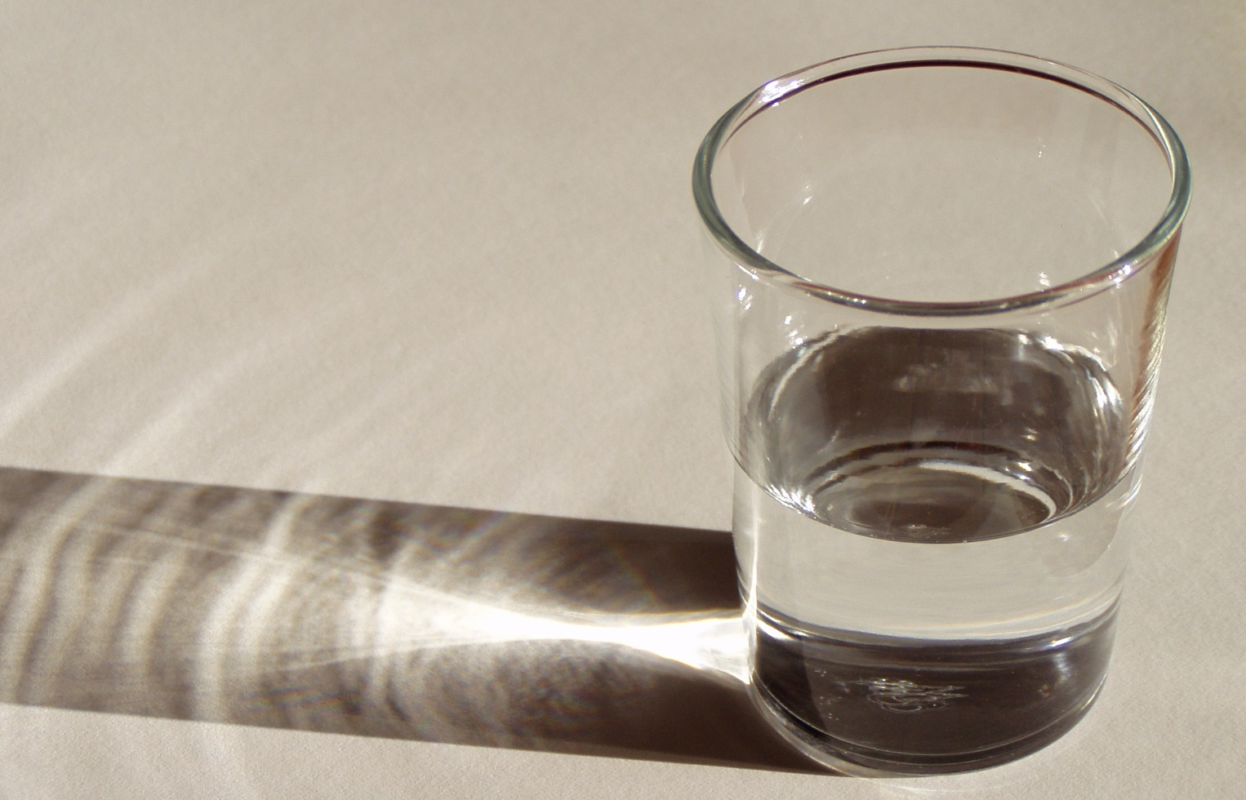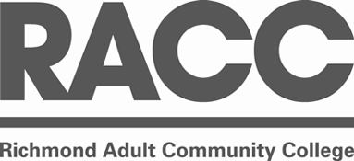

***on 19 June, 7pm-9pm***

***an Ideas Forum:***

***What is Happiness?***

***£5 – (£3 for Philosophy For All members) booking advised as places limited***

**The philosopher Jean Jacques Rousseau Once said that happiness is “a good bank account, a good cook and a good digestion.” But is this really all there is to it?**

**Come and discuss happiness and how to be happy with a team of cutting edge thinkers of our time: philosophers, psychologists, musicians, artists and other experts.**

**This event continues the “Cultural Salon” tradition recently revived at Ealing’s Pitzhanger Manor.**

**To reserve your place please email ….**



Philosophy For All

pfalondon.org

**and**

**present**

**as part of Adult Learner’s Week**