**KEYNSHAM WALKERS**

**ARE WELCOME** 

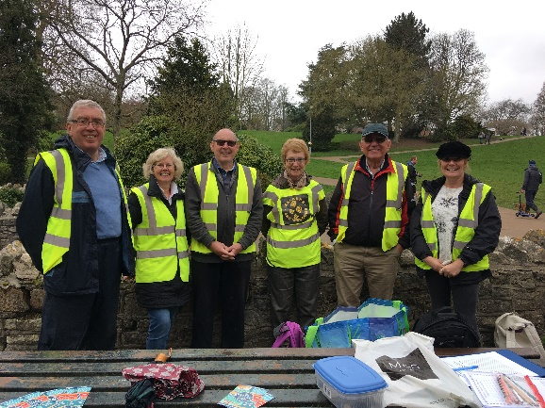

BRADFORD ON AVON

SUNDAY 29TH MARCH 2020

MEET AT KEYNSHAM STATION AT 9.30 TO CATCH THE 9.41 TRAIN, ARRIVING AT BoA AT 10.07. WE HAVE A 5 MILE TOUR AROUND THE COUNTRYSIDE SURROUNDING THE TOWN, ARRIVING BACK AT THE TOWN AT ABOUT 1.00

WE THEN HAVE A COUPLE OF HOURS TO OURSELVES TO LOOK ROUND THIS PICTURESQUE TOWN.

CATCHING THE 15.12 TRAIN BACK

IN CONJUNCTION WITH BRADFORD ON AVON WALKERS ARE WELCOME

.

**THE COST IS £7.00 AND INCLUDES DISCOUNTED TRAIN TICKET**

**SUITABLE FOOTWEAR ESSENTIAL**

**PLEASE LET ME KNOW IF YOU INTEND COMING SO THAT I CAN BUY TRAIN TICKETS IN ADVANCE**

**INFORMATION CONTACT DAVE**

[**wrwkeynsham@outlook.com**](mailto:wrwkeynsham@outlook.com) **or telephone 07866440968**