 KEYNSHAM

JOIN US FOR OUR FIRST WALK OF 2018.

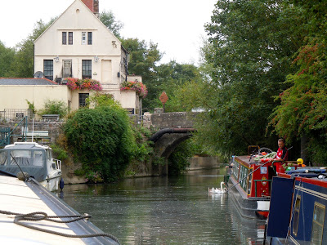

We will take a leisurely riverside walk to Saltford, returning to Keynsham via Manor Road Woodland

THIS IS A CIRCULAR **5 MILE** WALK.

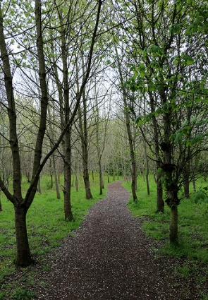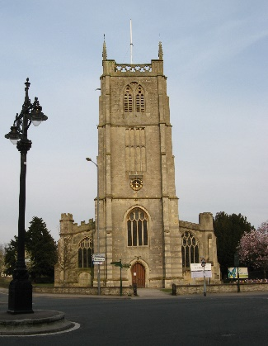

**SUNDAY 21st JANUARY 2018**

**MEET** **KEYNSHAM MEMORIAL PARK CAFÉ.**

**10.00 A.M.** **START**

EVERYBODY WELCOME

**SUITABLE FOOTWEAR ESSENTIAL**

**FOR FURTHER INFORMATION CONTACT DAVE**

[**wrwkeynsham@outlook.com**](mailto:wrwkeynsham@outlook.com) **or telephone 07866 440968**