Kingston Environment Forum meeting
NOTES
Tues 26th Feb, 10.00am – 11.30, in John Lewis Community Hub
Present: Pat Dobson (KEC); John Legate (KCC, Kingston Beekeepers); Marilyn Mason (TTK), Vicky Phillips (SWLEN); Bernie Simcox (ET)
1. Welcome; apologies had been received from Sophie Norden (ET), Stephen James (ET), Hilary Gander (TTK, KCC)
2. Review of previous meeting Notes and actions - only JL and MM had been at September meeting, so Notes were agreed by MM and JL; MM would publish them on the website, [along with these Notes once confirmed by email].
3. Updates and actions on KEF/Council issues as needed:
- KSP meeting in Jan – no report sent or given by JV or KEC, so it was assumed that no-one from KEF had attended.
- Air quality – the new KCAN (Clean Air Now) group and the Council are working on AQ; RBK plans some public meetings which KEF members could support and publicise. BS recommended Prof Frank Kelly of Kings College London, who lives locally, as a speaker, and MM recommended Dr Gary Fuller, also of KCL, who recently published a good book on AQ, “The Invisible Killer...” We recommended that KCAN kept in touch with MASC (which also included Richmond councillors and council officers) so that Richmond and Kingston groups could support and learn from each other. Richmond had agreed to roll out a 20mph speed limit and to start fining idling vehicles.
MM had a graph on environmental impacts of various kinds of vehicle (see Appendix 1) which showed that EVs still produce pollution – the graph was produced by a student group at Surrey University with no source, so would need checking and confirmation before sharing!
KEF still didn’t know what the AQ impacts of the Beddington W2E incinerator would be.
- Bees and 5G roll-out - It was acknowledged that the science, on both human health and impacts on insects, was uncertain, but that perhaps the risks outweighed the benefits of faster IT connections and driverless cars. All - See Appendix 2 and have a look at the petition to Government at https://petition.parliament.uk/petitions/233707/
- Other:
The Great Green New Year Gathering in Jan had been well attended, with some useful outcomes and potential collaborations. The meeting had chosen to focus on AQ and Climate Change and to prioritise those interlinked issues within their various groups, + to campaign more actively via letter-writing, contacts with councillors on environmental issues, using Kingston Environment News to highlight a theme per month... See the full report on the GGNYG at https://e-voice.org.uk/ttkingston/assets/other/green-gathering-jan2019-repo-3 . Occasional gatherings such as this could have some potential for replacing the information-sharing, collective actions, and work on particular themes undertaken by KEF up to now (see #4)?
Heathrow consultation ends on March 4th – responding to that would be the first campaign highlighted in the next Kingston Environment News, t b published before the end of Feb. All - please respond if you haven’t already and ask your supporters to do so – Kingston will be affected.
Updates from ET and TTK Energy group in Appendix 3
4. Future of KEF, Chair, priorities etc: See Appendix 2 in the Agenda circulated earlier for MM’s arguments for and against continuation. It was agreed that the more useful functions of KEF – sharing info, providing expertise and advice on environmental issues, responding to local consultations, occasional working parties on specific local concerns etc - could continue satisfactorily without the need for a collective view or for quarterly KEF meetings (with all the associated effort of finding venues, writing agendas, notes, reports...) or attendance at other stakeholder meetings such as KSP’s. No one had volunteered to take over chairing from MM, who stood down at this meeting, which made the decision to retrench somewhat easier!
Member-groups could continue to offer advice to the Council and liaise with relevant councillors and council officers ad hoc on their own areas of expertise, as most do already, without needing to come to a collective KEF view which had proved all but impossible. Member-groups could also support the Council when it was undertaking useful environmental actions (e g Go Cycle) and nudge it generally in the right direction; in fact, there could be more useful and better focused interactions with the Council this way than via KEF. Cllr Hilary Gander, RBK lead on environmental issues, would probably find this helpful.
Members with particular topical concerns could still call upon KEF via the Facebook group (which is a public group so others will see posts too) to form working groups and perhaps produce statements that could be held on the KEF website.
MM would archive current KEF ToR (revised last year) and publish a new shortened version on the website to encompass the above changed focus. MM would also notify KSP that for the time being KEF would no longer attend KSP meetings, unless invited to speak on specific topics, or to the KSP annual conference where it was agreed that the environmentalist presence could be very useful, or KSP wanted to invite another Kingston environmental group (KEC? TTK) to attend regularly to represent a green perspective (but necessarily not a collective one).
This cut-back of activities was not necessarily final – if someone came along who wanted to chair KEF, organise meetings, attend KSP meetings etc, it could probably be revived. But for the moment we would step back and focus more clearly, and possibly more effectively, on member-groups’ particular areas of concern.
5. AOB
MM had been sent TCC’s report, Recipe for Disaster, about food, farming and the environment too late for TTK’s Saturday 23/2 stall on Clarence Street, and handed out some copies. She would also ensure that spares went to KEC [and maybe Kingston libraries?]. The report can be read at https://www.theclimatecoalition.org/recipefordisaster. (Contact Kingstonfirst if you want a street stall.)
Kingston Council now had a Green Party councillor, Sharron Sumner, formerly LibDem, then Independent, now Green Party (and active in the new KCAN group) – could change the complexion of the Council a bit?
JL thanked (seconded by the others present) MM for her work in keeping KEF and its meetings going for as long as she had!
6. Dates: No further KEF dates planned.
KEC would host a Seedy Sunday event on March 10th, this year expanded to include a clothes and CD swap.
APPENDIX 1, vehicle impacts on the environment
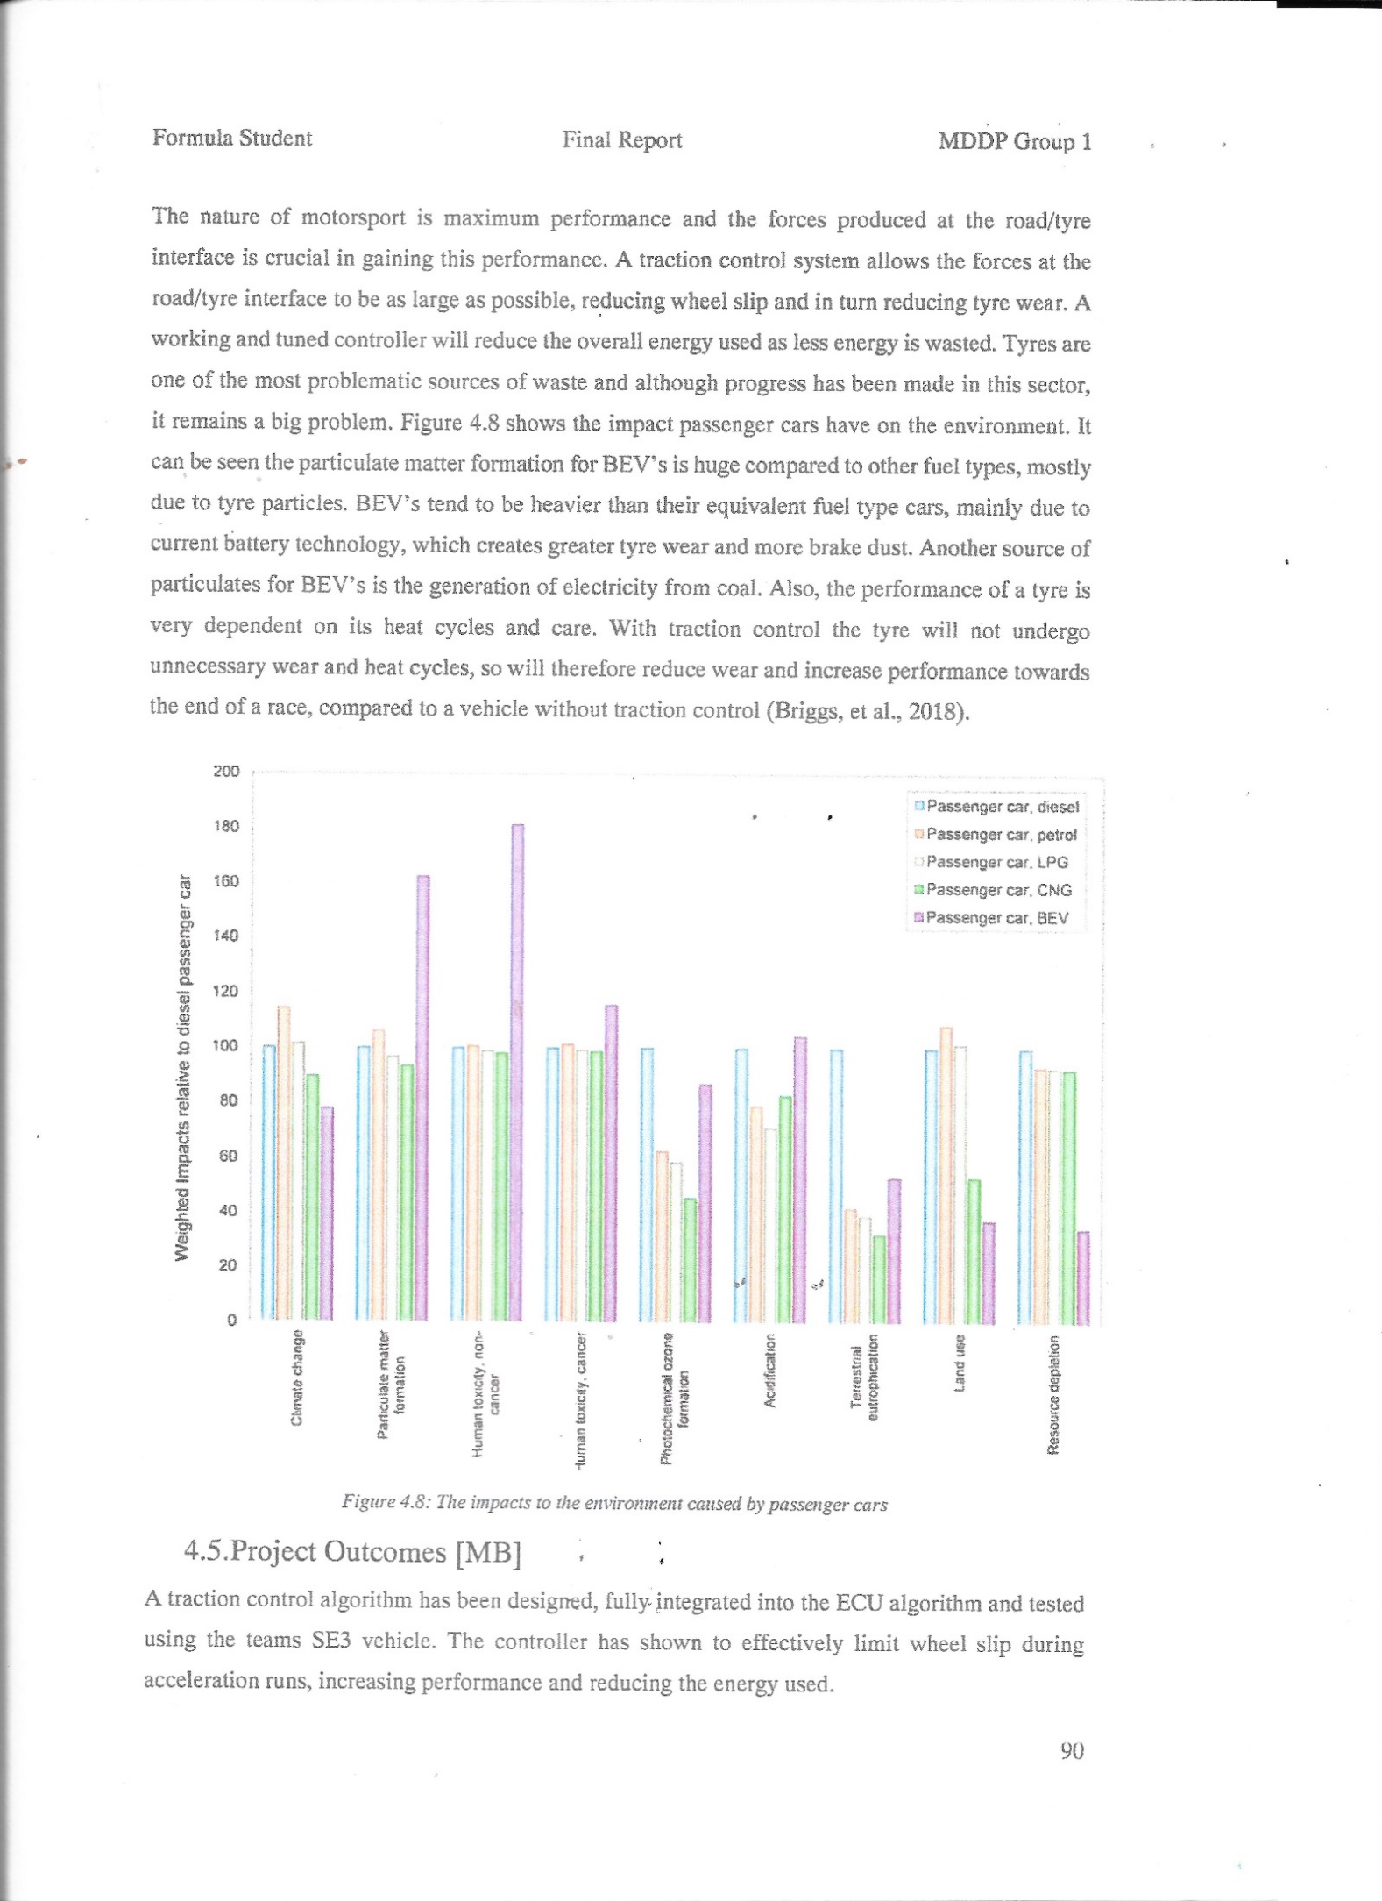

APPENDIX 2: On extension of 5G network
From a Kingston beekeeper:
"........The connection between colony collapse disorder and exposure to radio frequency and microwave radiation has been repeatedly argued by researchers, but at the smart farming conference a new, “smart” way forward was presented as the perfect solution to the problem: a new pollinator drone called “APIS”. The acronym stands for Autonomous Pollination and Imaging System. It is a fully autonomous “micro air vehicle” designed for greenhouses – one of several currently being developed in different research establishments across the world.12 The technical advances that have been made in indoor navigation, miniaturization and precise vision-based control underpin the viability of the design. If our bees are being killed off by the new electronic ecosystem, never mind. The new ecosystem enables them to be replaced with robot bees......"
We already have one 5G ready small cell, base station, mounted on a lamp post in Mill Street. The council have just confirmed to me today that there will be 15,000 of them in Kingston by 2025. One mounted on every third lamp post in high footfall areas and one mounted on a lamp post per street in low footfall areas. We are next to Knights Park campus and Middle Mill Halls of Residence so we are a high footfall area.
This will be happening all over the country to the same density - not just Kingston.
Do you really want a wireless transmitter mounted outside your house at bedroom window level, giving off microwave radiation, 24/7, 365 days a year. At the very very least this will kill all insect life. You may already have heard the news today that insects may be extinct within a century. In some areas of the world we already have lost 98% of the insect population.
Please sign this important petition and pass on to friends - we must get to at least 100,000 signatures to have it debated in parliament. This is vital for everyone's future. https://petition.parliament.uk/petitions/233707/

Appendix 3A: Updates from the ET and TTK Energy Group
From the Environment Trust, some current issues from Stephen James:
Kingston Green Infrastructure, Energy and Water– Shadia Snelling is on maternity leave and Francesca Campagnoli has taken over as the main commissioner. We made a presentation in Jan at the South of Borough neighbourhood committee and made useful contacts for Chessington and Hook. You probably have these contacts: Cllr Andreas Kirsch at Churchfields and Cllr Pat Bamford at Huntingate. The chair is Cllr Lorraine Dunstone.
I went to an interesting talk on 19th Feb about District Heating in Kingston organised by Francesca, run by Buro Happold. Hilary Gander was present and several reps from RBK, also Kingston Hospital and Thinking Works. Research has been undertaken around seven ‘clusters’, i.e. areas with potential. I imagine you know about research into possibility of using heat from the outfall of the Hogsmill sewage treatment plant to supply new houses planned for Cambridge Road estate? You may well know more about all this than I do.
I intended to have a document ready for KEF and Transition Town Kingston about air quality but unfortunately this will not be possible in time. I have it on my list to do and will aim for end of March at the latest.

Appendix 3B: Report on Study of District Heating Networks in RBK - presented by Buro Happold on 19/02/19 at a meeting hosted by Kingston Council Peter Mason, TTK Energy Group
RBK has commissioned Buro Happold Engineering (BHE) to study the potential for district heating networks (DHN) in the borough. The concept of DHN’s has been around for a long time; the main historical driver being the lower capital cost of a large single source of hot water compared to the total cost of lots of individual boilers. The principal technical disadvantage is the large network of insulated pipework, usually in the street. RBK’s particular brief to BHE was to explore the potential of DHN’s for reduction in green-house-gas emissions. (Preliminary report can be seen here.) BHE have identified seven clusters of buildings which could show benefits. None are in North Kingston, the particular interest of the North Kingston Forum. The best project is probably the imminent total reconstruction of the Cambridge Estate. For this, the heat source is principally the warmish treated effluent from the sewage treatment works, just where it is discharged into the Hogs Mill. The extraction of energy would be by water source heat pump (running on electricity), and this can be supplemented by waste heat from the adjacent crematorium. This project is made easier by having one owner, RBK, new build from scratch and little pipework in busy urban streets which are already full of services. This looks a good use for a DHN. The other projects get more difficult, with multiple owners (who have to cooperate), pipe-runs in the streets, use of Combined Heat & Power (CHP) which means burning fossil fuel in an internal combustion engine on site and the removal of choice of energy supplier for the end-user. All this is against the backdrop of new building regulations which reduce heat loss by improving insulation and air-tightness and so make space heating a less significant user of energy than it has been both in total energy and in months in the year needed.

