  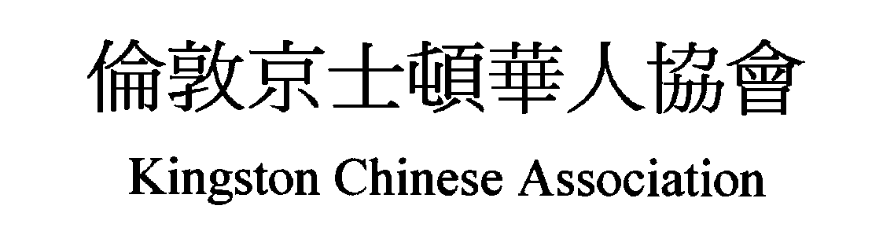  Address: c/o Milaap Centre, 140 Acre Road, Kingston upon Thames, KT2 6EE 6666666666666ee6ee6666EE  www.e-voice.org.uk/kca |  |  |  | Membership Application Form  會員 申請表
(From 4 years old - age between 10 to 20 will also be member of Kingston Chinese Youth Group 由四歲起 - ＋至二十歲將自動加入少年組)
Forenames 名 : |  |  | Surname 姓 :
Name in Chinese 中文姓名 : |  |  | Birth date 出生日期:
Ethnicity 種族 : |  |  | Gender 性別 :
Home phone 家居電話: |  |  | Mobile 手機:
E-mail address 電郵地址: |  |  | Disability 殘疾 :
Home address 家居地址:
Postcode 郵政编碼:
School or Employer name 工作或學校名稱:
Postcode of School or Employer 工作或學郵政编碼 : |  |  | Profession 職業 :
Next of Kin -Full name 家屬姓名: |  |  | Next of Kin -Tel. no.家屬電話:
Declaration:
I agree to abide by all the rules and regulations of Kingston Chinese Association and Kingston Chinese Youth Group.
I also understand that the final decision for the acceptance of my application to become a member of Kingston Chinese Association
will be at the discretion of the Management Committee and these data may be shared amongst KCA and KCA partners.
本人同意遵守倫敦京士顿華人協會及少年組所立规章制度,及以上資料供協會與伙伴使用。(個人會費1年£2 由4月1日201___年至3月31日201___年)
Signature 簽名 : |  |  | Date 日期:
Signature of parent or guardian if under 16: |  |  | Date 日期 :
＋六歲以下請家長或監護人加簽名 :
Annual membership fee: £2 for the year 1 April 201___ to 31 March 201___. |  |  | KCA membership no.會員號碼:
Fee collected by (print name) 收費人: |  |  | Date 日期 :
KCA Co-ordinator 聯絡人: |  |  | Remarks 備注:

