Application number: 06/2019/1451
Former Cottam Brickworks, Cottam Avenue, Preston
Hybrid planning application for development comprising: i. Full planning application for the erection of a retail foodstore (1,785 sqm) (Use Class A1) together with associated car parking, servicing, access and landscaping; ii. Outline planning application (all matters reserved excluding access) for the erection of up to 11,425 sqm of flexible use commercial floorspace for A1, A2, A3, A4, B1, C3 and D1 uses; up to 89 no. residential dwellings; and associated landscaping, car parking, servicing and open space; iii. Detailed vehicular access for retail/commercial area (the village centre) including access arrangements from Tom Benson Way and Cottam Avenue and detailed points of vehicular access to the proposed residential area.

Recommendation is that Ingol & Tanterton Neighbourhood Council object to this planning application based on the safety of our local Community from traffic related issues.
This planning application must be considered alongside the ongoing planning applications 06/2017/0255 & 0256 and the previous outline application 06/2015/0085.
06/2015/0085 is the outline masterplan for the site with a reduced supermarket and with vehicular access only from Tom Benson Way. Access from Cottam Avenue was for the local bus and emergency vehicles, which would be controlled by rise and fall bollards. 06/2015/0085 consisted of 9800m² of retail units and 206 residential units.
This proposal consists of 13200m² of retail units and up to 89 residential units and 114 residential units under 06/2017/0255 & 0256. Access for the whole of the 203 residential units would be via Cottam Avenue.
Cottam Avenue, a 20mph road, is a narrow two-lane road with no centre line markings, limited off road parking, includes part of a local bus route and a children’s nursery.

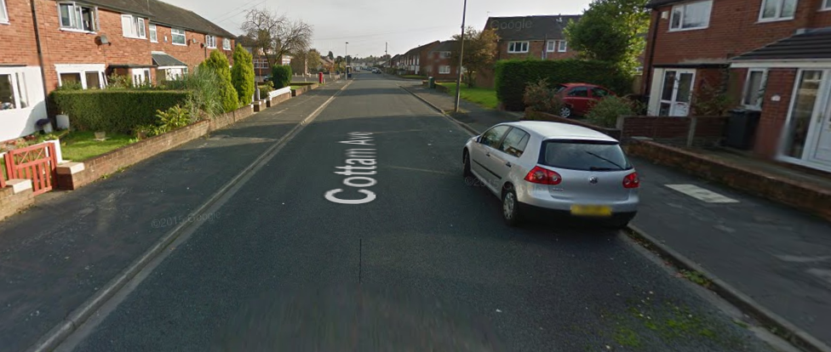
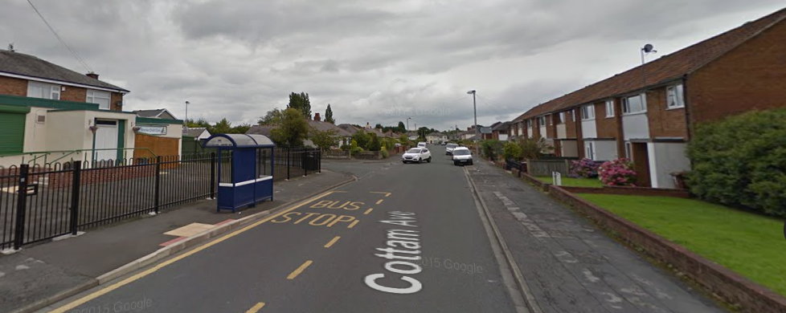
Cottam Avenue joins Tag Lane (B5411) at a three-way junction.
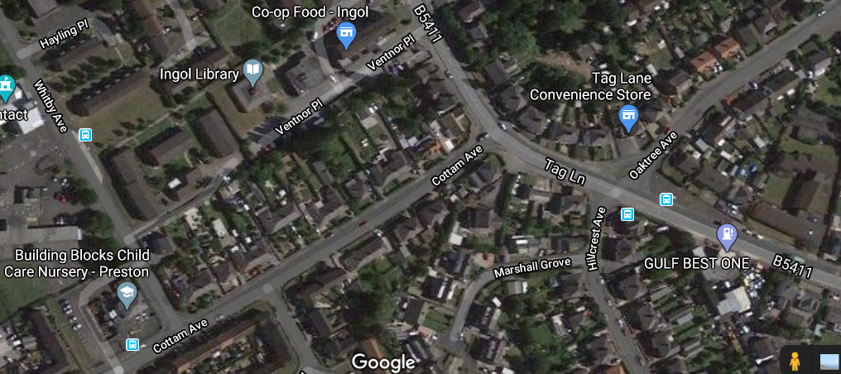
Traffic on Tag Lane according to the details within the Traffic Assessment is heavier at peak times than Tom Benson Way, but this planning application proposes that all the residential traffic exits through Cottam Avenue onto the busier Tag Lane.
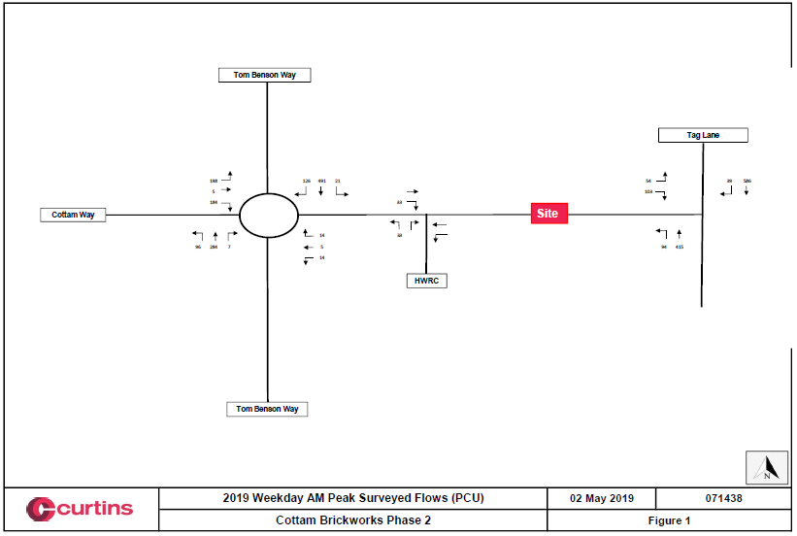
Tag Lane/Cottam Avenue Southbound = 576 vehicles per hour
Tag Lane/Cottam Avenue Northbound = 415 vehicles per hour
Tom Benson Way/Cottam Way Roundabout Southbound = 491 vehicles per hour
Tom Benson Way/Cottam Way Roundabout Northbound = 284 vehicles per hour

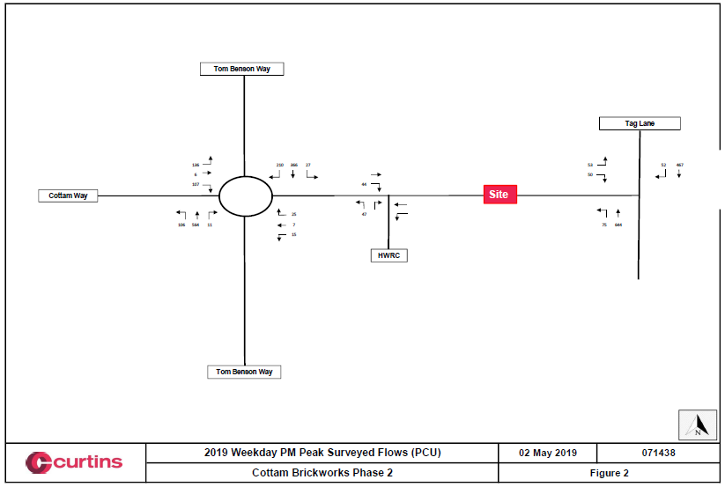

Tag Lane/Cottam Avenue Southbound = 467 vehicles per hour
Tag Lane/Cottam Avenue Northbound = 644 vehicles per hour
Tom Benson Way/Cottam Way Roundabout Southbound = 366 vehicles per hour
Tom Benson Way/Cottam Way Roundabout Northbound = 564 vehicles per hour

576 cars Southbound per hour peak period equates to 1 car every 6 seconds.
415 cars Northbound is 1 car every 7 seconds.
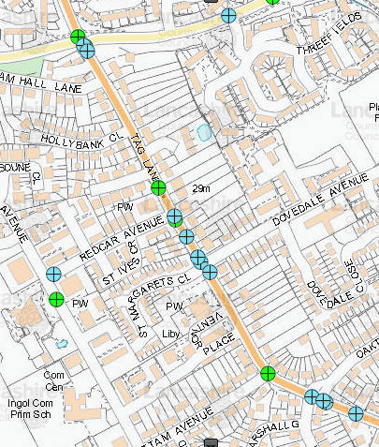
This gives virtually no time to turn right (Southbound) towards the city centre or one of only 2 East/West crossing points of the West Coast Mainline North of the city centre other than the Northerly Tom Benson Way route. These being Blackpool Road and Cadley Causeway.
With all the extra traffic trying to exit the proposed site onto Tag Lane, accidents due to frustrated drivers trying to exit Cottam Avenue will occur. As records show Tag Lane has seen numerous traffic accidents over the past few years.
Blue dot = up to 2 collisions
Green dot = Up to 2 Collision Involving Child, Cyclist/Pedestrian

06/2019/1451 consists of a much larger commercial area of 13200m² and a similar number of residential units to 06/2015/0085 yet proposes a traffic system with residential traffic exiting onto a peak hour busier road than the original access only Tom Benson Way.

For the reason of Local Community Safety, Ingol & Tanterton Neighbourhood Council object to this planning application.
The only vehicular access this Council will accept is the original proposal for access off Tom Benson Way and only the local bus and emergency services via Cottam Avenue controlled by rise and fall bollards.

