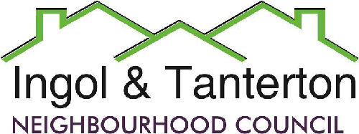
Gill Mason - Clerk and RFO
Email: ingoltantertonnc@hotmail.co.uk

Agenda
All parish councillors are hereby summoned to the meeting of
Ingol and Tanterton Neighbourhood Council on Wednesday 17th March 2021 at 7.00pm.
Due to the Covid 19 virus regulations the meeting will be held remotely.
If any parishioner would like to join the meeting by video communication please contact the clerk.

Open forum
Jeff Scales – Locality.

1.To receive apologies.

2.To approve the minutes of the meeting held on Wednesday 17th February 2021.

3.To receive declarations of interest.

4.To consider the quotes for a defibrillator and resolve to purchase and install the system at the TVC.

5.Finance.
Expenditure
BACS | Gill Mason – clerk | Expenses January | £42.68
BACS | MB Landscaping | Lengthsman’s hours (basic)March | £450.66
BACS | Gill Mason – clerk | Wages March | £680.73

6.To consider the lengthsman’s update.

7.To consider planning matters and applications.

8.Reports from the neighbourhood council working groups:
- Neighbourhood council review working group.
- ITNC communications working group.
- Outreach to community groups working group.
- Tanterton shops area improvement working group.
- Planter sponsorship working group.

9.To consider the arrangement of the temporary monthly meetings.

10.To consider and accept Cllr Yates’s resignation.

11.Reports and correspondence.

12.Date and time of meetings.

