*** Covid – 19 Awareness***
HOTHERSALL PARISH NEWS
Spring 2020

In this time of national and international crisis, it is important that Hothersall Parish takes care of its parishioners. We are fortunate to live in a beautiful part of the world in which to self-isolate, but we must be as aware of our neighbours as in any other area. People may need help with shopping, dog walking, posting a letter or just a chat on the phone so please contact your nearest neighbour to check on them. If they are in need and you aren’t able to help, then please contact one of your councillors and they will be able to coordinate a response. If you require any other information, then please look at our noticeboard and website.

www.e-voice.org.uk/hothersall

Government Guidelines

STAY AT HOME TO STOP THE COVID-19 VIRUS SPREADING
You should only leave the house for 1 of 4 reasons:
- shopping for basic necessities, for example food and medicine, which must be as infrequent as possible
- one form of exercise a day, for example a run, walk, or cycle – alone or with members of your household
- any medical need, or to provide care or to help a vulnerable person
- travelling to and from work, but only where this absolutely cannot be done from home

Important - These 4 reasons are exceptions – even when doing these activities, you should be minimising time spent outside of the home and ensuring you are 2 metres apart from anyone outside of your household.

There is separate advice about:
- staying at home if you're at high risk of getting seriously ill from coronavirus
- staying at home if you or someone you live with has symptoms of coronavirus

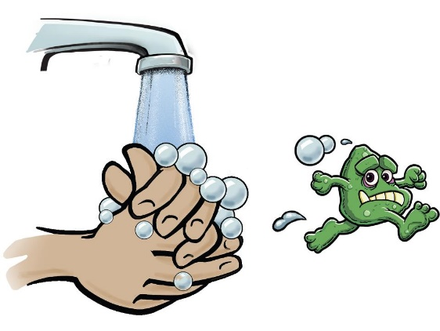

SYMPTOMS AND WHAT TO DO
Do not leave your home if you have either:
- a high temperature – this means you feel hot to touch on your chest or back (you do not need to measure your temperature)
- a new, continuous cough – this means coughing a lot for more than an hour, or 3 or more coughing episodes in 24 hours (if you usually have a cough, it may be worse than usual)
To protect others, do not go to places like a GP surgery, pharmacy or hospital. Stay at home.
Use the 111 online coronavirus service to find out what to do.

Surgical Masks
We have a quantity of surgical masks available for residents. Please contact Debbie Gale (details at the end of this letter) to arrange how many you require and delivery.

Ribble Valley Community Hub
Ribble Valley Borough Council have launched the Ribble Valley Community Hub for anyone needing support on 01200414597 9am -5 pm Monday – Friday
“We have set up a dedicated phone number to help the most vulnerable people in our community who are facing difficulties, worries and loneliness as a result of Coronavirus- this will be manned by Council staff
We will be working in partnership with residents, businesses, partners and the voluntary sector to provide free help and support with everyday needs such as; obtaining food parcels, collecting prescriptions, preventing loneliness, housing advice, financial and debt advice, help with shopping and Meals on Wheels
This helpline is available for residents that may need additional support during the outbreak, those wanting to volunteer their time and services to help those in need in their local community and local businesses seeking advice or the latest Government information”
https://www.ribblevalley.gov.uk/info/200394/council_news/1741/coronavirus_covid-19/3
Coronavirus Scams

Inevitably a minority of people are taking advantage of this crisis for their own gain. Please open the link below (right click document object and open) to read advice from Lancashire County Council regarding bogus door to door salesmen, offers of shopping and online suppliers and scam emails from WHO and “researchers”. If you can’t open the link, then please contact Debbie to drop off a hard copy.

Local firms’ opening hours and those making deliveries

Ribble Farm Fare 01772783386/782693
Veg Box £16.50 Fruit Box £8.50

Andertons 01772783321 brendanandertonbutchers.co.uk
free delivery Wed and Sat

Little Town Farm Dairy 01772786198 littletownfarmshop.co.uk

Booths Booths.co.uk/home-delivery
Elderly and vulnerable 9.30 – 11.00 pm Monday – Friday
NHS, police, fire services, army personnel social care workers teachers and Booths colleagues 7.00-8.00 am and 8.00-9.00pm Monday to Sat 9.00-10.00 Sunday

Swifts Hardware 01772784250

Sainsbury’s
NHS ID holders have priority Monday to Saturday 07:30 - 08:00. Elderly customers, carers and disabled customers have priority Monday, Wednesday and Friday 08:00 - 09:00.

Co op
Dedicated shopping hour for our vulnerable customers, those that care for them and NHS workers 8am to 9am Monday to Saturday, 10am to 11am on Sundays.
Simon Thompson has Hothersall reared Aberdeen Angus beef available from the freezer. Will deliver. 07837 636121.

Gary Rowles Butcher 01772786308

Anji’s Emporium 01772780073

Annual Assembly and AGM

This event has had to be postponed and indeed all RVBC Committee meetings have been cancelled. Our Parish meetings have been conducted via the internet. We will follow guidelines issued for the recommencement of normal events and will let you know when a new date can be made. Our Annual Assembly is a very sociable affair and will be sorely missed, however it is worth remembering all our neighbours and taking time to make contact with them.

Annual Litter Pick

Unfortunately, the current crisis means our annual litter pick has had to be postponed. We would hope to schedule another in the autumn or next spring.

Clerk to the Council

We are delighted to announce we have a new Clerk to the Council; Deb Groves from Ribchester has stepped into the role. Deb is also Clerk to Ribchester Parish Council. Contact her at hothersallpc@gmail.com

Save the trees Please email your details to hothersallpc@gmail.com to receive this newsletter electronically.

Hothersall Calendar 2021

Some years ago, a group of residents coordinated and produced a Hothersall Calendar which was hugely successful. Time has passed and we feel the appetite is there for a Hothersall 2021 Calendar. So, whilst sitting at home with nothing else to do (!) we could all be sorting through our old photos and indeed, on our daily walks we can look for new inspiration. If you have any images you think could be included, (bearing in mind we would want images to reflect the 12 months of the year) then please send them to the Clerk at hothersallpc@gmail.com . We will let you know when the calendars are available to buy.

Autumn Walk

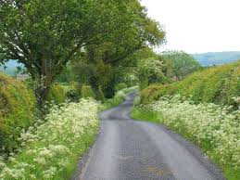

Cllr Julie Parry has agreed to plan and lead another walk this Autumn, date to be confirmed. Hopefully
by then we will all be able to get out into the fresh air.

Coronavirus: Waste and Recycling

Paper Collections
We are suspending all paper white sack collections until further notice.

Parking
Now that more people are working from home please make sure when parking to leave access for our refuse wagons to collect bins.

Disposing of waste
Personal waste relating to anyone who has, or is suspected of having, coronavirus (Covid-19) needs to be treated differently.
- put disposable cleaning cloths and used tissues in a plastic rubbish bag
- put that bag into another bag and tie it
- store it securely, away from your other waste, for a minimum of 72 hours
- then put it in your burgundy bin
If your next burgundy bin collection is more than 72 hours away, you can put your double bagged rubbish straight into the bin.
Other waste can be disposed of as normal.

Excess waste
During this difficult time, we find ourselves in, unfortunately Ribble Valley Borough Council cannot collect excess waste from your household.
Whilst we understand the Household Waste Recycling Centres are closed, our priority is to operate as normal a service as possible, therefore any waste which is not in the bins or lilac sacks cannot be collected.

Household Waste and Recycling Centres
Lancashire County Council have now closed all waste and recycling centres in an effort to prevent the spread of coronavirus.
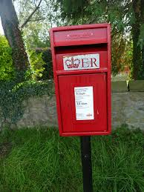
Post Box
The more eagle-eyed residents will have noticed we have a new post box. It has replaced the old one which collapsed, after many years’ use, under the weight of Hothersall’ s correspondence!

Hothersall Parish Councillors

Debbie Gale (Chair) 01772785032 07891901642 debbie.gale1@icloud.com

Maria Gee (Vice Chair) 01772782419 07793561308 maria.gee51@me.com

Ian Forrester 017727863560 07860719480 ianrforrester@hotmail.com

Simon Thompson 01772783356 07837636121 thompsonbff@gmail.com

Steve Warren 01772783284 07392389797 cjwarren@hotmail.co.uk

Julie Parry 01254878898 07824701329 jparry121212@gmail.com

Lorraine Soper 01772202202 07971462135 lorraine.soper@hallishudson.com

Deb Groves (Clerk) 01254878617 hothersallpc@gmail.com
Website https://e-voice.org.uk/hothersall/

