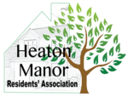

HMRA Annual General Meeting 22nd November 2022: Agenda

- Welcome and Introductions – Jon

- Election of Committee for 2023

- Peel Moat Open Space Update - Peter

- Adoption of the Estate by Stockport Council Update - Cathy

- Greenbelt takeover and recognition of the Residents’ Association - Peter

- Meeting with St Thomas’s School - Peter

- Any Other Business

