

ANNUAL REPORT 2017

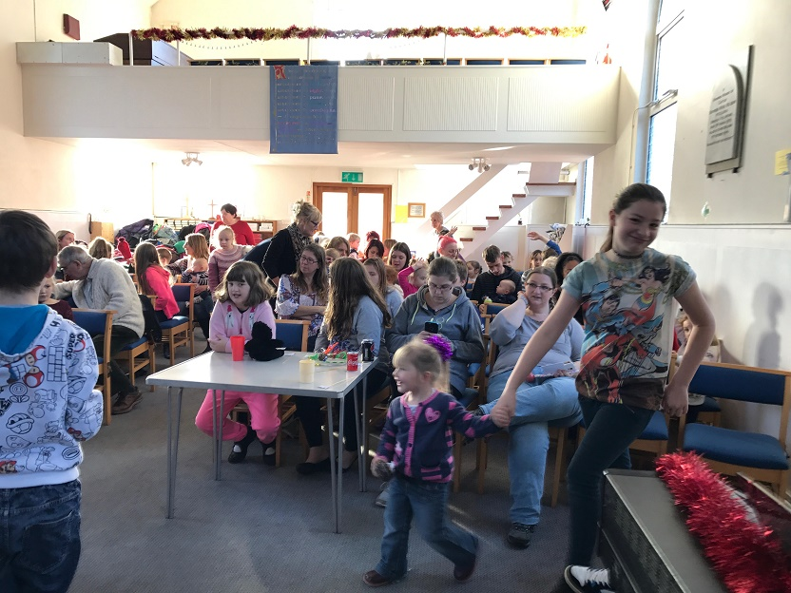

(photo from Messy Easter 2017)

Minister’s Report

"Where can I go to escape from you? Where could I get away from presence? If I went up to heaven, you would be there; if I lay down in the world of the dead, you would be there." (Psalm 139: vs. 7-8)

My Appointment at this church comes to an end in a few weeks’ time. Thank you for taking a punt on having a URC minister over these last seven years. I have greatly valued working and leading Methodist worship here and within the United Area.

It has been a particular joy to be involved in the Messy Church here in Hailsham. Over this last year, it has been good to share the Gospel with families from our town. I hope in the coming year as Rev Roger Leslie leads you to hopefully a new Appointment in September 2018 that we will continue with the Messy Church outreach. It is a real blessing to see how many people from our church come together to deliver the Messy Church. Thanks especially to Sheila Butland for keeping a watchful eye on all of this.

As I come to say goodbye there are many memories of people and events in the life of the church over these last seven years. Thank you to Barbara Edwards and those on the property committee who through their hard work have got the fabric of the building to a good place.

With the sadness of the departing the words of the Psalmist above provide comfort for God's people. As we come and go in life we are always in God's loving presence of God. A kind Minster said to me prior to my Ordination in 1996: "John, may you bloom where God plants you!" As I begin a new URC ministry in Banstead I will cherish the memories of you all and of living here among you in Hailsham.

Wishing God's Blessing on you all into the future.
Reverend John Gordon.

Steward’s Report
The Stewards have continued to meet during the year to discuss the life of the Church and items raised both at Church Council and from members of the congregation.
Firstly, we would like to thank everyone who contributes to the greater life of the Church whether by volunteering to welcome everyone each Sunday, provide refreshments and flowers, play the organ or piano, prepare for Communion, visit as a Pastoral Visitor or work on our property. By working together we ensure that the Church continues to be a vibrant community which will hopefully attract people to join us in the future.
Secondly, the Stewards have been discussing a number of major issues throughout the year; namely, Rev John Gordon’s replacement, finances, outreach and property.
As everyone will be aware, Rev John’s ministry was planned to conclude at Hailsham at the end of August in 2017 and a new Minister had been sought through the usual processes. However, 2017 saw a larger than usual number of Ministers moving and no replacement was possible. Rev Roger Leslie has very kindly agreed to step in and look after Hailsham until August 2018 and Stewards will be working closely with the Area to seek a new Minister for September 2018. The Stewards will, obviously, join the other members of the Church to say goodbye to Rev John at his last service in June but we would like to extend our very grateful thanks for his ministry at Hailsham and for his continued service to his new URC churches.
Finances have continued to be a concern but thanks to a higher than usual number of lettings the Church has managed to keep afloat. However, some of these lettings are coming to an end and the future is, once again, uncertain as to how much revenue will be gained. Stewards have recommended that any future major works such as the refurbishment of the Church Hall be put on hold until the Church has sufficient funds to pay for the work and still have the reserves it is legally required to hold. Our thanks, once again, go to not only the Property Group for maintaining the Church to such a high level but also to everyone involved in the financial side of the Church. These are tasks that sometimes go un-noticed but are very important to the continued existence of the Church in Hailsham.
Following another successful summer outreach last year Stewards asked for recommendations from member of the Church for a charity for this summer. It has been decided to support HOPS (Hailsham Old Pavilion Society) this year and two events have been planned. A summer afternoon tea and a quiz afternoon in September. Further details will be forthcoming in the Church notices.
Thirdly, if there is anyone who would like to join the Stewards we would be very pleased to welcome you, whether you wish to be a full Steward or an Assistant Steward undertaking only some of the duties your help would be invaluable. Please see any of the Stewards to find out about this.
Finally as Senior Steward I would like to say a personal huge thank you to Carole, Pam and John without whom the Church would not continue to run as it does. I cannot give as much time as I would like to the Church due to work commitments and having them beside me is a blessing.
Jenny Gandy.

Finance
The Church financial year runs from September to August so we are only ¾ of the way through the year. The annual financial report is prepared in the Autumn by the Church Accountant, Pat Aisbitt.

As “Treasurer” all I do is send details of income and expenditure, plus the bank statements every month by e-mail to Pat and I then receive back from Pat a monthly statement of income, expenditure and the balances in the various church accounts. These statements are then forwarded to all members of church council who have email, and printed out for those who need it.

Last February HSBC in Hailsham, which is where the church current account Eastbourne. It was decided at church council to apply for on line banking and this has proved a great help.

For the purpose of this meeting I have compared a few items from the last financial report and this year.

Average monthly collection 2015-2016 | £1626
Average this year over 8 months | £1634
Income from hall hire last year | £11,346  (average £945 month)
Income from hall hire over 8 months | £7480  (average £935) month)
Gas and Electricity last year | £1,494  (£124 per month)
Over 8 months this year  (This will come down with the summer month bills) | £167 per month

I have a copy of last years’ accounts and this years’ monthly statements should anyone wish to view them.
Sheila Butland

Property Report

- Since the AGM last year, we have negotiated a better insurance deal for the church premises with Methodist Insurance company, agreeing to paying an excess of £500, reducing the annual premium to £657.86; previously it was £933.40 per annum. This premium is fixed for 5 years.
- PAT test (bi-annually) was completed in July
- Peter Cox completed damp-proof work in the hall after some difficulty with quality of workmanship in August 2016
- Allan Honisett finished external painting in August 2016 at a cost of £4385. He recommends a 6 year cycle for painting the exterior as it will drastically cut down on the amount of preparation that will need to be done. (Due 2022)
- A window cleaner comes twice a year now
- Stewards decided that a complete refurbishment of the hall is needed but it was deferred for 2 years until we save up. Proposed work will be;
Damp course and damp proofing; walls plastered to skirting level; many new socket points put in to make the hall more rentable; re-painted; new radiators with covers; new carpet.
- Rights of Way into next door neighbour’s garden is ongoing and may need a lawyer to intervene.
- Volunteers have painted the porch interior; both sides of the lower wall of the altar; the corridor between the church and the hall; the corridor leading off the kitchen and office; and one coat has gone on the corridor outside the Minister’s office. We then ran out of manpower due to illness and Christmas!
- New LED lights have been put up in church now that the dimmer switch has been romoved.
- We will have to have the gutters cleaned before the Quinquennial Inspection in October 2017.
- We have a full electrical inspection to do before the Quinquennial.
- We await the removal of Youth Club equipment before we paint the Junior Church room.

THANKS must be given to Pauline Thomas and Sheila Butland who have carried the responsibilities of the Property Committee single-handedly when Barbara was unavailable due to surgery (5 months). Without voluntary help, the church premises would be looking shabby and unclean, and we are lucky to have people willing to hire the halls which enables us to keep going.
Barbara Edwards

Fellowship Report
We have really had a mixed year with only half the meetings being held due to hospitalisation and recovery of Barbara.
In May 2016, the group enjoyed a home-cooked meal in the hall made by Barbara and served up with the assistance of Pam Russell. The June meeting was cancelled, and in July the group travelled to Heathfield and enjoyed a coffee morning in the garden of Hugh and Barbara. Excess funds raised on this occasion went towards the autumn Fair, planned by the Church Stewards and fund-rising committee.
In September, Barbara prepared a talk on the work of Christian Aid which was well-received by those present.
In October, the group put their hands to good work to assemble the gift ‘baskets’ for the Autumn Fair and over 30 were ready for sale by the end of the morning.
The November meeting was cancelled, but in December, Barbara asked all members to prepare a little talk on a work of art depicting the Advent Season, while she did some research on the internet, producing pictures of art work that covered all four weeks of Advent, together with artistic notes from the experts on the internet! This was very well received with members commenting how much they had learnt during the morning on what the artists were trying to depict in their art. (This had nothing to do with Barbara’s expertise she hastens to add, not being able to draw even a tree herself!)
As usual, in January, no meeting was scheduled, but Barbara’s operation was on the 20th. This put her out of action for the February and March meetings, and no-one else felt able to take on the leadership.
Barbara has talked to all members about turning this group into a social fellowship group, by all of us going out for a meal once a month. It is still in the discussion stage, and could start up again in this form for June if that is what people would like. Barbara is happy to arrange venues and transport (lift-sharing). She would be pleased to hear from people whether they would like this to happen (current members of the group and others who would like come company on a regular monthly basis too).
Barbara Edwards

Toddlers
Our toddlers group continues to provide a much-needed service/support to parents and carers in Hailsham. As more and more budget cuts in public sector services kick in we are growing. We are finding that when the babies/toddlers grow older and start school a lot of them come to Messy Church which is wonderful as we can continue to see them grow up.
One of the carers, Sam, leads the children in action songs about Jesus at the end of the play session each week which the children love taking part in. One of our parents has got involved with the Christmas Fayre last year, baking cakes for it. We have a local curate's wife who comes and is very good at talking to mums new to Hailsham, telling them all that is going on locally for families.
The children enjoy playing with the toys especially the ride on toys for the older ones and the pop up activities for the younger babies. The group is run by Sarah and Sheila and Pauline fills in on an ad-hoc basis.
Sarah Griffin/Sheila Butland

Messy Church
Wow!!! Messy Church has been going for 9 years and we are very much looking forward to our 10-year anniversary! (An excuse for cake!) We continue to be lucky with getting regular helpers and have managed to hold 4 sessions in the past year:
- The little man who climbed a tree to see our Lord – Zacchaeus
- Messy Easter
- Messy Christmas
- Messy Moses
Some of the children were babies when they started and it is wonderful to see them grow up and lovely to be able to continue to offer this to our toddlers group.
We are still mourning the loss of one of our talented artists – Joy Easton – who has produced some fantastic pieces of art work around our many themes.
The format works – families enjoy craft activities which are related to our worship theme, there is a note on each craft table showing how this craft fits into the bible story. Worship is led by Rev John, and includes a story and songs and frequently dancing and a lot of noise. We then have lunch prepared and served by Sarah Griffin and Pam Russell.
Looking back over the 9 years since Messy Church started, one of the biggest changes is that our families are much more comfortable with worship. We have had to change how we present the Bible stories to them, and the sort of music and songs that they enjoy, but to see our church full of young families (see image on first page of this report) makes it all worthwhile.
Sheila Butland.

New in 2017! Knit and Chat
A knit and chat group has started in the church once a month. We are currently knitting squares which go to Dippy Doodahs in the High Street to be made into blankets to help those in need, locally and abroad. We also have an option to knit baby clothes for local premature babies and there are many Hailsham families grateful to receive knitted baby clothes. It is lovely to be able to help the local community in this way and a great way to have a ‘natter’ while we do it. It is a very informal group – just turn up if you are interested and open to people outside of the church as well – we have had one person turn up to one session after seeing a poster at Tesco’s and we hope to build on this by publicising more and holding the sessions at the back of church where people who pass by can see us. Jenny provides wool and needles from her stash!
We have an exciting project planned for the Autumn – we are linking up with Hailsham via Dippy Doodahs to knit a cover for one of Hailsham’s lamp posts and cover it with knitted nativity figures – this is a local councillor’s initiative and a good way for us to be involved in the wider community in Hailsham. All welcome why not drop in one Saturday for a natter if you don’t knit!! The sessions will be on the 1st Saturday of each month.
Jenny Gandy/Carole Short/Pam Russell

Ruby, pictured below, who turned up to the last session with ‘homework’ – she had knitted 15 squares!!!!

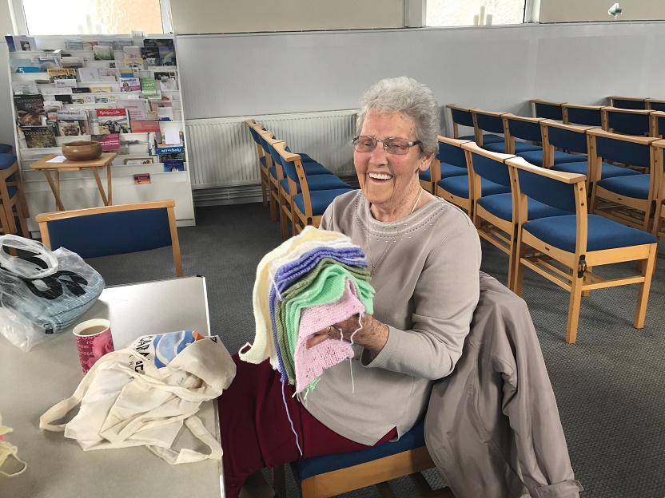

Pastoral
Our pastoral team have once again done a fantastic job, visiting those who are ill/housebound and keeping the stewards/church council informed of any needs within our congregation. We are sad to have lost much loved members during this past year and will remember them in our ‘Act of Remembrance’ during our AGM. We currently have 37 members.
Anita Carter.
Lettings
We have lost our two dance groups during the past year but are pleased to welcome 2 fitness groups. Sadly, Hailsham Historical will be ceasing to meet at our church from June. This is good news for them however as their numbers have grown to such an extent that our premises are not big enough to accommodate them.
Current lettings are from:
- Slimming World
- Healthy Living Club
- Redefine Fitness
- Zumba
- Hailsham Historical – until June
- U3A
Some slimming world members baked items for our Christmas Fayre held last year. We also have ad-hoc bookings from: East Sussex booking rooms for training; charities booking rooms for training: children’s birthday parties.
The Methodist Church changed the way they issue licences – they are now issued on a yearly basis instead of a ‘lifetime’ basis in the past. All of our keyholders have signed the necessary declarations meeting our eligibility criteria.
Carole Short

Communication


Our communication team aims to be as inclusive as possible – John Griffin produces a weekly sheet which has details of who is leading the service and who are supporting as well as any notices that people want to include, readings, and hymns – a new addition!
Carole Short leads on:
Facebook – Hailsham Methodist Church – this is quite popular with our Messy Church people and we have had new people come from seeing it on Facebook. It is also a good way to share photos from church events and telling people about what we are doing.
Website - https://e-voice.org.uk/hailshammethodist/ - we are having an average of 120 ‘visitors’ per month, with 9 over the last year coming from Germany. There is now a Facebook link on the website which you can click onto to see pictures and posts. Our photo albums on the website are quite popular too. We also have a Calendar of Events – we put all our events and hirers on here and it is a way of offering free publicity to our hirers.
Twitter: Jenny Gandy has recently taken this over and regularly sends out tweets, pictures of our events, etc. This is a great way of reaching the wider local community and also what is going on elsewhere nationally.
Carole Short/John Griffin/Jenny Gandy

Finally………



A big thank you to
Sarah and Helen Griffin for providing us with delicious cakes/scones/biscuits once a month with all proceeds going to church funds
Irene Mead for leading on our enjoyable Christmas Fayre event last year
Organisers of the Renaissance Singers who performed at our church last Spring; those who helped spring clean the church recently, those on the cleaning rota, Pauline who liaises with the Ministers/Local Preachers each week and plays the piano, Alison for playing the piano, and Barbara for playing the organ.

