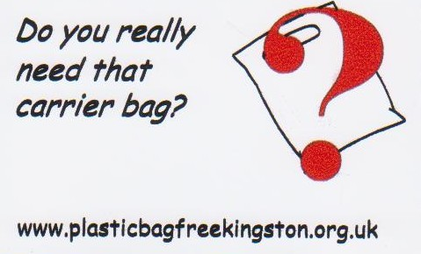
PRESS RELEASE, September 6th 2008: Another weapon in the battle of the bags

This week a new resource became available to Kingston businesses wanting to cut the number of plastic and other throw-away bags they give out. Towards a Plastic-Bag-Free Kingston has 200 free till-magnets to give away to retailers concerned about waste and the environment. The magnetic cards (see left) carry a message reminding shoppers that they may not need yet another carrier bag, and shop assistants to ask, rather than give them out automatically. Some shops on Richmond Road are already displaying them.

Towards a Plastic-Bag-Free Kingston volunteers have also been out and about in the town centre, giving out flyers explaining the problems caused by throw-away bags and offering some solutions. They have found Kingston shoppers remarkably positive about the campaign, quite well-informed and keen to find out more. Many would be happy to carry their own long-life bags with them all the time, and just need reminding to develop the habit.

"Plastic bags are a small part of a much bigger problem - the litter we see around us and the long-term effects of our throwaway life-styles on the environment and wildlife,” says co-ordinator of the campaign, Marilyn Mason. “but giving them up is one of the easiest ways for both shops and shoppers to make a difference. We don't need so many of them, and bags lying on our roadsides or floating in the river are not good advertisements for the retailers that supply them. I hope that raising awareness about their impact will encourage shoppers to get into the habit of taking a bag with them and retailers to stop giving them out automatically."

Retailers are invited to contact Towards a Plastic-Bag-Free Kingston via the website www.plasticbagfreekingston.org.uk if they would like to display a till-magnet or flyers. These resources have been enabled by a grant from UnLtd; environmentally-friendly businesses that would like to sponsor future printings are also invited to get in touch.

See www.plasticbagfreekingston.org.uk to find out more.

