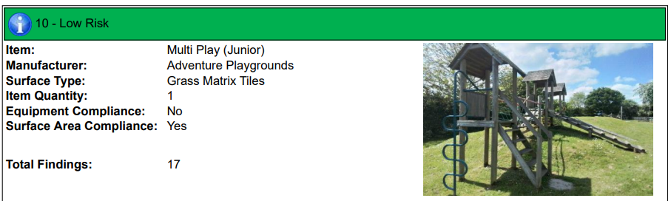

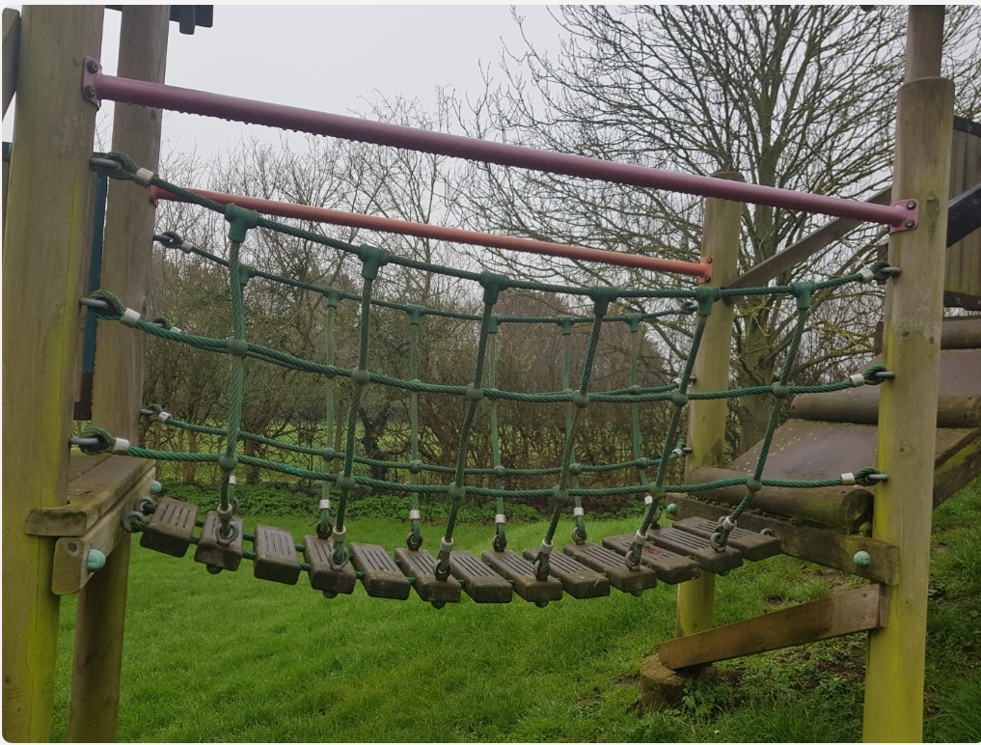

Picture 1.

The wooden towers are failing, and we have replaced multiple individual pieces .

The wooden slats on the bridge – we have one slat now failing.

As can be seen from the picture below – picture 2 the rot has started in a single slat.
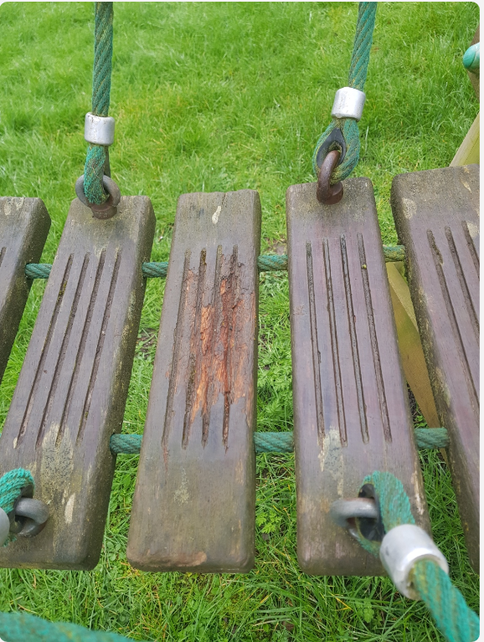
Picture 2.

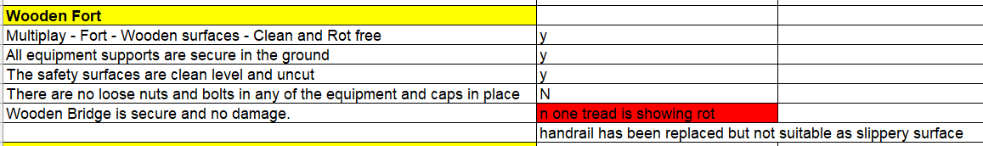
Picture 3.

Unfortunately, the supplier who manufactured and installed the unit has gone into liquidation – in 2014 and no company covers their spares.

As you can see from the bridge is a unique design and the rope travels through the slats so that we cannot replace an individual slat.

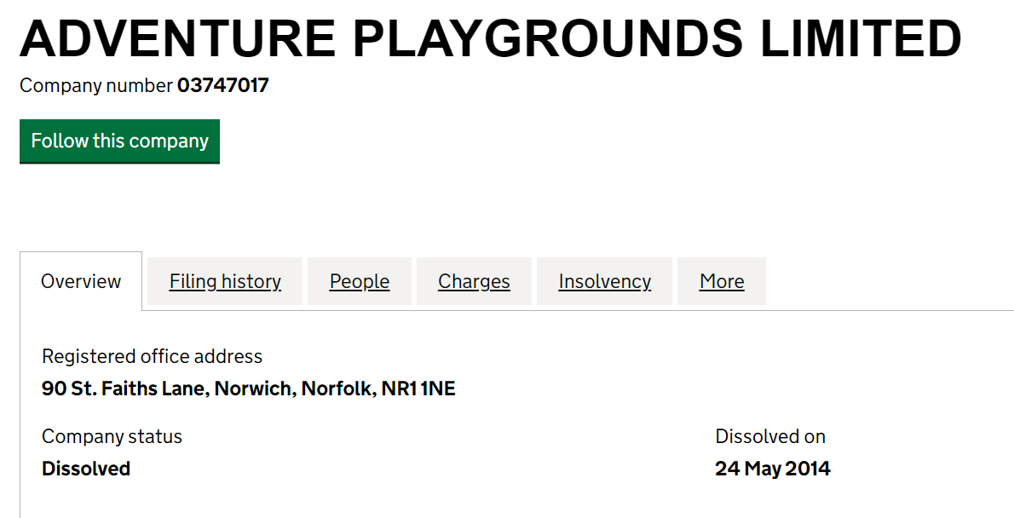

Proposal is a change to the bridge altogether to a standard wood free construction.

The ‘Burma Bridge’ is available with any size , length, or connections from ‘Online Playgrounds.’

Cost is estimated around £600 subject to confirming length , fittings, and colours.

