Great Waltham Parish Council (“GWPC”) – Banbury Square and War Memorials Maintenance Strategy

- The strategic approach detailed in this document ensures that the area of Banbury Square, Great Waltham and its war memorial and the war memorial at Ford End for which GWPC has responsibilities remain subject to a holistic regime of upkeep and maintenance, both routine and exceptional, as necessary to preserve their existing qualities and character.

Background

- In 2022 GWPC acknowledged the deteriorating condition of the war memorial at Banbury Square and engaged with the War Memorial Trust (WMT) with a view to effecting approved renovations, in particular to the lettering of inscriptions and names. In 2023 it resolved to also develop a strategy for the upkeep of the wooden posts which form the boundary of the enclosed area around the memorial. This document embraces not only consideration of those specific issues, but also the overall upkeep and maintenance of these assets.

- GWPC owns the central, grassed area at Banbury Square, Great Waltham (including its war memorial) and the war memorial located in the grounds of the Church of St John the Evangelist, Ford End. The grassed area and the two war memorials have separate entries on GWPC’s current asset register and are insured under its insurance policy.

War Memorials

- Banbury Square, Great Waltham

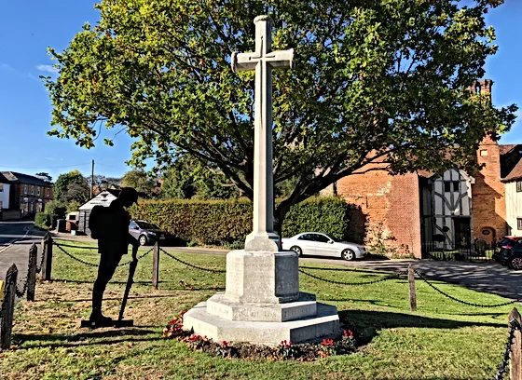
  - ‘The memorial is approximately 4m high, made of Portland Stone and comprises a round shaft surmounted by a cross with simply carved arms. The east face of the cross has a mark from a centrally placed sword which has been removed. The base of the shaft is chamfered and moulded’. It has an inscription and the names of those who died in WWI and WWII.

  - ‘It was erected in 1920 to the design of Architect, Arthur Richard Dannatt, a son of the well known farmer, William Dannatt of Margaret Woods Farm, Great Waltham, at a cost of £200 paid for by public subscription which came mostly from the villagers. It stands on land gifted by Colonel W N Tufnell DL to the east of the Church of St Mary and St Lawrence. It was unveiled on the 19 December 1920 by Brigadier General LCG Tufnell CB and dedicated by Rev. J.H. Morgan’.

  - ‘The war memorial at Banbury Square, Great Waltham is designated at Grade II because of the following reasons –

* Architectural Interest: this bespoke memorial is constructed with craftsmanship from good quality materials and has design interest.

* Historic Interest: it is a poignant reminder of the impact of world events on the local community and the sacrifice made for the defence of the country;

* Group Value: it has considerable group value with the Church of St Mary and St Lawrence (Grade I), Badynghams (also known as the Guildhall, Grade II*) and many other Grade II listed buildings around Banbury Square’.

  - Discussions between GWPC and the WMT have established that the Portland stone used for the memorial is more susceptible to weathering than other materials (such as the granite used for the Ford End memorial), and therefore any and all cleaning and renovation activities must be carefully considered beforehand.

- Grounds of Church of St John the Evangelist, Ford End

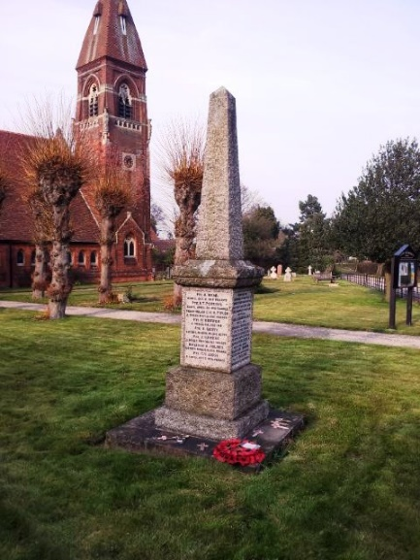
  - This is a ‘rough hewn grey granite rectangular obelisk on a two stepped rectangular base with the inscription and names on all four faces of the lower part of the obelisk constructed from cast lead letters’. It ‘stands in the grounds of St John the Evangelist Church in Ford End, Essex in Church Lane, just off the main road. […] There are 20 names listed for World War 1 and three for World War 2 engraved on the four sides of the plinth. […] The names here have been sorted into alphabetical order within conflict to ease research and reading’.

  - The inscription states it was erected by the parishioners of Ford End as a tribute to those who fought in the Great War 1914-1919 and a memorial to the fallen of the Second World War 1939-1945. This memorial is not currently listed.

  - GWPC is not responsible for the maintenance of the grassed area around the Ford End memorial.

- Both war memorials are used as focal points during Remembrance commemoration events.

Enclosed Area Around War Memorial at Banbury Square

- The war memorial at Banbury Square is bounded by a triangular arrangement of twelve oak posts each linked to its neighbour by a chain. While not primarily a physical deterrent, the barrier does enhance the perception of the special regard for and desire to protect the structure. It is effective in preventing casual approaches to and interferences with the memorial and the wreathes around it.

Grassed Area, Banbury Square

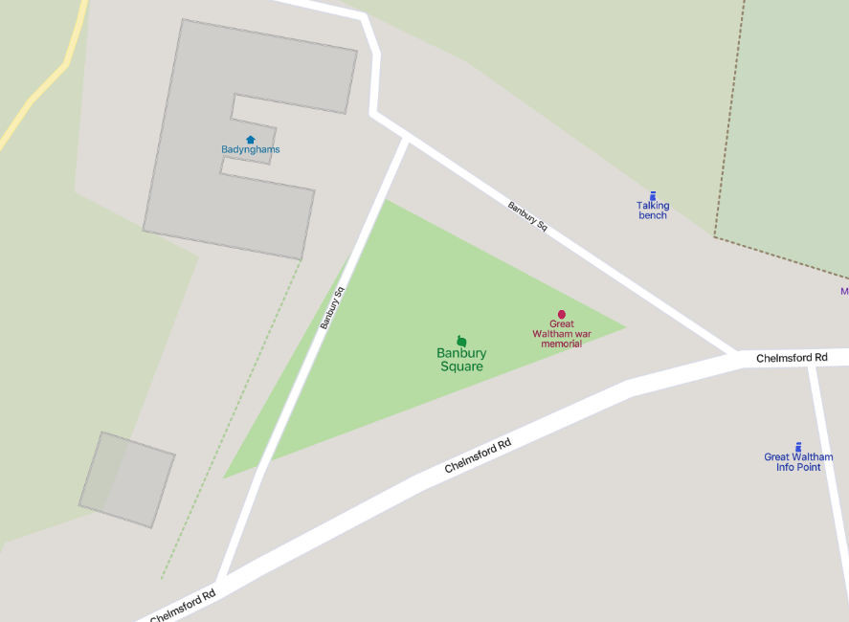
- This is a roughly triangular grassed area making up much of Banbury Square. It is bounded by Chelmsford Road and a semi-circular access road known as ‘Banbury Square’, with the memorial and enclosed area at its eastern side. GWPC has no responsibilities for the surrounding roads and pavements. The grassed area also contains an oak tree which is used to carry seasonal lighting decorations (used in winter, but remaining on the tree all year around). The tree is quite young and is expected to grow significantly, albeit over a long period of time. The power for the lights is currently supplied and paid for by the owners of the adjacent property known as Badynghams.

- The grassed area is mowed and maintained by the GWPC handyperson as part of the overall upkeep and maintenance duties of the role, although special arrangements are generally made each year to ensure the tidiness of the general area in preparation for Remembrance Sunday events in November.

Strategic Plan

- GWPC will:

  - Continue to effect routine maintenance work at the Banbury Square site and on the war memorial at Ford End and to prepare them as necessary for special occasions (in particular, Remembrance events in November).

  - Complete monthly inspections of the sites, and in particular, to focus on the conditions of the memorials’ stonework and the wooden posts and chains of the boundary barrier at Banbury Square.

  - Continue to liaise closely with the War Memorial Trust when it needs advice and approval for any necessary repairs or renewal work to the memorials.

  - Carry out any and all agreed repair and renovation works at the sites as promptly as possible.

  - Include specifically agreed amounts in its annual budgets to cover the costs of both (a) routine maintenance and (b) exceptional repair or renovation works at the sites. The latter may take the form of an earmarked reserve which can be carried over from one financial year to the next.

The current version of GWPC’s Asset Register is available at https://e-voice.org.uk/greatwalthamparish/copy-of-parish-directory/
Great Waltham War Memorial (2023), The War Memorial. Available at: https://www.greatwalthamwarmemorial.co.uk/ warmemorial. (Accessed 13th March 2023).
Ibid.
Ibid., Great Waltham War Memorial (2023).
Imperial War Museum (2023), War Memorials Register, Ford End – Obelisk. Available at https://www.iwm.org.uk/memorials/item/memorial/22245, accessed 24/03/2023.
Royal British Legion (2023), Roll of Honour, Ford End War Memorial. Available at https://www.roll-of-honour.com/Essex/FordEnd.html, accessed 24/03/2023.
Ibid., Imperial War Museum.
See GWPC Investments and Reserves Policy, available at https://e-voice.org.uk/greatwalthamparish/copy-of-parish-directory/policy-files/

