Actions to take towards 20mph speed limits.
DRAFT PROPOSAL following feedback from webinars with Parish, Town and District Councillors in Essex
This Action Plan is based on online meetings held in July and November 2022 with 120 councillors from over 40 Essex councils.
This Essex Action Plan was initiated by Daniel Kenning, Parish Councillor for Pleshey, as a mitigation of the increasing vulnerability of pedestrians to car accidents, especially children outside the playground in Pleshey. He discovered that many local councillors across the country are facing the same challenge and has drawn on the research of the charity “20’s Plenty” and the shared ideas and suggestions of over 120 Essex Parish Councillors to create this proposed Action Plan.

Objectives of the proposed actions:
- Make communities safer and more amenable for walking, cycling, and outdoor play.
- Contribute to climate change goals by enabling people to use active travel in safety.
- Do what is possible within the remit of parish councils to minimise the risk to pedestrians from road crashes.
- Respond to the greater risk posed by the increasing number, size and speed of cars.
- Promote a policy that the safety and comfort of people in communities takes precedence over the (arguably insignificant) time saved for people driving through them.
- Approach the challenge as groups of collaborating parish councils.

Existing policies:
Policy | Status | Action
ECC Vision Zero https://bit.ly/3N9WKPI" https://bit.ly/3N9WKPI | Awaiting Road Hierarchy review; speed reduction commentary excludes specific mention of 20mph | Request ECC to prioritise Vision Zero
ECC Speed Management review | Stalled, awaiting ECC road hierarchy review | Propose to ECC to adopt the principle of wide area 20mph ahead of the ECC Road Hierarchy review
ECC Roads Hierarchy review | Currently a bottleneck to progress, but also arguably not relevant | Request ECC to prioritise but emphasise that not needed for 20mph (see above)
Dept for Transport guidance on setting local speed limits https://bit.ly/3sBZ0WK | Reference to 24mph threshold by ECC precludes / makes 20mph expensive | Emphasise that plenty of Local Authorities are implementing 20mph without referring to pre-existing speeds
Stockholm Declaration https://bit.ly/3SG0gCG | UK National Government supports declaration of 20mph / 30kph as the maximum speed limit where people and motor vehicles mix | Ask ECC to lobby UK Government for a national default speed of 20mph on restricted roads

Proposed Actions (select some or all):
- Campaign actions
- Agree and adopt a Parish Council motion based on the attached template, also available at: https://www.20splenty.org/parish_council_motion
- Communicate benefits of 20mph to parishioners:
  - A template article for Parish Magazines, see Appendix below.
  - Explain why road speeds are going up (better vehicle engineering, heavier cars, faster cars)
  - Explain link between speed and risk and harm
  - Explain what parish councils can and can’t do for their communities / electors.
- Write to Transport Authority (ECC)
  - Use template email text (see Appendix letter template below)
  - Address to
    - Lead Member for Highways Maintenance and Sustainable Transport at Essex County Council (Cllr Lee Scott)
    - Local representatives in ECC – district and county councillors
- Identify a resident (councillor or non-councillor) to register a “20’s Plenty” Campaign in your parish
Do this online here: https://www.20splenty.org/form_a_campaign
- Implementation actions – the proposal is to:
  - Base programme on the low-cost, whole-community “wide-area” approach adopted in Scottish Borders, Oxfordshire, Cornwall.
(see https://www.20splenty.org/universal_demand_for_20 and https://www.scotborders.gov.uk/news/article/4202/permanent_20mph_plans_approved).
  - 20mph speed limit across whole communities, a “wide area scheme”
  - Not linked to road status in “roads hierarchy”, PR1, PR2 etc
  - Everywhere where people mix with cars
  - Adopt 20mph as default for whole of Essex, with higher speeds the exception not the rule
  - To create a uniform and consistent speed-limit practice across Essex so that it is simple and consistent for drivers.
  - Cluster communities together to seek implementation in groups, such as contiguous communities in an area bounded by main roads.
  - Road signs only, low-cost installation.
  - Starting assumption that no civil engineering required; possibly small amount if it proved appropriate but not part of the main programme.
  - There is no need to delay the process or introduce the cost of additional data collection: adequate data is available from existing programmes elsewhere in UK.

Appendices to circulate with proposal:
- Template email for PCs to send to ECC
- Template motion for PCs to use to adopt support for 20mph
- Template article / press release for parish magazines / local newspapers where they exist.

Appendix 1: Template email that can be used to write to Essex County Council.

FAO: Cllr Lee Scott, Essex County Council Cabinet Member for Sustainable Transport
Address: Members' Suite, Essex County Council, PO Box 11, CM1 1LX
Email: cllr.lee.scott@essex.gov.uk
Setting 20mph as the default speed limit in towns and villages in Essex
[xxxx] Parish Council requests Essex County Council to adopt 20mph as the default speed limit for urban and village roads in the county. A higher limit can be set as an exception, where there is evidence that it will be safe for pedestrians and cyclists. Regarded as global best practice, the UK government committed itself to 20mph speed limits by signing the 2020 Stockholm Declaration.
What has happened to make average speeds so high these days? Vehicle size has been lowly increasing as carmakers compete to build in more safety and comfort equipment for occupants. , suspension and engine engineering gets better all the time, so people can drive faster without the discomfort of bumps when they have to go off the tarmac. Road accident do lead to fewer serious injuries, but this benefit is mostly for occupants, not pedestrians (quote source of data). Harm from being hit by a car is proportional to square of speed, so speed has bigger impact than even size of car.
The benefits of 20mph are clear: better for children, better for the elderly, better for pedestrians, better for cyclists and better for disabled. 20mph reduces road casualties and emissions, makes it more likely that people will walk or cycle and has almost no effect on journey times for those in motor vehicles.
Stopping distance: Stopping distance at 20mph is about half compared to 30mph. Where visibility is limited, such as after a corner, on narrow roads, or where there are close hedges and nowhere for pedestrians to leap out of the way, the risk is higher.
20mph is popular. In survey after survey, around 7 in 10 people say they support 20mph speed limits. 28m people in the UK live in local authorities that have committed to a 20mph speed limit on most urban and village roads. Essex is rapidly becoming an outlier among Highways Authorities by endorsing speeds of 50% higher on most built-up roads.
Even where Essex County Council considers a 20mph scheme, its recommendation of high-cost engineering solutions effectively prevents many Parish Councils from implementing 20mph. A signed-only wide-area scheme combined with education is easier and better for everyone: cheaper for ECC and for communities, is more effective and doesn’t impact emergency services.
We ask that you work with other decision makers and officers in Essex to set an authority-wide default 20mph limit for urban and rural community roads and make it easier for communities like ours to secure a speed limit of 20mph.
We also ask Essex County Council to write to the UK National Government and request that 20mph be made the national default speed on restricted roads, with 30mph as the exception where warranted.
Please keep me informed of your progress.
Signed:

For xxx Parish Council

Appendix 2: Template Motion for PCs to agree
[Your Parish or Town council name]:
• Supports the 20’s Plenty for Essex campaign;
• Calls on Essex County Council to implement 20mph in [your place]; and
• Will write to Essex County Council to request 20mph speed limits on streets throughout the county where people live, work, shop, play or learn, with 30mph as the exception on those roads, where full consideration of the needs of vulnerable road users allows a higher limit.

Appendix 3: Template article for Parish Magazines

(also additional content is available on the 20’s Plenty website: www.20splenty.org)

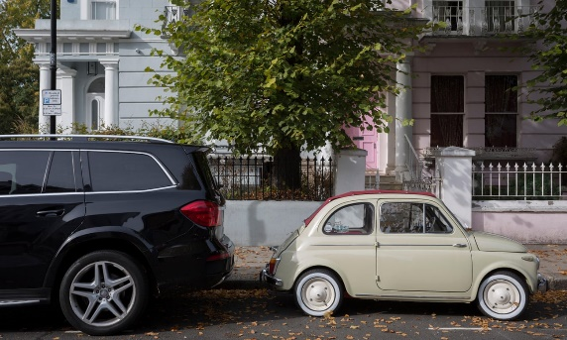
Bigger cars mean more danger for vulnerable road users. For many reasons including occupant safety but also convenience and increased profits, car manufacturers continue to make and sell vehicles that are bigger, heavier and faster. Here is a 1960s Mini (603kg, max speed 92mph in some discomfort!) and a 2019 equivalent (1,282kg, max speed 155mph in great comfort). 30 years professional experience in automotive engineering supports this. There is also a trend away from ordinary cars towards SUVs which are even bigger and heavier, such as a typical Range Rover, 4 times as heavy and twice as fast as a 1960 Mini (2,300kg, max speed 155 mph in great comfort!).
Car suspension engineers continue to make ride and handling better, which improves comfort and enables rivers to drive faster in greater comfort.
Car engine engineers continue to improve performance including economy but also acceleration and speed.
SUVs are specifically designed to provide occupant comfort over rough terrain. On country roads that were built to adequately accommodate reasonably sized cars, these very large cars hav eto drive on the soft verges. Their excellently engineered suspension means the drivers don’t feel the bumps, so they don’t need to slow down.
All this combines to increase the risk of serious injury or death on impact with a pedestrian, especially a small child. Parish Councils can’t make people choose smaller cars, but we can reduce the speed limit in order to reduce the risk to pedestrians in our communities. The degree of harm caused by an impact of a car on a human is directly proportional to the kinetic energy in the car, which is a function of mass and speed: K = ½ mv², where K is kinetic energy, m is mass and v is speed. This shows that harm is directly proportional to mass, but proportional to the square of speed. Higher speed becomes the biggest danger, and also the easiest way to reduce risk. Reduction of speed by 30% has the same effect as reduction of mass by 50%.
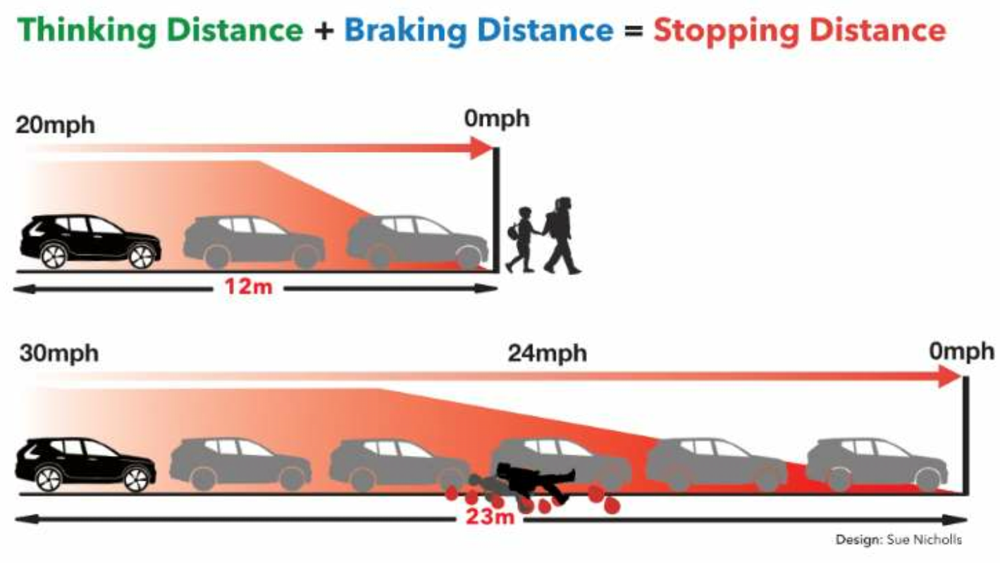
Stopping distance at 20mph is about half compared to 30mph. Where visibility is limited, such as after a corner, the risk is higher. This entrance is only visible about 10-15m away so speed must be lower to avoid hitting an emerging child.
The risk that a pedestrian is fatally injured in a crash if they are hit at 30mph is about 7x greater than at 20mph (ref www.20splenty.org/).
Lower speed also reduces the FEAR of a road accident, thus making the streets more attractive for people to walk and cycle, especially to go to a playground.
Reduced speed limits also support all other efforts to reduce CO₂ emissions from road traffic and to try to leave a human-safe climate for future generations.

