Software Packages Parish Council

Great Waltham Parish Council 2023

GWPC
The Parish Office, Great Waltham Village Hall (Houlton Hall) , South Street, Great Waltham. Chelmsford , Essex.
CM3 1DF

clerk@greatwalthamparishcouncil.co.uk

Great Waltham Parish Council (GWPC)

What software is available ?

Commercial standard software

Workday

XERO

QuickBooks

Sage

Parish Council focused software

Parish Soft

Scribe

Rialtas

Advantedge

EasyPc Accounts

Review of Commercial Standard Software

Workday (https://www.workday.com/en-gb/homepage.html)
- XERO (https://www.xero.com/uk/small-businesses/)
- Quickbooks (https://quickbooks.intuit.com/uk/why-quickbooks/)
- Sage (https://www.sage.com/en-gb/sage-business-cloud/intacct/)

There is more detail in the November report but I felt there are better packages that focus on the Parish Council.

Review of Parish Council focused Software

Parish Soft (https://www.parishsoft.com/accounting-for-parishes/)

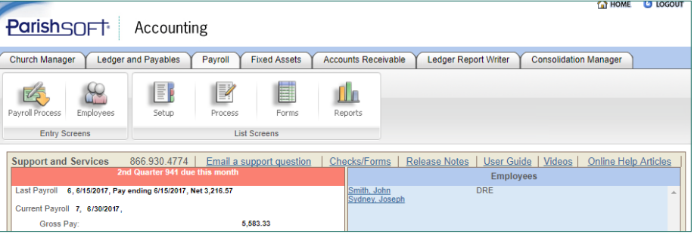

This is a Catholic Church based system that links in with fixed assets , payroll, pensions and general accounting. It is Church focused so misses some of the other areas such as allotments , VAT etc. It is web based and a single logon.

However, it also links in to the Church offering system and understandably is focused in that direction.

Scribe (https://www.scribeaccounts.com/)

As a Parish focused software, it covers several of the essential tasks , AGAR , Vat 126 , Invoicing , Bank reconciliation , Reserves and asset register.

A lot of support and webinars available. The systems is not as extensive as the Rialtas or Advantedge systems. Scribe has chosen to focus on the finance systems required by Town and Parish Councils.

Cost £1835 Year 1

£1356 Year 2 and subsequent year (plus % increase)

Rialtas (https://www.rialtas.co.uk/)

Web based system specifically for Parish and Town councils. The Alpha Accounts , Asset Management , Facilities booking management , Allotment Management (Including inspections) .

The systems look good and the advantage of the allotment inspections looks very useful.

Cost £3314 Year 1

£1196 Year 2 and subsequent years (plus % increase)

Advantedge (https://edgeitsystems.com/advantedge/)

https://youtu.be/Pi8RRNWVwaw

Web based system. An extensive range of solutions . The first one I have seen with ADMIN + that covers Agendas , Minutes , Notices and declarations of interest. Allotment Management, Asset Manager , Facility bookings , Finance , Inspection Playgrounds/Allotments and service manager. All integrate using Inspect edge for Assets , Playground and allotments.

This would cost the Parish Council :

Year 1 £3,000 (ex Vat)

Year 2 £1200 (ex Vat)

Year 3 £1200 (ex Vat)

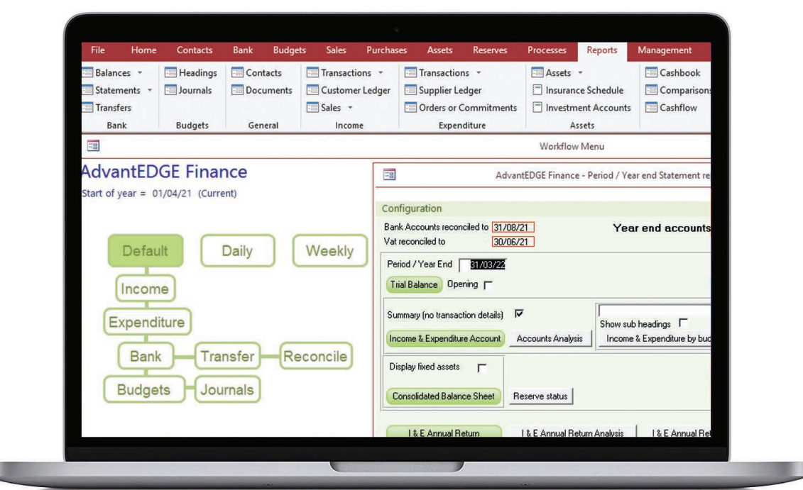

EasyPc Accounts (http://www.easypcaccounts.co.uk/)
An extremely basic accounts only system. Very low cost but with no additional modules available.
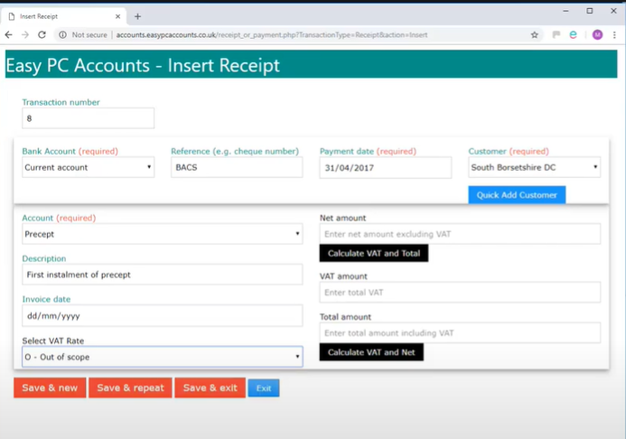

Recommendation
The two main software packages are Rialtas and Advantedge. The costs are very similar, and both software’s are web based.
The advantedge continues to be developed with additional modules being built that will integrate with each other. The support is very good. The costs are unbudgeted in 2023 – 2024 but a software system will improve the professionalism and efficiency of the Parish Council.
After looking at the software and arranging demonstrations the Advantage software should be recommended to the Parish Council as a system to be purchased and used for the next 3 years starting 1st April 2023.

