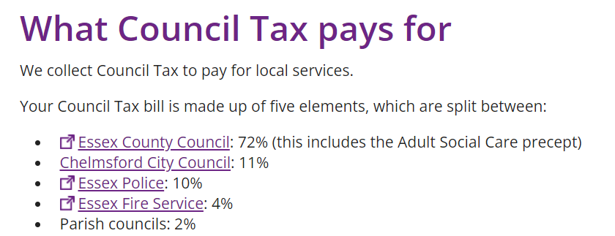Extract from CCC website.
Great Waltham Parish
- Largest Geographical Parish in Essex
- 3 Villages and several hamlets.
- 3 Playgrounds with a variety of Children’s equipment
- Several areas of Greens maintained by the Parish Council
- Rented office from the Village Hall
- Rented Allotment from a private Landowner
- We own 4 Bus shelters and 7 noticeboards
- We are responsible for over 40 mature trees around the Parish.
Each Parish Is unique:
- Broomfield has one recreation area and 4 members of staff. Large Reserves.
- Pleshey has one area for play equipment but rents the land off the Council for £3.95 per annum and the allotments are rented for £16 per annum
- Chignal has £40,000 in reserves due to receiving nearly £100,000 in Cil money and they have no children’s play equipment – Just a single Goal.
- Stock has a Clerk on 37 ½ hours a week and it has no play equipment on its asset register.
- Writtle Has a Clerk, Clerical officer, a Finance Officer, and a Handyman. 3 sets of allotments. No play equipment. Large Reserves
