Agenda Item 21/678 Report back from the Recreation Committee Working Group looking into defect reporting, recording and subsequent actions at recreation grounds.
Earlier this year it was agreed that a working group should look into the current arrangements for the management of recreation grounds with specific regards to the number of existing defects and reducing future defects.
The following is a summary of the issues considered by the working group and the recommendations made by the Recreation Committee.
Subject to the view of the parish Council it is proposed that the working group’s review is complete.
Working Group Scope:
As agreed at the Recreation Committee meeting held on March 3rd 2021 the scope of the review is as follows:
- Determine who is the Playgound Manager and who has legal and moral responsibility for the play areas.
- Review existing inspection programme and suitability, weekly, quarterly and annual.
- Review existing maintenance and repair arrangements.
- Review current reporting processes, handyman to Clerk and Clerk to the Parish Council.
- Agree inspection processes that satisfy the Parish Council that defects are identified and reported as soon as possible after they occur.
- Agree maintenance programmes that prevent unnecessary defects occurring.
- Agree repair programmes that address defects as soon as reasonably practicable.
- Implement measures to prevent the build up of defects at the recreation grounds.
Outcomes and recommendations:
- The Clerk is designated as the Playground Manager
- The existing inspection programme was considered and a number of changes proposed:
- The annual inspection provider was changed from Playsafety Ltd to the Play Inspection company. The 2021 inspections have since taken place and reports made available, a summary is included at the end of this paper.
- The quarterly inspections will continue to be carried out by the Clerk
- It was agreed that better use could be made of the handyman’s hours if the weekly inspections are carried out by trained volunteers:
Agenda item 21/680 Discuss and agree the need for additional Playground Inspectors to be trained so that the Inspection workload of 3 hours a week can be shared, and the handyman resource can be focused on other value adding tasks. (Approximate cost £680.00 for 2 Councillors)

For this proposal to be successful it relies on a number of factors:
- Because of the requirement to inspect 3 sites 52 times each year it is recommended that a minimum of two additional volunteers receive the necessary training.
- The cost of training provided by the EALC is currently £340.00 per person. While there would be an initial investment cost it would be slightly offset by negating the need to maintain the handyman’s qualification.
- There would be ongoing costs to maintain two volunteer’s qualifications.
The handyman is currently allocated 3 hours each week for inspections. The benefit would be an additional 144hrs per year for maintenance work (3hrs per week x 48 weeks (52 weeks minus annual leave)).
- The existing maintenance and repair arrangements were reviewed and it was felt that there would be benefits in identifying contractors suitable to carry out certain works, this resulted in the following proposal:
Agenda item 21/681 Discuss the recommendation for the Clerk to advertise for approved contractors to be appointed for prompt work on the Parish Assets to support the Handyman’s workload
- The current reporting process for the handyman to the Clerk was reviewed and the EALC E-Bulletin was used to ask how other parish councils record inspection results, unfortunately we received no feedback. The working group also considered electronic recording systems but there was not anything readily available that would work better than paper forms. The reporting forms have been recently updated and it was agreed that these were still the most appropriate recording method.

- The process of recording information that enables the Clerk to identify and report defects to the parish council was reviewed and a method of sharing the latest information has been recommended:
Agenda item 21/682 Discuss the recommendation for the Clerk to sets up a shared folder for digital record of the worksheets to be available for the working group to see ‘live’ works
- The development of maintenance programmes to prevent unnecessary defects occurring was discussed and it was agreed the best way forward would be for the Clerk to collate and share a list of routine maintenance work. Any councillor could then volunteer to manage a working group to undertake maintenance at appropriate intervals, cleaning and applying preservative to wooden play equipment is an example of the type of work volunteers could undertake:
Agenda item 21/683 Discuss the recommendation that the Clerk creates a list of jobs that can be undertaken by volunteers and a list of available equipment on the shared drive.

- Ways of agreeing repair programmes that address defects as soon as reasonably practicable was reviewed and it was felt the solution would be addressed in the adoption of the proposals detailed above. However, it was accepted that this may require changes to some existing policies, in particular the financial regulations. Subject to the agenda proposals being accepted there will be a need to monitor any effect on policies and make changes where necessary.
Agenda Item 21/689 Discuss the addition of pre-approved contractors to the Financial regulations

- The main driver for the working group was to identify better ways of managing defects and the prevention of defects at the recreation grounds. It is felt that some improvements have already been made and others will follow in due course. Too much reliance has been placed on the annual inspections to manage the safety of the recreation grounds. Consequently, previous annual inspections have highlighted significant numbers of defects and one of the intentions was to pre-empt negative inspection results by managing maintenance more effectively. The 2021 annual inspection reports indicate an improvement.

Summary of 2021 Annual Inspections
The Play Inspection company have provided very comprehensive reports for each venue, a summary of each site follows:
Table showing the risk matrix used. 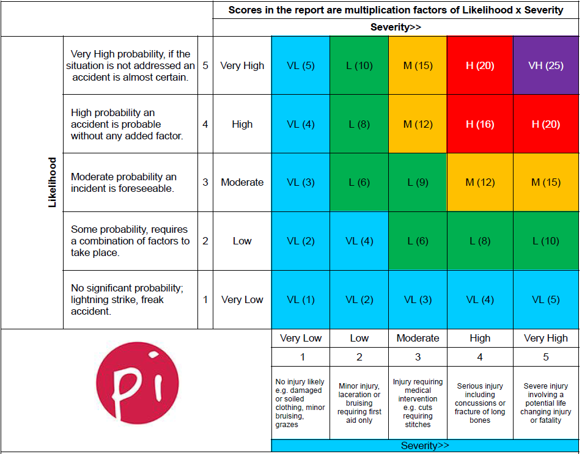

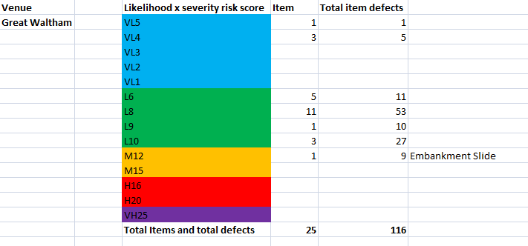

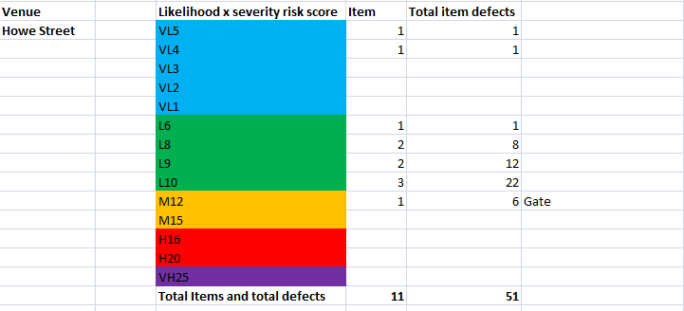

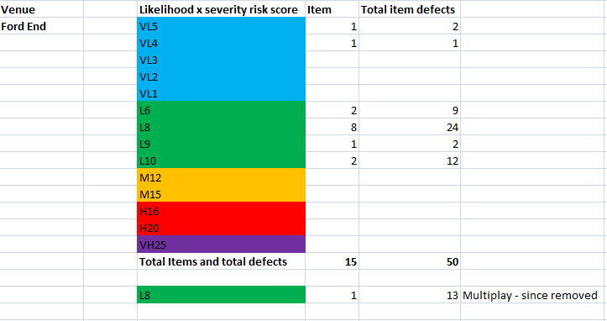
Full details are contained within the reports.
A total of 217 defects across three sites – 202 in the very low to low category – 15 in the medium category

