Great Waltham Parish Council

Clerk, W J Adshead-Grant,
E Mail: clerk@greatwalthamparishcouncil.co.uk Website: https://e-voice.org.uk/greatwalthamparish

Minutes of the meeting of the Recreation Committee held on Monday 8th April 2024 at The Pavilion, South Street, Great Waltham.

- Chair’s Welcome
Chair: Martin.
Cllrs: Jenkins, Gilbert, Palmer, Jackson, and Bradley.

- Apologies for Absence
None required as all present.

- Declarations of interests (existence and nature) regarding items on the agenda and to consider any dispensations required to transact the business on the agenda.
There were no declarations.

- Public Participation session with respect to items on the agenda or any items that they wish to bring to the Councils attention.
There were no members of the public present.

- Update on available plots on Brook Mead and Bury Lane.
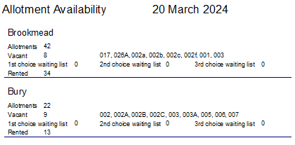
One allotment has been taken on since the report was run. The numbers of plot holders remain steady.

- Report on Playground Inspections.
Cllr Palmer received her inspection tablet for the digitised inspection records through InspectionEdge.
- The rope bridge between the towers to be replaced.(Great Waltham).
- The Climbing board at the tower to be replaced. (Great Waltham).
- Minor observations of low-level issues.
- Note that one upright of the monkey bar has a slight wobble when wet weather.

- Report from Allotments Supervisor.
Cllr Palmer provided a written report with some recommendations regarding the vine area and pre-school plots at the Brook Mead site. Bury Lane allotments have been strimmed. Brookmead plot 26A needs to be recovered. Plot 13 at Bury Lane confirmation of matting replacement.

Resolution: Repurpose the Vine area as a storage area.

Resolution: Cllr Palmer to draft a letter to the Pre School concerning options for their use of the allotments.

- Updates on the Action Tracker.
Several items can be closed as actions have completed.
See report online.

- Review progress and outstanding actions on the Recreation Grounds Inspection Tracker.
Several low-risk items were left in the report.

It was noted that significant progress has been made over the year addressing defects with a small number of low and very low risk defects remaining.

Resolution: The Annual Inspection is imminent. Review the new report when it’s issued.
Expectation of no high or medium items on the inspection.

- Update on Pavilion bookings including expenditure and income. And new items of expenditure.

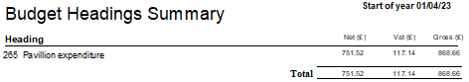
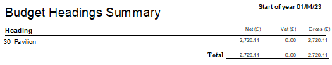

The good return on investment was noted. In addition, the saving on a years’ worth of room bookings for meetings was noted.

- Discuss the need and if necessary, arrange working groups for the following:- (Cllr Martin).
  - Play equipment maintenance ahead of the annual play area inspections.
  - Great Waltham goal post removal and agree locations for new goal post sockets.
  - Outstanding tree works following the recent tree survey.

Resolution: No action required regarding the play equipment.
Resolution: Support required for lifting the posts – prefer mechanical assistance.
Resolution: JCM to confirm tree works completed.

- Discuss and agree the protocols for memorial requests at Recreation Grounds.

The recent request from a member of the public to donate a memorial bench at Great Waltham recreation ground prompted the view that a policy for any future requests would be helpful.

Resolution: The Committee supports the drafting of a policy.

- Discuss the benches for Recreation Grounds.
One bench has kindly been donated by BPI Plaswood (Derbyshire).
One Bench is a potential donation from a member of the Parish.

Resolution: The donated bench from BPI Plaswood to be installed at Great Waltham Recreation Ground.

- Discuss and agree the bench bases for Recreation Grounds.
For the longevity of the benches and to improve the security anchoring of the products a concrete base is felt to be the best option.
A guideline quote would be £500 for a concrete base.

Resolution: A concrete base to be prepared at the Hatchfields end of the Great Waltham Recreation Ground – on the land owned by the Parish Council.

Members – Gilbert, Martin, Jenkins, Palmer, Jackson, Bradley and (Vacancy).

Meeting Closed 20.55
Will Adshead-Grant
Clerk to the Council.

