
 | PAST TIMES | No 77 June 2022
Introduction
This edition has a changed format to allow details of a special event on the last page.

Forthcoming Society Talks
Wednesday 8th June 2022 – History in the Landscape. A talk by Julian Whybra.
Julian gave a well received talk to us on surnames in June 2018 and now returns to give the talk originally scheduled for June 2020. Julian has also penned our lead article on The History of Morris Dancing.

Wednesday 14th September 2022 – The Chelmer Navigation. A talk by William Marriage. William is an active Board member of the Chelmer Canal Trust and we are hoping he will be able to include slides of the canal donated to us by Jill Bellamy.

President & Chairman: Graham Smith. Vice-Chairman & Editor: Ken Edwards.
Treasurer: Geraldine Willden. Secretary & Programme Director: Gillian Parker.
Committee: Stephanie Troop and Patricia Stuart.

Comments and contributions to the newsletter are welcomed by the Editor
Ken Edwards, 2 Vale End Galleywood, CM2 8NZ Tel - 01245 474425.
Email - kenedwards2012@btinternet.com.

The History of Morris Dancing

Morris is not an antiquarian revival or an attempt to resuscitate something dead and buried. It is as much alive and a normal part of contemporary existence as football or cricket. Although you might not guess it from watching Morris, it has a very ancient history, so ancient that its origins are lost in the distant past.

Early British scholars of folklore were influenced by James Frazer’s The Golden Bough, which viewed Morris dancing as a survival – albeit debased – of a pre-Christian male fertility ritual. Some contemporary ‘revisionist’ folklorists suggest a late mediæval, non-‘survivalist’ origin for it but have so far provided no supporting evidence. There is no written evidence for the ‘survivalist’ theory either although there is a multitude of persuasive social anthropological, historical, literary and linguistic paradigms from across northern Europe where there are precedents in, and parallels with, secular north European folk-dances. Their abundance would certainly appear to undermine ‘revisionist’ writers’ theories.

Each English region has its own particular form of the Morris, peculiar to it and it alone. Until about 150 years ago each region’s villages had their own Morris sides, each with its own variant of the dance and traditional dancing times. For Cotswold Morris it was Whitsuntide & May Day, for North-West Morris it was Rushbearing at the end of harvest-time in September, for North-East Morris Sword Dancers it was Yuletide, for Molly Dancing (East Anglia & Essex) it was Twelfth Night & Plough Monday.

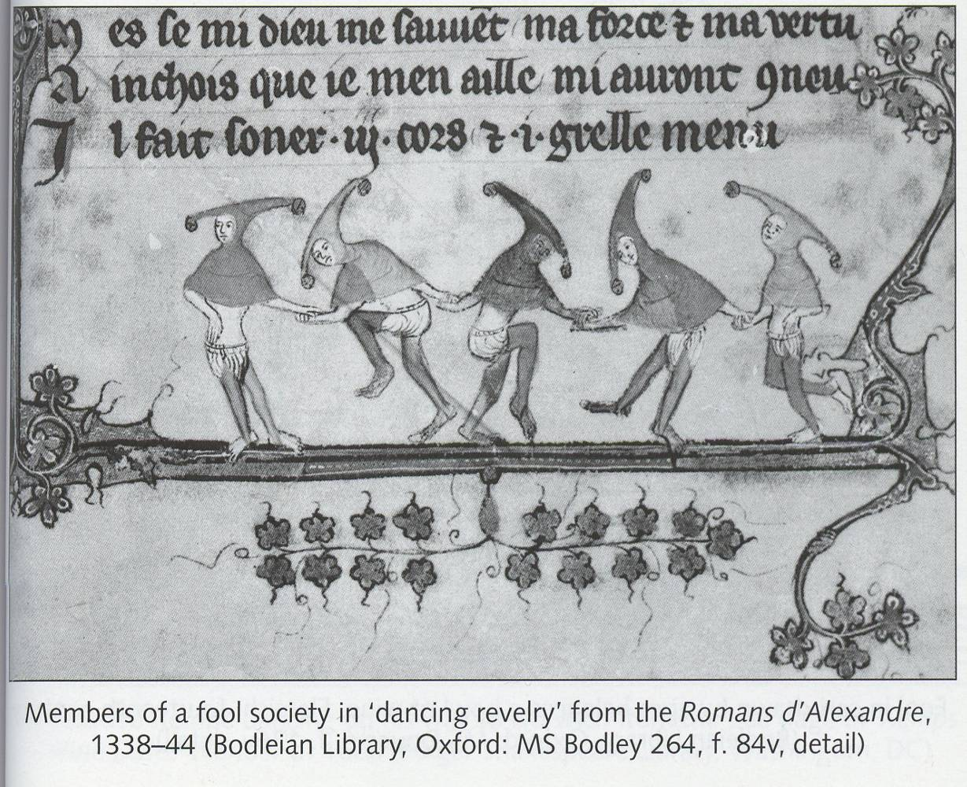

The first recorded written usage of the word ‘Morris’ was in 1448 but pictorially it can be taken back further. Morris’s heyday was 1750-1850 but changes in 19th-century social conditions resulting from rural depopulation and urban industrialization affected it badly and many village sides disbanded. In some villages the Morris persisted through these upheavals, generally due to the determination of one man. Such a man was William Kimber (1872-1961) of Headington Quarry Morris Men, Oxfordshire.
By chance he met the musician and composer Cecil Sharp (1859-1924) in 1899. On Boxing Day Kimber’s side happened to perform outside a house where Sharp was visiting. Sharp came out to see what the ‘noise’ was, and became hooked. He had ‘discovered’ the Morris and spent the rest of his life tracking down surviving Morris sides, recording and learning the dances and tunes, teaching them to others, and attempting revivals where possible.

He found just four Cotswold villages where sides had existed continuously from time immemorial (Headington, Bampton, Abingdon, and Chipping Campden). Elsewhere he found just one or two dancers still alive to act as his informants. Sharp missed some sides who perished wholesale on the battlefields of the First World War. Even so, he was able to preserve a canon of over 320 dances and by means of the English Folk Dance Society, which he founded in 1911, was able to spread knowledge and practice of them.

Without Sharp’s persistence and enthusiasm, most of the Morris might be lost for ever. Yet it was from these fragile beginnings that the Morris gradually grew and flourished such that today there are over 250 sides nationally.

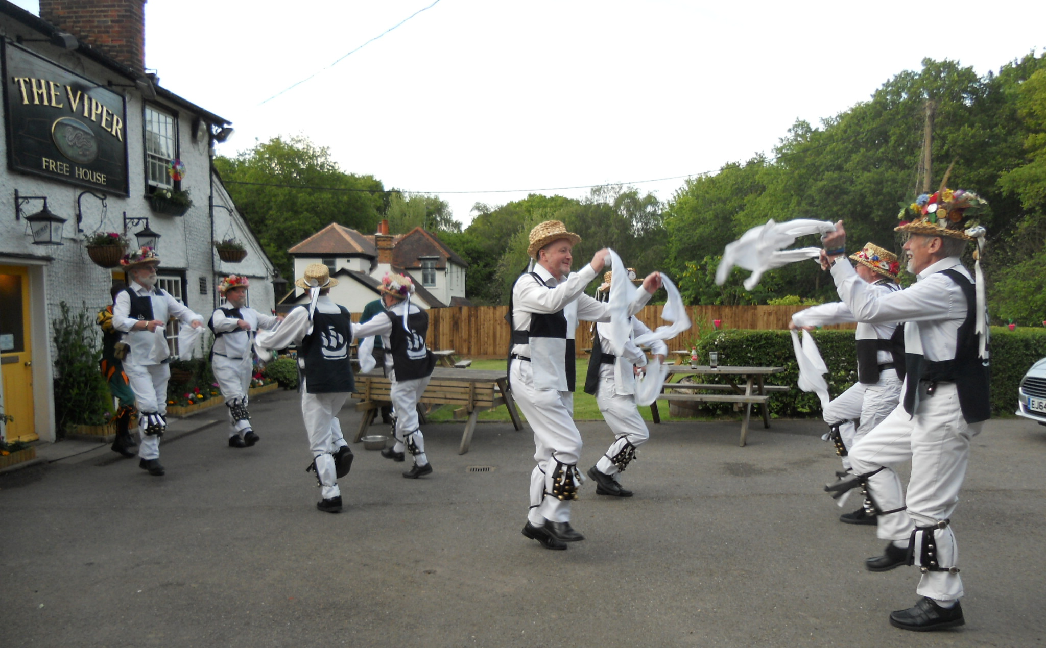

Your nearest side is the Mayflower Morris Men of Billericay (www.mayflowermorris.com) which can trace its origins to 1575 and can be seen performing at venues throughout the summer
 | Galleywood Historical Society  is proud to host
THIS ENGLAND
A JUBILEE CELEBRATION
combining the best English prose, verse and song


performed by
Serendipity

Friday 3rd June at 7.30pm
St Michael’s Church, Galleywood Common

Tickets £12
Available by sending a cheque, made payable to
Galleywood Historical Society together with a
stamped, addressed envelope to:

Daphne Field
9 Colvin Chase, Galleywood, CM2 8QQ
Tel. 01245 263936 Email thisengland70@gmail.com

Any net surplus proceeds will be divided between
Galleywood Historical Society and St Michael’s Church, Galleywood

