
 | PAST TIMES | No 74 September 2021

Introduction

The talk program returns at last

After more than a few false dawns, the Society returned to running a series of talks with a special Galleywood Festival talk on the afternoon of 21st July. The venue by courtesy of the Parochial Church Council was St Michaels Church and the subject - Monte Rey.

Some 14 members and 8 guests were present to hear Ken Edwards give some background on his commercial career as ‘Radio’s favourite singer’ and top of the bill during the 1930’s and 40’s. This was followed by Chris and Les Whybro talking about the man himself and his time living in Galleywood based on their personal experiences. The talk was given in memory of our late President David Stacy whose son Rob was present.

Galleywood Heritage

Our main article this month is about the village archives held at the Galleywood Heritage Centre. It was written by Archivist Wendy Cummin and Susan Wilson who look after the archives and its activities. They give an overview of the collection as well as posing a few questions.
The Heritage Centre building was rescued in a derelict form after a series of uses including as part of the racecourse grandstand and most lately a Council depot. A group of local volunteers with financial and wider support from the Parish Council oversaw the leasing, alteration and rebuilding of the site to its now multiple purpose use including hosting the village archives. This team was led by John Turkentine who was recently made Honorary Life President of the Centre and remains a trustee and active volunteer.
Archives of Galleywood Heritage Centre

The first entry into the archives was the Ron White photo collection which was in the possession of Galleywood Parish Council. This is a massive collection of over 3000 photos of people and places in Galleywood.
They are now all stored and indexed on the computer, and there are also large files containing copies of the photos, together with some extra information. These are available in the Heritage Room for browsing at leisure.

Other collections were soon donated, including the vast information gathered by Christine Whybro on the history of Galleywood where she was born. Much of the information we now have is thanks to her.

Many others have donated items large and small to our archives over the years, including paintings, maps and models. We have information on the farms and the public houses of Galleywood.

We have a full history of Galleywood Racecourse thanks to the dedication of the late Ted Hawkins, after whom the Heritage Room is now named. He was a recognised expert on this subject. Do you know which horse that won races at Galleywood went on to win the Grand National in record time, not beaten until Red Rum won? Red Rum was later invited to one of the pubs. Which one?

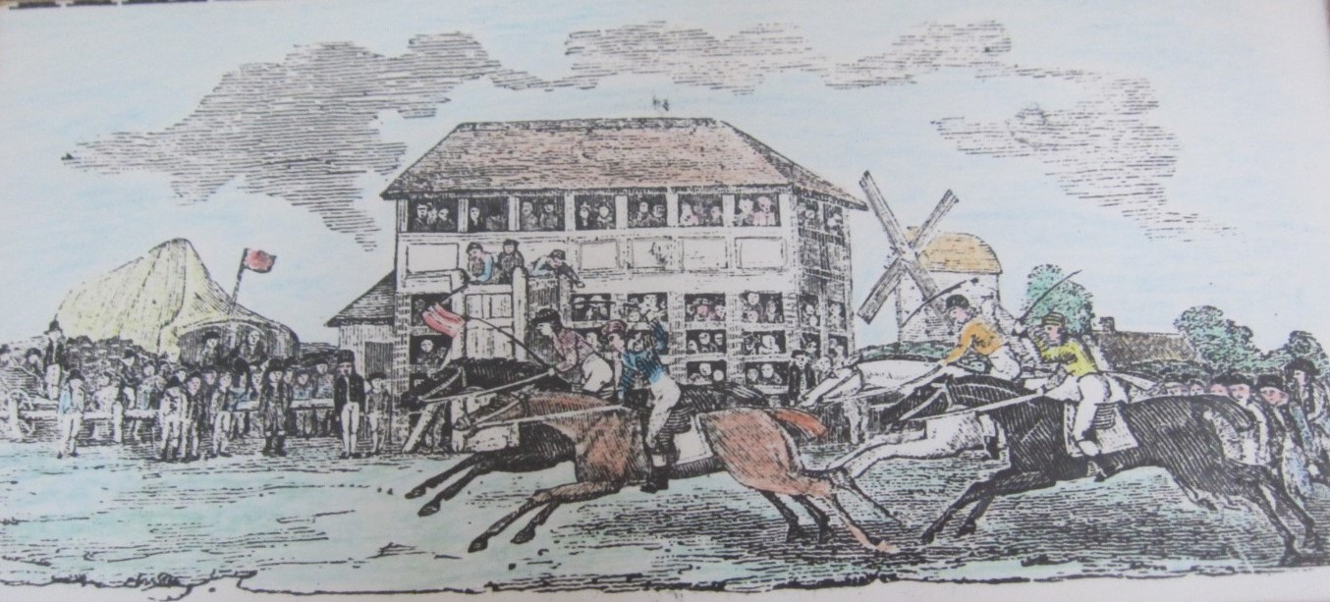Photo courtesy of Galleywood Archive – recent painting donation circa 1843.

We have the history of Chelmsford Golf Club which began on Galleywood Common, and also the history of the church. Do you know the name of the controversial vicar who attracted newspaper headlines?

We also have the history of the Old School, with many photos of old pupils and the punishment book showing who was caned and why!

There is also the history of the Keene Hall and the Parish Council. There is the story of Galleywood’s War Memorial with information on all of the casualties and some of the survivors. In WW2, Galleywood had a temporary mortuary. Where was it? And where was the Air Raid Warden based?

We have details of many of our “Notable residents”, including John Henry and Lavinia Keene, Monte Rey, Markland Barnard, Peter Seabrook and Charles Cottey. Did you know that one of these was a gentleman-at-arms to Queen Victoria, and that another was Galleywood’s greatest benefactor?
We also have some family histories of Galleywood residents.

We have photos of carnivals and flower shows, and also a box with information on the Keene Hall Players drama group, with many photos and reviews!
The archive also holds copies of all the Oral History project recordings, well over 40, where residents talk about past village life. These are all catalogued and can be searched for any subject of particular interest

When normal times return the Heritage Room will be open on Tuesday afternoons from 1.30-3.30 when the tearoom will be open. It may be possible to access the archives at other times by prior arrangement with Wendy on 01245 250499 or wendy.gf@blueyonder.co.uk

Again in normal times there are regular displays on local history in the Heritage Room, and talks are arranged each year. There are usually one or two exhibitions each year. An events leaflet will be available to give notice of events when they can resume.

Compiled by Wendy Cummin and Susan Wilson

Local Historical Society News

The pandemic has not been kind to many local volunteer groups including those with an interest in local history. Unable to hold their usual social and talks activities, membership has also fallen for reasons we do not need to dwell on here. An example is The Friends of Chelmsford Museums. Since 1990 the group has given over £30,000 to support the Museum mainly for acquisitions. Several of its committee members have stayed on as caretakers whilst new officers are sought so far without success. It is now unclear if at their AGM in September there will be enough volunteers to see it continue.

November sees your own Society’s Annual General Meeting which takes up a few minutes at the start of our usual meeting. Fortunately we continue to have a small but dedicated group who run the Society’s affairs. Partly from some personal donations and a legacy, we are strong financially although in common with our peers our membership has been declining. Do encourage people you know or meet to join us so we can continue long into the future.

Forthcoming Society Talks
Wednesday 8th September 2021 – A photographic tour of Essex Gardens.
An illustrated talk by Pat Gilby.
Wednesday 19th November 2021 – The Rich family, Earls of Warwick and the County (of Essex). A talk by Chris Thompson will follow a short AGM.

GALLEYWOOD HISTORICAL SOCIETY
galleywoodhistoricalsociety.org.uk
President & Chairman: Graham Smith. Vice-Chairman & Editor: Ken Edwards.
Treasurer: Geraldine Willden. Secretary & Programme Director: Gillian Parker.
Committee: Stephanie Troop.

Comments and contributions to the newsletter are welcomed by the Editor
Ken Edwards, 2 Vale End Galleywood, CM2 8NZ Tel - 01245 474425
Email - kenedwards2012@btinternet.com.

Past Times is printed by The Design & Print Partnership
Tel: 01245 478600. Email: nigel@designprint.org.uk Web:www.designprint.org.uk

