
 | PAST TIMES | No 71 November 2020

Introduction
The September talk went ahead with 17 people in the hall, well within the overall limit of 30. This was disappointing as a number of members who had booked to come did not turn up on the evening.  Those present were treated to a whistle stop tour through the life of Sylvia Kent and how she came to be such a prolific author. | 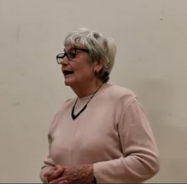  Sylvia Kent. Photo courtesy of John Turkentine
We had hoped to record and make the talk available to members, however technology defeated us - so as they say, you had to be there.

Your Committee met on 1st October and decided that in the light of expected covid-19 restrictions and the low level of support for the September talk,
the scheduled 11th November talk by Wendy Cummin will NOT go ahead.

November would also usually see our AGM but your committee has decided not to hold one this year. The Committee members have all agreed to serve for another year and once the annual accounts (which will show a surplus) have been agreed and examined they will be available to any member who wishes to see them – please let the editor know if you wish to be sent a copy.

Your Committee also agreed to reduce the membership fee for 2020-21 to reflect the situation. A membership form alongside this newsletter outlines the revised fees and what action to take.

The schedule of planned talks in 2021 also accompanies this newsletter.
Growing up in Galleywood

Readers may recall recent mention of a diary written by William Weeks (1909-1989) entitled ‘Growing Up in Galleywood’. This charts his early years living in the village at Wentworth House in Watchouse Road. We are grateful to his son John for sharing the material and agreeing to its use here. A copy of the full diary is held at the Heritage Centre and Essex Record Office.

We will be publishing extracts in Past Times over future issues and we start this quarter with the village supply of those diet staples of bread and milk.

Bread
.... not so the smell of the village bakery, run by Mr. George Barton - this was a place with quite a romantic aroma, guaranteed to make a small boy feel hungry the minute he stepped over its threshold. How well I remember my mother once sending me to fetch some loaves of bread and the irresistible temptation on the quarter mile return journey to pull a piece out of the underside of the loaf and eat it. One piece led to another and by the time I reached home one load had quite a sizeable groove along its underside.

Although I took the precaution to place it flat on the kitchen table my mother, unfortunately, turned it over. She just looked at me and said, "What had happened to this loaf?" to which I replied, "It looks as if the mice have been at it!" "Yes," she replied, "the biggest two legged mount I ever saw - next time I send you for bread, my lad, don't nibble it on the way home and bring me a story like that!"

Milk

The production and distribution of milk was very differently organised in my boyhood days to what it is now. At that period the cows were driven into ill-lighted and ill-ventilated barns and milked by hand into buckets, watched by fascinated young children and a miscellaneous collection of farmyard cats, the latter hoping to be favoured with a friendly squirt. Their patience was often rewarded. The milk was then poured over a water fed cooler, and later stored in great galvanised churns until such time as it was transferred to the gleaming brass capped and brass bound churn on the milk delivery float. Milk in excess of local requirements was sent into the town some 3½ miles away.
The milk float was a light two wheeled vehicle, open at the rear with a driver's seat at the rear right hand side. Its equipment consisted of the brass bound churn already referred to, and a large oval shaped delivery can, complete with a hinged lid, inside of which was a rail on which hung pint and half pint dip cans attached to a long hooked handle. The milkman carried this can from door to door and ladled out half pint or pint measures into the householder's own jugs. The churn acted as the milkman's reservoir from which he could recharge his delivery can from a brightly polished brass can as required. Tuberculin testing milk was then almost unknown and the modern sealed milk bottle or carton had not yet been devised.

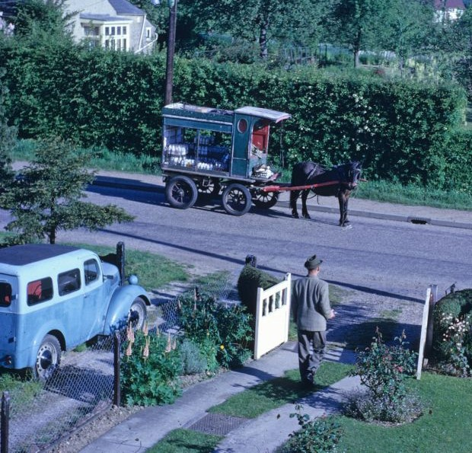 | Dairymen took enormous pride in their milk floats, which were always spotlessly clean, and the highly polished brass rails which surmounted their sides and gleaming horse brasses and harness added real glamour to a vital public service.  Picture left - Milk delivery by horse and cart continued into the 1960’s.  Ron White Collection
The milkman was a welcome daily visitor to all homes, there was then no perfunctory dumping of milk bottles on the front step. His usual greeting was a hearty "Milk ho!" about four yards from the kitchen door, followed by a hearty rat-tat-tat: as he ladled out the milk required, little pieces of news and gossip were exchanged and the whole village knew in a matter of hours all the events of importance which bound them together as a community.

I well remember one young man who regularly delivered our milk and who, one morning, failed to arrive at the usual hour. Later when his boss delivered the milk it was learned that although suffering from a severe chill he had gone forth on his rounds as usual, but with disastrous results. Halfway through his task he had collapsed and, a few days later, died from pneumonia - his passing was keenly felt as a personal loss in every house in the village and his funeral attended by a far greater proportion of the population than that of any civic dignitary.
Forthcoming Heritage Centre events

At time of writing the series of historical and other afternoon talks is suspended although the Tea Room is currently open on most Tuesdays, Thursdays and Sundays – see website for latest details
Historical Society News

I hope members agree that Past Times is produced to a high quality rather than on flimsy paper - excluding of course those who receive it by Email!

We are proud to support a local small business to produce it for us and can recommend Nigel as good value for any printing needs. His contact details are at the foot of the page.

Forthcoming Society Talks
The following scheduled talk has been CANCELLED
Wednesday 11th November 2020 – The Galleywood Soldiers of WWI. Heritage Centre Archivist Wendy Cummin was to talk to us on Remembrance Day.

At time of writing we are hoping the following talk will be able to go ahead:
Wednesday 10th March 2021 – The steam tug ‘Brent’. Janet Hall will talk about this vessel which members may have seen moored at Maldon Quay.

GALLEYWOOD HISTORICAL SOCIETY
galleywoodhistoricalsociety.org.uk
President: David Stacy. Chairman: Graham Smith.
Vice-Chairman & Editor: Ken Edwards. Treasurer: Geraldine Willden.
Secretary & Programme Director: Gillian Parker. Committee Stephanie Troop.

Comments and contributions to the newsletter are welcomed by the Editor
Ken Edwards, 2 Vale End Galleywood, CM2 8NZ Tel - 01245 474425
Email - kenedwards2012@btinternet.com.

Past Times is printed by The Design & Print Partnership, 66 High Street Great Baddow, 01245 478600 nigel@designprint.org.uk

