
 | PAST TIMES | No 69 June 2020

Introduction

This has been a singular edition of Past Times to edit.
On the plus side, we have a guest article from member Malcolm Stuart who lives in Well Lane and has made a study of the history of many of its buildings. Thank you Malcolm. You will also have noticed a ’bonus’ pullout entitled The Battle of Norsey Woods’ penned by Julian Whybra. Julian is due to give our talk on the evening of 10th June at the Keene Hall but you will understand why as I write, that event is in doubt. We are very grateful to him for letting us share this article with members prior to wider publication. Thank you Julian.
On the down side, with the Covid-19 crisis it is difficult to be sure what if any events will take place over coming months. Decisions on this will be subject to government guidance and our concern that many of our members are of an age when the results of catching the virus are more serious.

We are also looking at the possibility of some past talks and/or several oral history interviews being made available online as part of Galleywood Festival (6th-14th June). However listening to any of these online will require access to a computer with sound and internet connection.

For those who receive Past Times by Email it will be business as usual. For those who get paper copies we will do our best to distribute as soon as we
are able by hand or post. You should also find with them information about whether the talk will take place and any Festival related broadcasts.

If you have an Email address, do please advise our Membership Secretary Geraldine Willden (geraldine.willden@hotmail.co.uk). This will allow us to keep you informed of events in a timely manner in these unusual times.

Discovering a Tudor House in Galleywood

Discreetly hidden away behind a high hedge are two attractive Grade 2 Listed Cottages numbers 27 & 29 Well Lane. They have been vastly altered over the centuries but still show many original features.

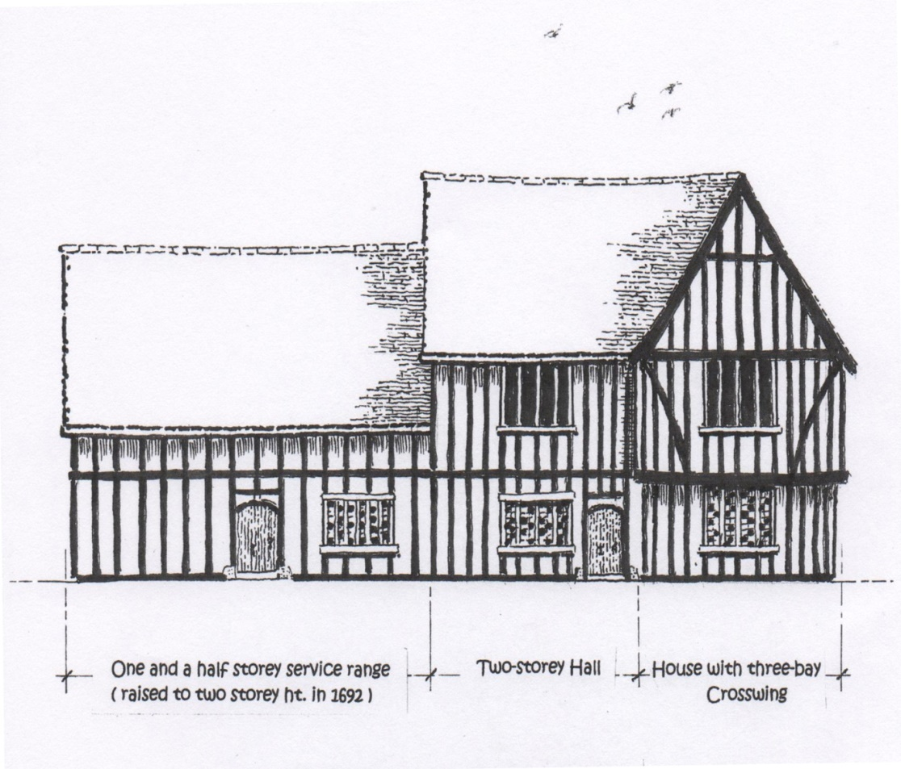
The original mid-16th century building comprised a central two storey hall (now No.29) with the original one and a half storey two bay service range (now No.27). There was no chimney stack and cooking would have been done in an outhouse. It is possible from examination of timbers in the existing hall to see evidence of the original diamond mullioned windows and sliding wooden shutters on the upper floor and to deduce where the now demolished three bay cross-wing stood. The original building would have looked as shown in this reconstruction by Derek Wilks.

The service range was raised to two storeys in 1692 with evidence carved onto an oak beam between the two front bedrooms of No.27 which reads:

“This house was built (re-built) in 1692 at the charge of Jacob Panett the eldest, Susannah his wife, Susannah his daughter who wrought exceeding hard for it. Pray do not spend it”

On the death of his first wife Jacob remarried another Susannah on 30th December 1708 therefore he did not have to alter the carving.

The two storey range to the rear was added in 1770 in Flemish bond red brick and gabled old roof tiles.

Early records dated 30th June 1763 show the dwelling was owned by Richard Osborne, shop keeper, his wife and daughter. On the 2nd September 1800 the dwelling was leased to John Beswick (Yeoman) and Martha Beswick and described as “two tenements together with shop, outhouses, stable buildings, yards, gardens and an adjacent orchard which was rented for £16 per year.

In 1923 the building was described as a freehold shop with two dwelling houses adjoining buildings and lands. It passed into the ownership of Mrs Florence Emma Jackson on 19th February 1947 and some villagers will remember her shop which she kept until 1959.
The shop was extended in 1970 by Marion Freeman with a new shop frontage to No.27 but this extension was demolished in 1972 when the new owner Paul Tarling converted it back into a house. In the 1990’s No.29 was extended on the side and a porch added to the front door.

Malcolm Stuart with thanks to the previous and current owners for allowing access to their beautiful cottages , Derek Wilks of the Galleywood Art Club and Brenda & Elphin Watkins of the Essex Historic Buildings Group

Forthcoming Heritage Centre events
At time of writing no events are scheduled due to Covid-19.

Historical Society News

We bid farewell to Alex Gilbert who has stood down from the Committee.

Our May Committee meeting was conducted by way of Email and telephone but fortunately the future program is well planned and settled.

Through his son John, the Society has acquired two booklets ‘Growing Up in Galleywood’ written by William Weeks, born 1909. William spent his formative years in the village. They are an autobiography and provide a fascinating first hand snapshot of village life then. It has been agreed to deposit the originals with the Archives held at the Heritage Centre.
Forthcoming Society Talks
Subject to change – please see separate information with this newsletter.

Wednesday 10th June 2020 – History of Landscape. Julian Whybra makes a welcome return to answer the question – How does history shape our landscape and to talk about how to ‘read’ landscape.

Wednesday 9th September 2020 – Preserving the Past on Paper. Established Essex writer and columnist Sylvia Kent talks on this subject.

GALLEYWOOD HISTORICAL SOCIETY
galleywoodhistoricalsociety.org.uk
President: David Stacy. Chairman: Graham Smith.
Vice-Chairman & Editor: Ken Edwards. Treasurer: Geraldine Willden.
Secretary & Programme Director: Gillian Parker. Committee Stephanie Troop.

Comments and contributions to the newsletter are welcomed by the Editor
Ken Edwards, 2 Vale End Galleywood, CM2 8NZ Tel - 01245 474425
Email - kenedwards2012@btinternet.com

