GREAT HORWOOD PARISH COUNCIL

Register of Members Disclosable Pecuniary Interests
The Relevant Authorities (Disclosable Pecuniary Interests) Regulations 2012
Pursuant to Sections 29 and 30 of the Localism Act 2011

Section 30 of the Act defines a ‘Disclosable Pecuniary Interest’ as a pecuniary interest of a description which is specified in regulations made by the Secretary of State and which is either an interest of the Member’s or an interest of Member’s spouse or civil partner, a person with whom the Member is living as husband and wife or a person with whom the Member is living as if they were civil partners, and the Member is aware that the other person has the interest.

Section 31 of the Localism Act 2011 requires disclosure of any Disclosable Pecuniary Interests not already entered on this register.

Section 31 also prohibits a member from participating in any discussion or vote on the matter in relation to which a member has a Disclosable Pecuniary Interest.

Section 32 covers sensitive interests – fact of interest rather than actual interest itself has to be disclosed.

Section 34 makes it an offence for failure to comply with a notification requirement - it also makes it an offence to knowingly provide information that is false or misleading or is reckless as to whether the information is true and not misleading.

A copy of this register is required, as provided for by Section 29 of the Act, to be available for inspection at the authority’s offices at all reasonable hours and published on the authority’s website – and on the relevant Parish’s website if they have one.

For the purposes of the Regulations

“body in which the relevant person has a beneficial interest” means a firm in which the relevant person is a partner or a body corporate of which the relevant person is a director, or in the securities of which the relevant person has a beneficial interest;

“director” includes a member of the committee of management of an industrial and provident society;

“land” excludes an easement, servitude, interest or right in or over land which does not carry with it a right for the relevant person (alone or jointly with another) to occupy the land or to receive income;

“member” includes a co-opted member;

“securities” means shares, debentures, debenture stock, loan stock, bonds, units of a collective investment scheme within the meaning of the Financial Services and Markets Act 2000 and other securities of any description, other than money deposited with a building society.

If you have no interests under any category please put “None” in the relevant box

Name: Caroline Cousin

Neighbourhood Plan Review Committee

Part A - Disclosable Pecuniary Interests

You are required to disclose your own interests under the headings listed below and any interests of your spouse/civil partner (or a person with whom you are living as such) of which you are aware

1 Any employment, office, trade, profession or vocation carried on for profit or gain. | Self – None  Partner – None
2 Any payment or provision of any other financial benefit (other than from the council) made or provided within the previous 12 months in respect of any expenses incurred in carrying out your duties as a member | Self – None  Partner – None
3 Any contract (which has not been fully discharged) for the provisions of goods, services or the execution of works made between the Council and you or a firm in which you are a partner, a company of which you are a remunerated director or a company in whose securities you have a beneficial interest. | Self – None  Partner – None
4 Any land in the Council’s area in which you have a beneficial interest. | Self  Russets  Nash Road  Great Horwwod  MK17 0RA
5 Any land in the Council’s area for which you have a licence (alone or jointly with others) to occupy for a month or longer. | Self – None  Partner – None
6 Any tenancy where to your knowledge the  landlord is the Council and the tenant is a body in which you are a partner, a company of which you are a remunerated director or a company in whose securities you have a beneficial interest. | Self – None  Partner – None
7 A body who to your knowledge has a place of business or land in the Council’s area, and in whom you have a beneficial interest in a class of securities that exceeds the nominal value of £25,000 or one hundredth of the total issued share capital of that body or if the share capital of that body is of more than one class, the total nominal value of the shares of any one class in which you have a beneficial interest exceeds one hundredth of the total issued share capital of that class. | Self – None  Partner – None
PART B – Other Personal Interests
You are only required to disclose your own personal interests under the headings listed below

8 Any body exercising functions of a public nature  of which you are a member or in a position of general control or management | Action on Hearing Loss  Great Horwood Parish Council  Great Horwood Village Hall Committee
9 Any body one of whose principal purposes includes the influence of public opinion or policy (including any political party or trade union), of which you are a member or in a position of general control or management. | None
10 Any gifts or hospitality worth more than an estimates value of £50 which the member has received by virtue of his or her office | None

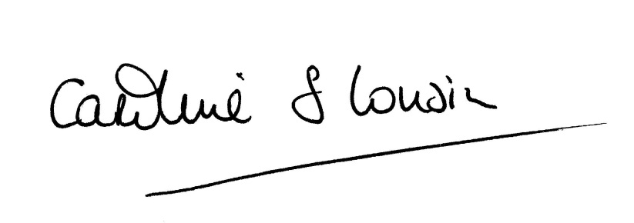

Signed

Dated: 28 May 2019

