NEW PARISH CLERK
I am delighted that we have been able to appoint a new parish clerk starting from 1st September.
Many of you will know Sarah Biswell as she has lived in the village for 27 years.
She has been a governor of the Great Horwood C of E School since 2017 and Chair of Governors for the last 5 years.
She has already been a very regular attendee at our monthly Parish Council meetings.
FUNDS FOR LOCAL CAUSES
As in previous years, Great Horwood Parish Council will once again be donating up to £3000 to local causes. If you would like your group to be considered, you need to start thinking about your bid. Forms can be obtained from the Parish Clerk, clerk@greathorwoodpc.org.uk. Applicants must be from organisations associated with the village. Winning bids will be announced at the December Parish Council meeting. The closing date for applications is 31st October 2023.
SPEEDWATCH
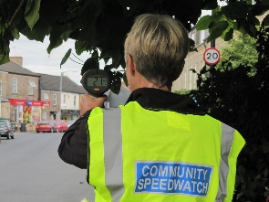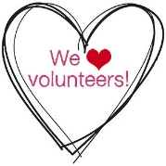
We are in the process of activating a Speedwatch team for Great Horwood so please contact me if you are interested in joining the team.
You will need to undertake an online training course and pass the online test at the end of the course. Once up and running the team will monitor speeds of vehicles at certain agreed spots in the parish and report the details direct to Thames Valley Police who will be able to take warning actions against speeding drivers. Cllr. John Gilbey johnwgilbeypc@gmail.com
FOCUS ONLINE
Did you know that there is an online edition of Focus with every copy from February 2012?
So, if you have mislaid your copy and can’t find the information you need, just log onto
https://e-voice.org.uk/ghpc/focus-magazine/

NEXT MEETING OF THE PARISH COUNCIL
The next meeting will be held on Monday 11th September at 7.30pm in the Village Hall. There is always a public participation period when members of the public can have their say. The Notice of the meeting is advertised on the Great Horwood Facebook page, the Parish Council website and the noticeboard in the High Street. Minutes of meetings can be found on the noticeboard and the Parish Council website e-voice.org.uk/ghpc/
Cllr. John Gilbey
Chairman of the Council
johnwgilbeypc@gmail.com

