PARISH PUMP
FOOTPATHS
There are a number of footpaths in the parish and these have been and are still maintained to a very high standard by past footpath monitors and our current monitor Alan Biggins. In this edition of Focus has been included a loose-leaf footpath map and so I hope that you will all now be able to find and use this network of easily accessible paths. If you want more information on some of the footpaths there are 6 route maps on the Parish Council website at:
https://e-vice.org.uk/ghpc/conservation-areas-footpaths/
VILLAGE PLANTERS
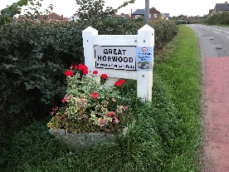
There are 5 planters – one at each entrance to the parish. For the last few years these have been planted out and maintained by Jane Holland with funding provide by the Parish Council. Jane has recently left the village and so we are looking to see if any residents are willing to volunteer to take over this role – or it could be split between 2 or more people. If you are interested please contact me on the email address below. If we do not get any volunteers we will have to pay a contractor to do the work as we did in the past.
NEW PARK IN LITTLE HORWOOD ROAD
The maintenance of the park is still the responsibility of High Street Homes until the end of a 12 month period next summer. However two very sturdy benches have now been installed. (One was contributed by High Street Homes and the other one was supplied by the parish Council). A dog bin is on the plan for just outside the eastern entrance to the park. However Buckinghamshire Council are currently not able to provide and install any bins but all responsible dog owners have a very convenient alternative just a short step away on the corner of The Close.
FUNDS FOR LOCAL CAUSES
This was advertised in the September edition of Focus so this is a reminder that if you would like your group to be considered for a grant from the Parish Council, you need to get your bid in. Forms can be obtained from the Parish Clerk, clerk@greathorwoodpc.org.uk. Applications must be from organisations associated with and serving the residents of the parish. Winning bids will be announced at the December Parish Council meeting. The closing date for applications is 31st October 2023.
SPEEDWATCH
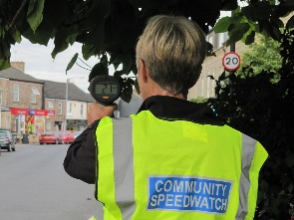
As I included in the September edition of Focus I am in the process of activating a Community Speedwatch team for Great Horwood. So far very few volunteers have contacted me so this is a reminder that Speedwatch is the most likely way of acting against drivers speeding in the parish, so please contact me if you are concerned about vehicles speeding in the village and are willing to give up some your time and join the team.
You will need to undertake an online training course and pass the online test at the end of the course. Once up and running the team will monitor speeds of vehicles at certain agreed spots in the parish and report the details direct to Thames Valley Police who will be able to take warning actions against speeding drivers. Cllr. John Gilbey johnwgilbeypc@gmail.com
FOCUS ONLINE
Did you know that there is an online edition of Focus with every copy from February 2012?
So, if you have mislaid your copy and can’t find the information you need, just log onto
https://e-voice.org.uk/ghpc/focus-magazine/

NEXT MEETING OF THE PARISH COUNCIL
The next meeting will be held on Tuesday 10th October at 7.30pm in the Scout Hut (this will be our normal venue whilst the Village Hall is being refurbished.)
There is always a public participation period when members of the public can have their say. The Notice of the meeting is advertised on the Great Horwood Facebook page, the Parish Council website and the noticeboard in the High Street.
Minutes of meetings can be found on the noticeboard and the Parish Council website e-voice.org.uk/ghpc/
Cllr. John Gilbey
Chairman of the Council
johnwgilbeypc@gmail.com

