PARISH PUMP NOVEMBER 2025

PARISH COUNCILLORS WANTED
We have vacancies for Councillors on the Parish Council. If you think you might be interested in volunteering to serve your local community as a Parish Councillor, please email the Clerk on clerk@greathhorwoodpc.org.uk for more information.

BUCKINGHAMSHIRE LOCAL PLAN
Buckinghamshire Council has issued a consultation on the draft Local Plan that will identify where and how future development should take place across Buckinghamshire up to 2045. The documents can be viewed at https://buckinghamshire.gov.uk/draft-local-plan
The consultation closes on 29 October 2025. This deadline is very tight but please have a look and comment if you can. It will affect all of us!
YOUR VILLAGE CONSULTATION DOCUMENT
Thank you for taking the time to complete either the paper or online document. It is much appreciated. Further feedback will be available shortly.
BUCKINGHAMSHIRE FIRE AND RESCUE SERVICE
The Parish Council have been contacted by the Community safety Co-Ordinator working for Buckinghamshire Fire and Rescue service. They are offering a FREE 'Home fire safety visit'. Please see notice below - if this is something that you would like to take up, please contact the Buckinghamshire Fire and Rescue Service on the contact details shown.

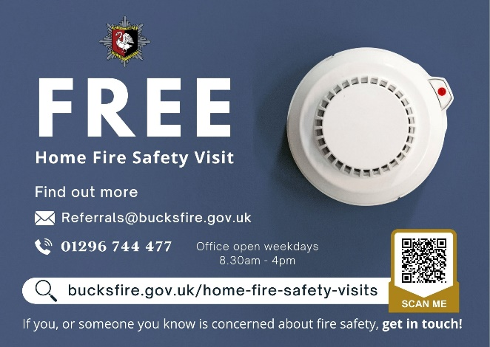

20MPH ZONE THROUGH GREAT HORWOOD VILLAGE
Following on from the village consultation, and the Change.org petition that so many of you signed up to, the Parish Council have written to the Leader of Buckinghamshire Council regarding a 20mph speed limit through the village – we will keep you posted on how this progresses.

FIX MY STREET

Just a reminder to everyone that “FixMyStreet” is an online facility where anyone can make a public report for things like graffiti, fly tipping, broken pavings slabs, and potholes that they see in the Village. This information gets passed to Buckinghamshire Council for them to action. The website address is https://www.fixmystreet.com
DOG WASTE
There are 8 dog waste bins within the village – please remember if you are taking your dog for a walk, please pick up after them and place the waste in the designated bin – thank you.
WELCOME PACK

If you are new to the village and have not yet received a Welcome pack, please email the Clerk and a pack will be sent to you – clerk@greathorwoodpc.org.uk
FOCUS ONLINE
Did you know that there is an online edition of Focus. If you have mislaid your copy and can’t find the information you need – just log onto the Parish Council website.
https://e-voice.org.uk/ghpc/focus-magazine/

NEXT MEETING OF THE PARISH COUNCIL
The next meeting will be held on Monday 24th November 2025 at 7.30pm in the Village Hall.
There is always a public participation period when members of the public can have their say – please feel free to attend. The Notice of the meeting is advertised on the Parish Council website and the noticeboard in the High Street.

Minutes of meetings can be found on the noticeboard and the Parish Council website.
e-voice.org.uk/ghpc/

