PARISH PUMP

WELCOME TO OUR NEW PARISH COUNCILLOR
We welcome Jonathan Evans who has been co-opted onto the Parish Council. This now brings Great Horwood Parish Council to its full complement.

OVERGROWN HEDGES
It’s that time of year when we think about tidying up our outside space ready for the winter months when we spend more time indoors. This is just a reminder to make sure your boundary hedges are not encroaching the pavements so they are accessible to walkers including those with pushchairs and prams.

SPEED INDICATOR DEVICE
We are all aware of speeding traffic entering our village. The Parish Council do have a handheld device that will record speeding cars but it does need a team of volunteers to man it. A short training session will be required, but nothing onerous. Please contact me if you would be interested in getting involved and making a difference to your community.

THANK YOU, MICK AND GILL WOOD
Over the past 7 ½ years, Mick and Gill have been responsible for the MVAS (Mobile Vehicle Activated Sign). They would regularly move it to the various locations at the entrances to the village and download and analyze the data. They are now stepping down for a well-earned rest. The Parish Council are very grateful for their hard work in all weathers and know that the sign makes a difference to the speed of drivers. We are, however, looking for volunteers to take on this task. Full training will be given. If you are interested, please contact me on the email below.

FOCUS ONLINE
Did you know that there is an online edition of Focus with every copy from February 2012? So, if you have mislaid your copy and can’t find the information you need, just log onto
https://e-voice.org.uk/ghpc/focus-magazine/
PLAY PARK AT HIGH STREET HOMES DEVELOPMENT
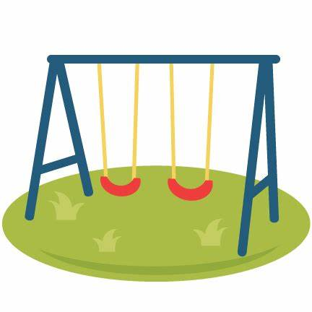
Many of you will be aware that there is a plan to install a play park next to the new homes on Little Horwood Road. This is in the S.106 agreement for the development of the homes but there is however, a process that needs to be adhered to before that land can be transferred into the ownership of the Parish Council. Unfortunately, the land is not at the standard that is required and there is much remedial work that High Street Homes need to carry out before the land goes into the 12- month maintenance period for which High Street Homes are responsible. Only after that time can the land be transferred to the Parish Council and opened to the public. This will also enable the play equipment to be installed by the Parish Council.
The Parish Council has no control over this very frustrating situation and this probably means a minimum 18-month delay for the park to be open to the public and for the installation to take place. We are being honest with residents because like you, we would love to see the space used in the way it was intended. Updates will be published when available.

WELCOME TO GREAT HORWOOD
We hope all new residents have enjoyed reading their Welcome Packs and found the information useful, and are settling into our lovely village community.
Would any new residents we are not yet aware of, like to receive a Welcome Pack? We wouldn’t want to leave anyone out. It has recently been updated and includes information on village organisations, the School, Church and the local area. Please contact John Gilbey by email on johnwgilbeypc@gmail.com

NEXT MEETING OF THE PARISH COUNCIL
The next meeting will be held on Monday 14th November at 7.30pm in the Village Hall. There is always a public participation period when members of the public can have their say. The Notice of the meeting is advertised on the Great Horwood Facebook page, the Parish Council website and the noticeboard in the High Street. Minutes of meetings can be found on the noticeboard and the Parish Council website e-voice.org.uk/ghpc/
Sue Brazier, Clerk to Great Horwood Parish Council
clerk@greathorwoodpc.org.uk

