PARISH PUMP NOVEMBER 2024

CROUDACE HOMES PROPOSAL
The Parish Council have written an article in this edition of Focus concerning the above. As you will see, development proposals on land outside the settlement boundary will not be permitted. Details of the existing Great Horwood Parish Neighbourhood Plan are on the Parish Council website.
PARISH COUNCIL “SURGERY”
As you know, the Parish Council have, for the past few months, set up a drop in point at the Village Hall every 2 weeks. This is held every other Wednesday at 10am when the Village Hall is open for the Post Office/coffee morning. If you are unable to get to the monthly meetings but wish to chat to the Parish Council, this is your opportunity.
Dates for the rest of 2024 are as follows: -
6th and 20th November
4th and 18th December

CALLUM ANDERSON – MP FOR BUCKINGHAM AND BLETCHLEY
Please see listed below the dates for his constituency advise surgery dates for the rest of 2024. These are also available on his social media pages and his website.
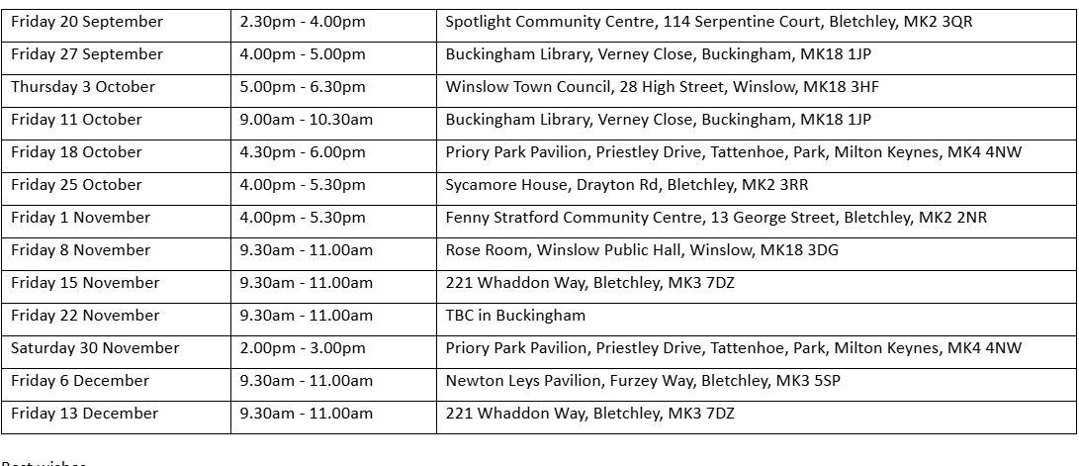

FUNDS FOR LOCAL CAUSES
As in previous years, Great Horwood Parish Council will once again be donating up to £3,000 to local causes.
Applicants must be from organisations associated with the village. Winning bids will be announced at the December 2024 Parish Council meeting.

FIX MY STREET

Just a reminder to everyone that “FixMyStreet” is an online facility where anyone can make a public report for things like graffiti, fly tipping, broken pavings slabs, and potholes that they see in the Village. This information gets passed to Buckinghamshire Council for them to action. The website address is https://www.fixmystreet.com
DOG WASTE
I am sure that you will have seen the various posts on the Great Horwood Facebook page concerning the amount of dog litter around in the village that is being left and not picked up. As I am sure you are aware, not only is this unsightly but it presents a health hazard.
There are 8 dog waste bins within the village – please remember if you are taking your dog for a walk, please pick up after them and place the waste in the designated bin – thank you.
WELCOME PACK
If you are new to the village and have not yet received a Welcome pack, please email Cllr Gilbey with your address and one will be delivered to you johnwgilbeypc@gmail.com
FOCUS ONLINE
Did you know that there is an online edition of Focus. If you have mislaid your copy and can’t find the information you need – just log onto the Parish Council website.
https://e-voice.org.uk/ghpc/focus-magazine/

NEXT MEETING OF THE PARISH COUNCIL
The next meeting will be held on Monday 11th November 2024 at 7.30pm in the Village Hall.
There is always a public participation period when members of the public can have their say – please feel free to attend. The Notice of the meeting is advertised on the Parish Council website and the noticeboard in the High Street.
Minutes of meetings can be found on the noticeboard and the Parish Council website.
e-voice.org.uk/ghpc/

