Parish Pump
CASUAL VACANCIES
The Parish Council has 2 casual vacancies and needs to co-opt 2 new members.
If you would like to find out more about what being a Parish Councillor involves in serving your local community then please in the first instance contact Cllr. John Gilbey by email at johnwgilbeypc@gmail.com and we can arrange to get together for a chat.

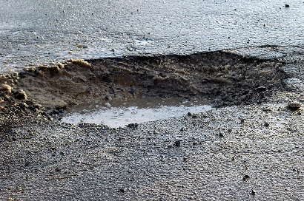
POT HOLES AND THE HIGH STREET????
We asked Buckinghamshire Council when the High Street in the village is going to be resurfaced and this is the answer we got – so don’t hold your breath.
“The Local Area Technician (LAT) are inspecting the road network constantly and also in response to reports received via Fix-my-Street. We monitor areas through our regular monthly, quarterly and annual inspections for further deterioration; any works required will be carried out to keep the condition of the carriageway safe, in line with our Highways Safety Inspection Policy.

Roads or footways for resurfacing are prioritised in conjunction with local Members to ensure that our available annual funding is spread fairly across the entire county. Many of our Members have had difficult choices to make, with numerous roads and footways needing to be prioritised. We take a balanced strategy to determine our future programme, aiming to produce a mix of treatments targeted at both preventative repairs, which offer the best value for money in the longer term, as well as resurfacing work to repair those areas which are not in an acceptable condition.”

LITTER PICK
It was a very damp morning on Sunday 26th March, but the Scouts, Cubs and Beavers still turned out in great numbers and together with help from a group from Nook Park and a couple from the Cricket Club together with Jane Holland a considerable amount of rubbish was cleared from the streets of the village.

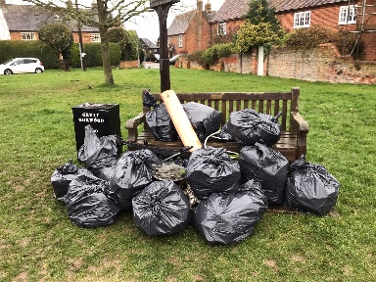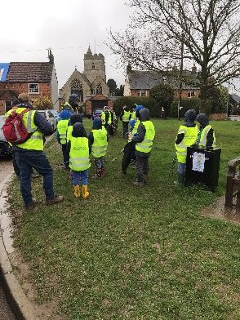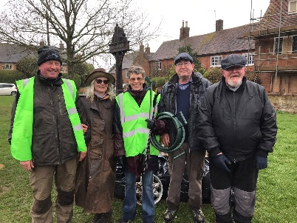

CORONATION WEEKEND
All welcome at the Cricket Club on Monday 9th May

NOOK PARK
We are waiting to find out how Buckinghamshire Council will enforce the replacement of the hedges back into their original position.

FOX COVERT SOLAR FARM
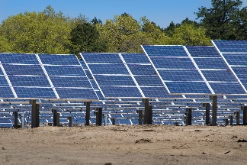
Work has started on the installation of the solar farm and so there will be movements of large items of equipment through the village in the coming weeks and months

FOCUS ONLINE
Did you know that there is an online edition of Focus with every copy from February 2012?
So, if you have mislaid your copy and can’t find the information you need, just log onto
https://e-voice.org.uk/ghpc/focus-magazine/

NEXT MEETING OF THE PARISH COUNCIL
The next meeting will be held on Monday 19th May at 7.30pm in the Village Hall. There is always a public participation period when members of the public can have their say. The Notice of the meeting is advertised on the Great Horwood Facebook page, the Parish Council website and the noticeboard in the High Street. Minutes of meetings can be found on the noticeboard and the Parish Council website e-voice.org.uk/ghpc/
Parish Council Clerk
clerk@greathorwoodpc.org.uk

