PARISH PUMP March 2024

LITTER PICK
A date for your diary – Sunday 17th March 2024, starting at 10am on The Green.
Please come along to help tidy the village. Litter pickers and rubbish sacks will be provided. We will also be providing hi viz jackets but if you have your own, that would be even better. Please could you bring your own gloves; gardening gloves would be good as thorns and sharp objects tend to tear plastic gloves.

FUND FOR LOCAL CAUSES
At the Parish Council meeting held on 13th February 2024 the remaining awards to the Great Horwood Scouts and the Great Horwood Football Club were given and certificates provided.
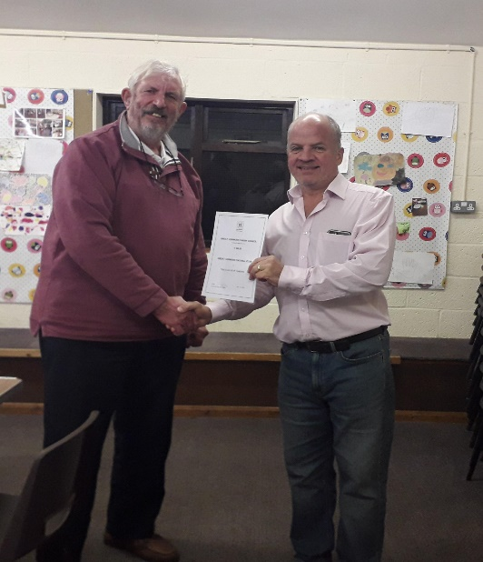
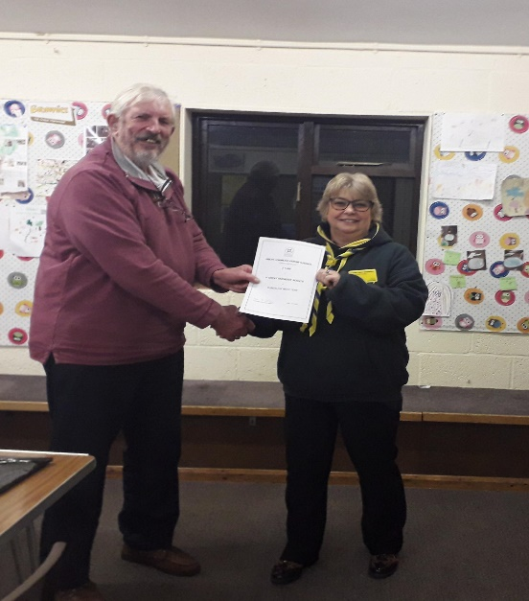
PARISH COUNCILLORS
We still have two vacancies on the Council. If you think you might be interested in volunteering to serve your local community in this way, please email and we can arrange to have a chat about the role and see if it is suited to you johnwgilbeypc@gmail.com

DOG WASTE
I am sure that you will have seen the various posts on the Great Horwood Facebook page concerning the amount of dog litter around in the village that is being left and not picked up. As I am sure you are aware, not only is this unsightly but it presents a health hazard. Please remember if you are taking your dog for a walk, please pick up after them – thank you.

SPEEDWATCH

We are pleased to announce that we now have a team of 6 members of the public for the Speedwatch team and will plan to start recording speeds within the next few weeks (once everybody has been trained in the use of the equipment).

FLOWER PLANTERS
If you would like to volunteer to be part of the “Planter Team” which helps with planting out and maintaining the 5 Planters around the village please get in touch – all help is gratefully appreciated.

ALLOTMENTS
There is one plot available on the allotments off Willow Road. Please contact Sarah Biswell on clerk@greathorwoodpc.org.uk if you are interested.

THE CROWN
The Parish Clerk has contacted Buckinghamshire Council (the Heritage function within the Planning, Growth & Sustainability department) a number of times over the last month to try to ensure that the current owner is not allowing The Crown (a listed building) to fall into a state of major disrepair. This is an ongoing discussion between the Parish Council and Buckinghamshire Council and further updates will be given when they become available.

WELCOME PACK
If you are new to the village and have not yet received a Welcome pack, please email Cllr Gilbey with your address and one will be delivered to you johnwgilbeypc@gmail.com

FOCUS ONLINE
Did you know that there is an online edition of Focus with every copy from February 2012?
So, if you have mislaid your copy and can’t find the information you need, just log onto
https://e-voice.org.uk/ghpc/focus-magazine/

PARISH COUNCIL WEBSITE
With Spring not far round the corner, it seems the right time to spring clean and update the Parish Council website with new photographs that have been taken around the village – if you have any local photographs that you would not mind being published on our website that depict the village life please forward these to the Clerk by email clerk@greathorwoodpc.org.uk

INFORMATION SHARING GROUP
This is a good way of communicating useful information to villagers. If you would like to receive information first hand, such as Thames Valley Police info, roadworks updates and other ad hoc information, please contact Sarah Biswell on clerk@greathorwoodpc.org.uk if you are interested and you can be added to the email group.

NEXT MEETING OF THE PARISH COUNCIL
The next meeting will be held on Tuesday 12th March at 7.30pm in the Scout Hut (this will be our normal venue whilst the Village Hall is being refurbished.)
There is always a public participation period when members of the public can have their say. The Notice of the meeting is advertised on the Parish Council website and the noticeboard in the High Street.
Minutes of meetings can be found on the noticeboard and the Parish Council website.
e-voice.org.uk/ghpc/

