PARISH PUMP JUNE 2024
ANNUAL PARISH MEETING
The Annual Parish Meeting went ahead on the 29th April 2024, with a splendid number of 49 people attending – thank you to all those that did.
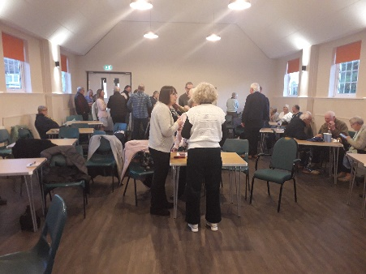
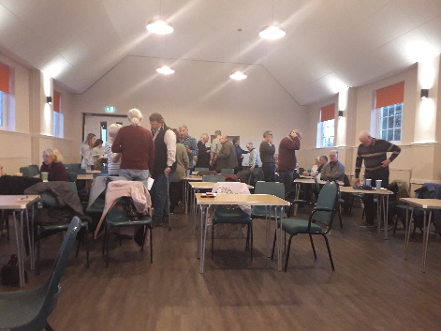
The primary purpose of the Annual Parish Meeting is for the Chairman to report on the activities of the Parish Council for the previous 12 months. The Chairman thanked his fellow Parish Councillors and all the various volunteers who contribute to the life in the Parish. There was a special mention to Sarah Biswell who took over as Clerk to the Council on 1st September 2023 and to Mandy Cliffe who has continued to assist the council with its accounting activities.
A great community event, hearing about what our local clubs and societies have been up to for the last 12 months. Also attending were the recipients of the Worthy Causes Grants that were presented last year.
The Village Hall has been refurbished as a space for everyone in the village to use, and the Chairman encouraged any group that needs a place to meet to get in touch with those who run the Village Hall to enjoy the space that has been created.
ANNUAL COUNCIL MEETING

At the Council meeting held on 13th May Cllr John Gilbey was re-elected as Chairman and Cllr. Cousin was re-elected as Vice Chairman.
Appointments were also made to various outside bodies including the following:-

- Winslow and Villages Community Board
- North Bucks Parishes Planning Consortium (NBPPC)
- Great Horwood and Singleborough Village Hall
- Poor’s Allotments (Castlefields) Charity
- Trustees to the Great Horwood and Singleborough Recreation Trust

COUNCILLORS
We have two vacancies on the Council. If you think you might be interested in volunteering to serve your local community in this way, please email and we can arrange to have a chat about the role and see if it is suited to you johnwgilbeypc@gmail.com

MOBILE VEHICLE ACTIVATED SIGN
We need a new team of two volunteers to operate the Parish Council's Mobile Vehicle Activated Sign (MVAS). This is the device that records the volume and speed of traffic passing and can be used in discussion with Buckinghamshire Council and Thames Valley Police to prove the need for some form of traffic calming. There are 5 sites around the parish where it can be used - 2 In Nash Road and 1 each in Little Horwood Road, Winslow Road and Singleborough. The operators are responsible for moving it to the various sites, downloading and analysing the data and reporting to the Parish Council.
If anyone would be interested in assisting with this please get in touch with the Clerk by email – clerk@greathorwoodpc.org.uk.
FACEBOOK PAGE
As mentioned last month, The Parish Council have now decided to have their own page on the social media platform, Facebook. It is simply called Great Horwood Parish Council. Have you liked this page yet?
FIX MY STREET
Just a reminder to everyone that “FixMyStreet” is an online facility where anyone can make a public report for things like graffiti, fly tipping, broken pavings slabs, and potholes that they see in the Village. This information gets passed to Buckinghamshire Council for them to action. The website address is https://www.fixmystreet.com
THE CROWN
Ongoing discussions between the Parish Council and Buckinghamshire Council and further updates will be given when they become available. Don’t forget to check the minutes of the Parish Council meetings to see the latest information.
WELCOME PACK
If you are new to the village and have not yet received a Welcome pack, please email Cllr Gilbey with your address and one will be delivered to you johnwgilbeypc@gmail.com
FOCUS ONLINE
Did you know that there is an online edition of Focus. If you have mislaid your copy and can’t find the information you need – just log onto the Parish Council website.
https://e-voice.org.uk/ghpc/focus-magazine/
NEXT MEETING OF THE PARISH COUNCIL
The next meeting will be held on Monday 10th June at 7.30pm in the Village Hall.
There is always a public participation period when members of the public can have their say – please feel free to attend. The Notice of the meeting is advertised on the Parish Council website and the noticeboard in the High Street.
Minutes of meetings can be found on the noticeboard and the Parish Council website.
e-voice.org.uk/ghpc/

