Parish Pump
Open Space Land Little Horwood Road
The Parish Council is delighted to announce that this plot of land is now open to the public. It has long been in the planning as it was part of our Neighbourhood Plan which was made in March 2015. The developers, High Street Homes, will remain responsible for its maintenance for the next year and then the land will be transferred to the Parish Council and we can once again start to plan for the installation of the play equipment. In the meantime we plan to install two benches, two litter bins and a dog bin as soon as possible

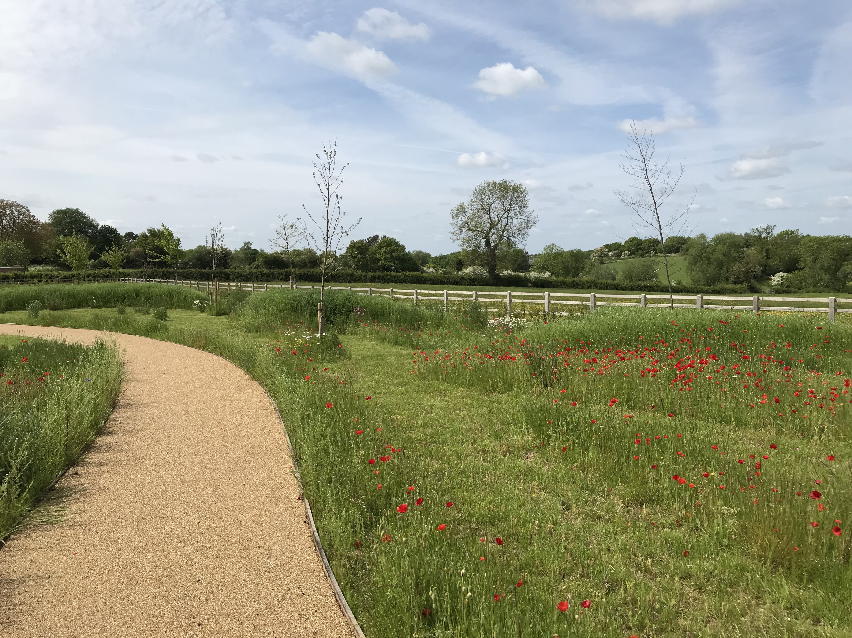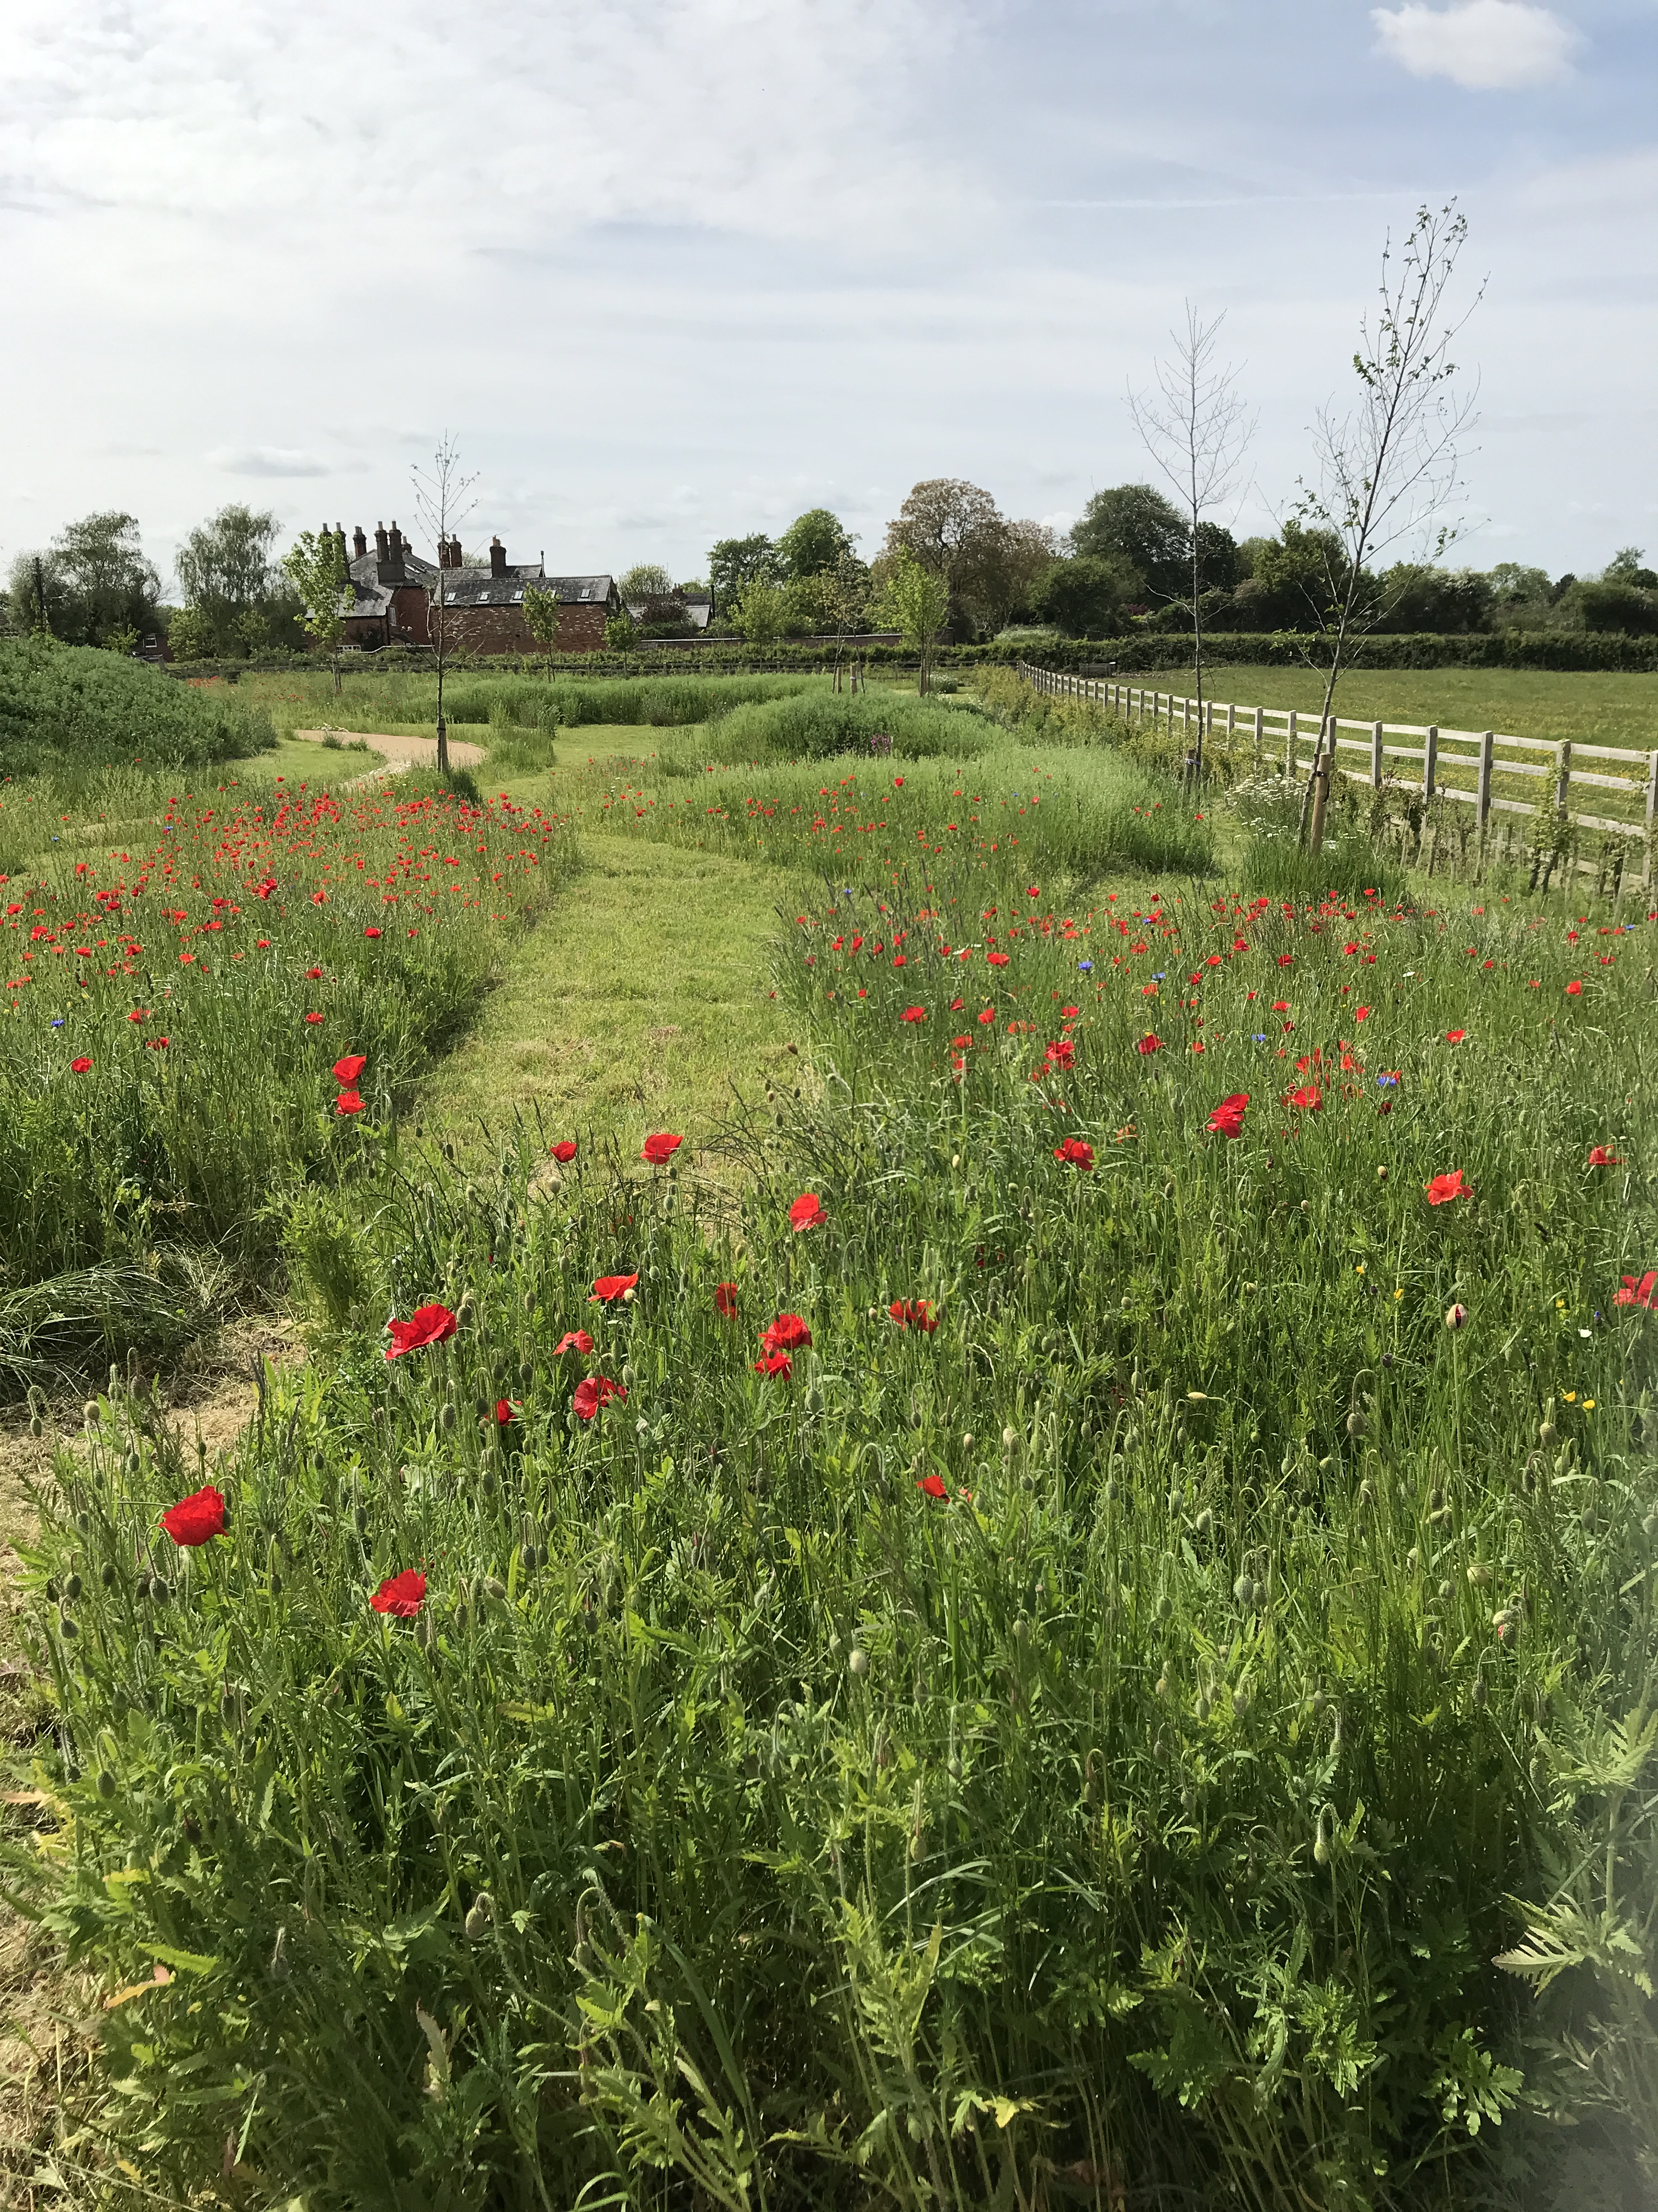

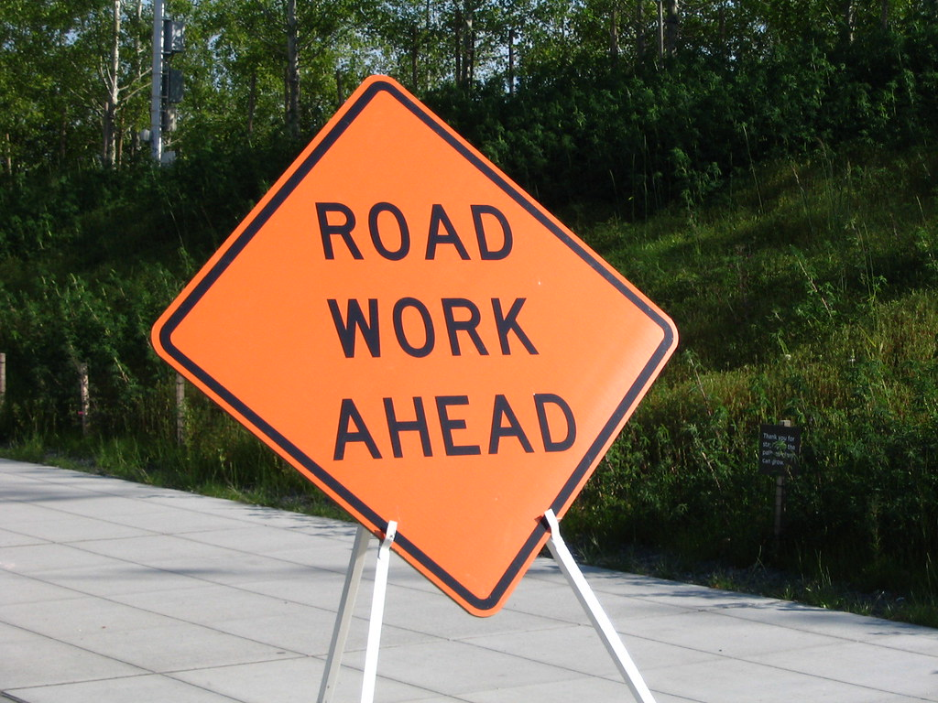
This will mean that the High Street will be
closed from 10pm to 6am from 17th to 21st July
and the adjacent section of Winslow Road will be
closed from 10pm to 6am from 24th to 28th July.
We have also now been told that Winslow Road
will actually be completely closed from
24th to 27th July by National Grid
to rebuild overhead lines

Believe or not!!! we have been told by Buckinghamshire Council that the High Street/Winslow Road are to be resurfaced in July.

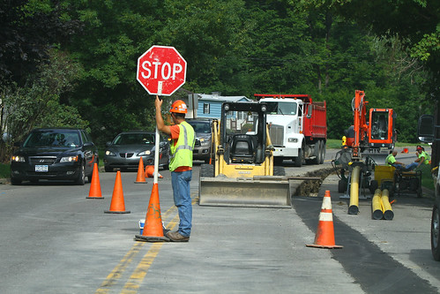

FOCUS ONLINE
Did you know that there is an online edition of Focus with every copy from February 2012?
So, if you have mislaid your copy and can’t find the information you need, just log onto
https://e-voice.org.uk/ghpc/focus-magazine/

NEXT MEETING OF THE PARISH COUNCIL
The next meeting will be held on Monday 10th July at 7.30pm in the Village Hall. There is always a public participation period when members of the public can have their say. The Notice of the meeting is advertised on the Great Horwood Facebook page, the Parish Council website and the noticeboard in the High Street. Minutes of meetings can be found on the noticeboard and the Parish Council website e-voice.org.uk/ghpc/
Cllr. John Gilbey
Chairman of the Council
johnwgilbeypc@gmail.com

