PARISH PUMP February 2024

The Crown
It is now 5 years since the The Crown ceased to operate as a public house and since then there have been seven planning or listed building applications made. Two have been withdrawn, 2 have been approved, 2 are awaiting a decision and the latest one has been refused.
Listed Building Application 23/03445/ALB refused on 14th December 2023
“Insufficient information has been submitted to determine whether the proposal would preserve the architectural interest of the listed building.”
Since 2020 the Parish Clerk has contacted Buckinghamshire Council Planning Enforcement and the Heritage function a number of times to try to ensure that the current owner is not permitted to allow The Crown to fall into a state of major disrepair.
The latest response to the Clerk from the Heritage team which was received on 10th January included the following statement:
“I’ve spoken to the enforcement team and they are working with our legal team on the best course of action as to which notice we can serve and will be the most effective.”
The Swan
In 2020 the Parish Council with support from local village organisations applied to register The Swan Public House as an asset of Community Value and this was agreed by Buckinghamshire Council as follows:
“The Council accepts the nomination by Great Horwood Parish Council and includes The Swan Public House, 1 Winslow Road, Great Horwood, Bucks MK17 0QG in its list of assets of community value.”
This decision was dated 15th December 2020 and lasts for 5 years and means that the community will have the opportunity to bid for the property if it is sold and gives powers of compulsory purchase if the community use of the asset is in danger of being lost.
The possibility of raising enough funds to purchase The Swan and to run it as a community pub would however require significant investment from a large number of people in the parish.
PARISH COUNCILLORS
We still have two vacancies on the council. If you think you might be interested in volunteering to serve your local community in this way please email me and we can arrange to have a chat about the role and see if it is suited to you.
FUNDS FOR LOCAL CAUSES
At the Parish Council meeting held on 12th December the awards were made to Great Horwood School, the Winslow Community Bus and the Girl Guides. The awards to the Scouts and the Football Club will be made at the February meeting.

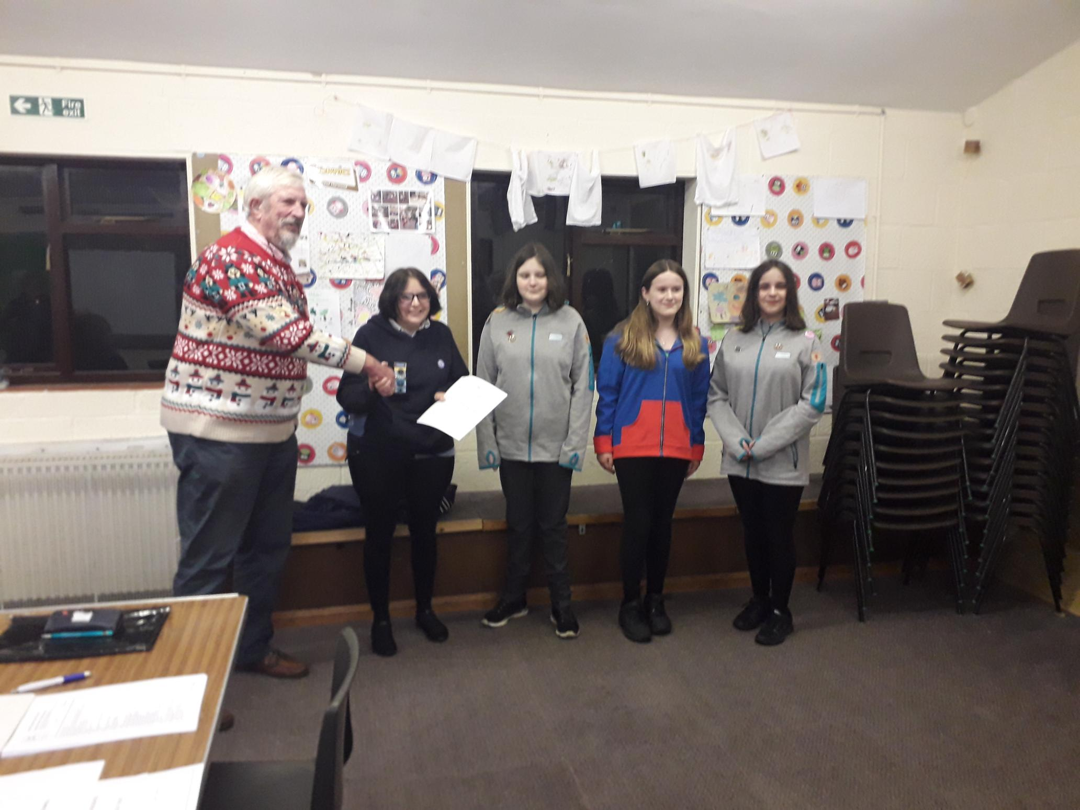
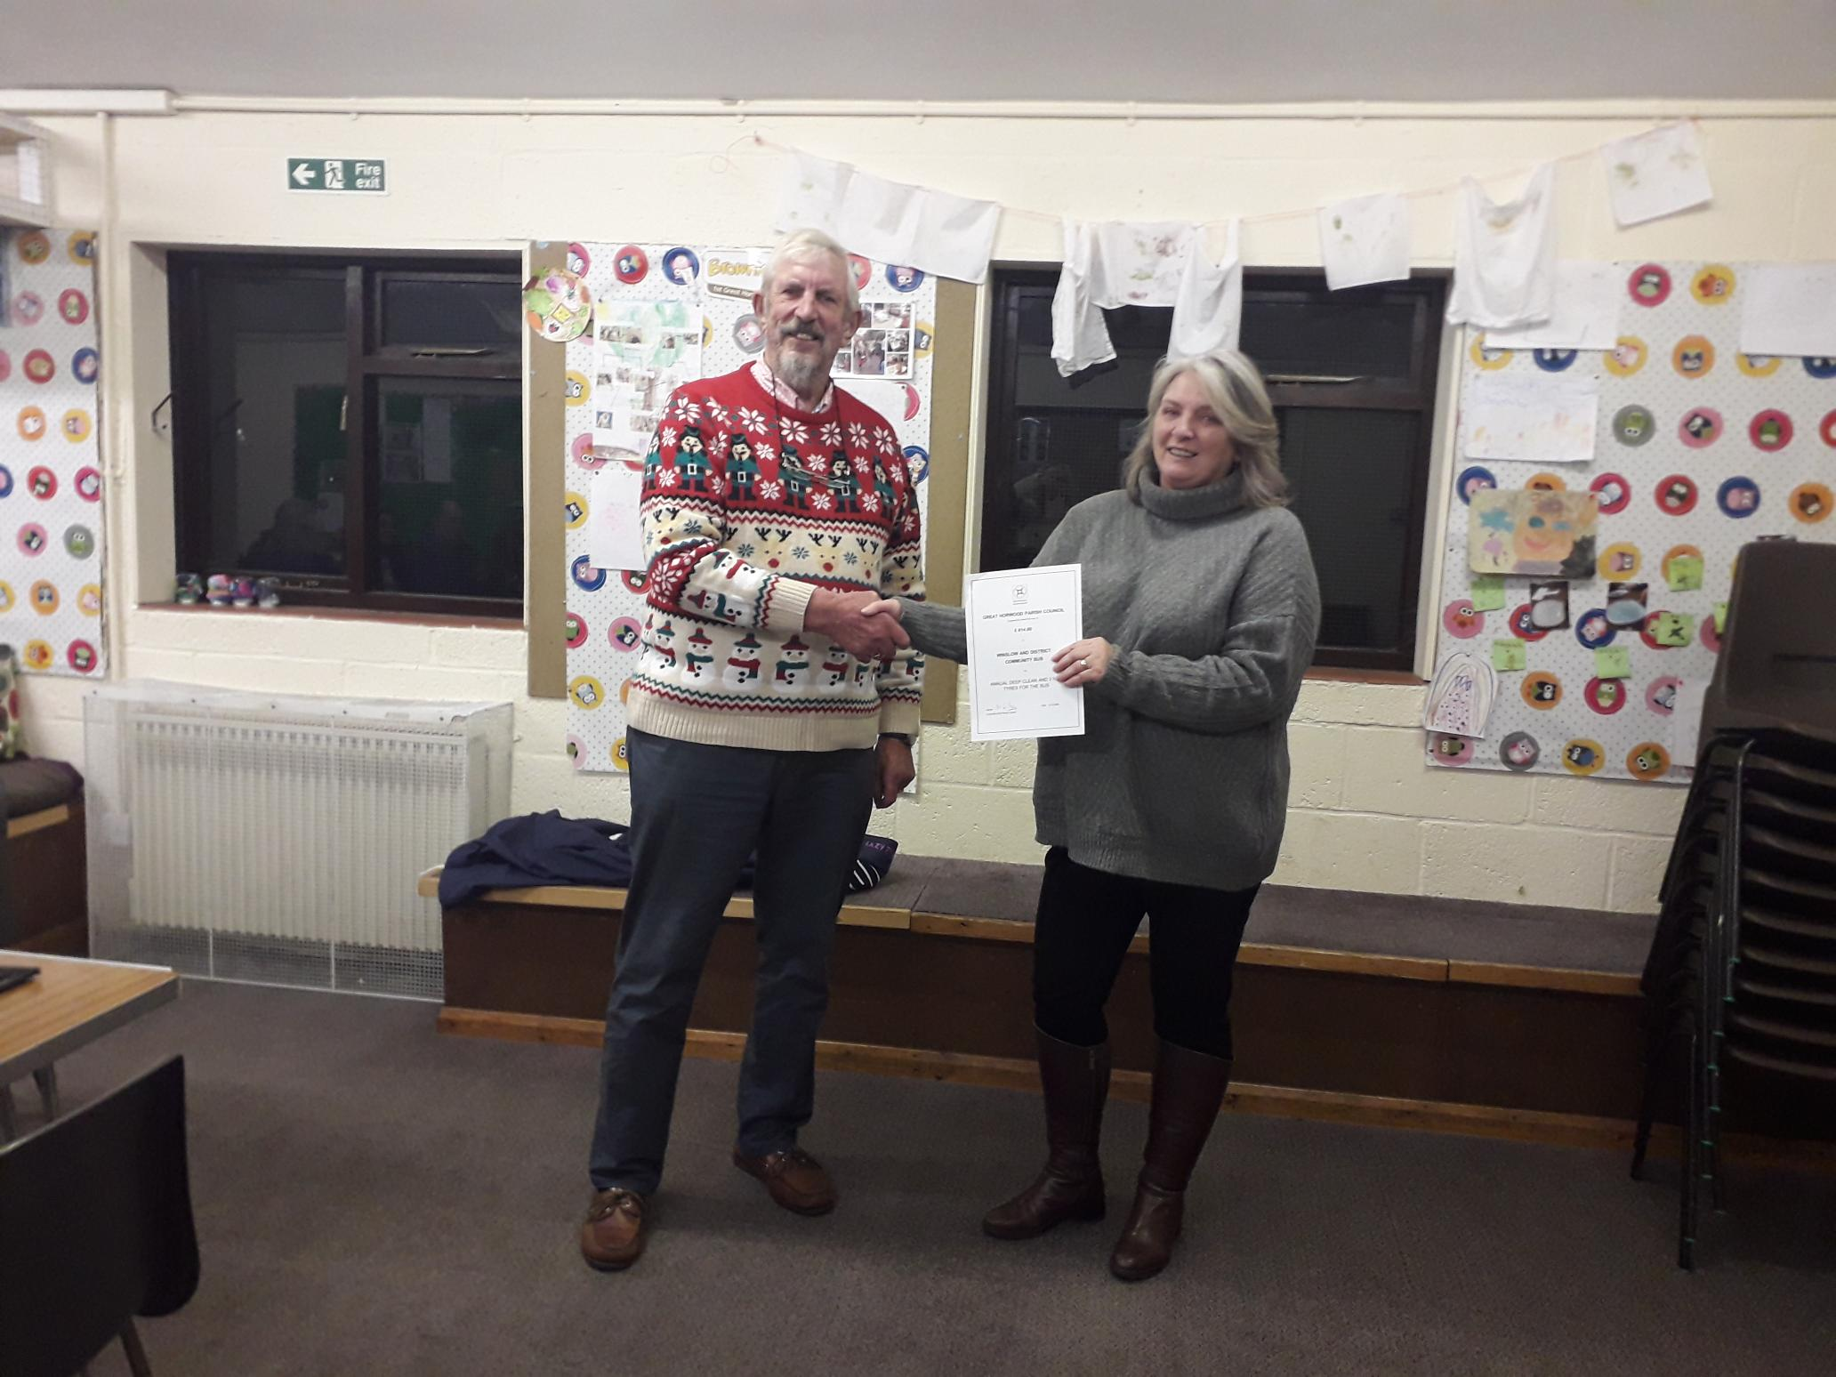
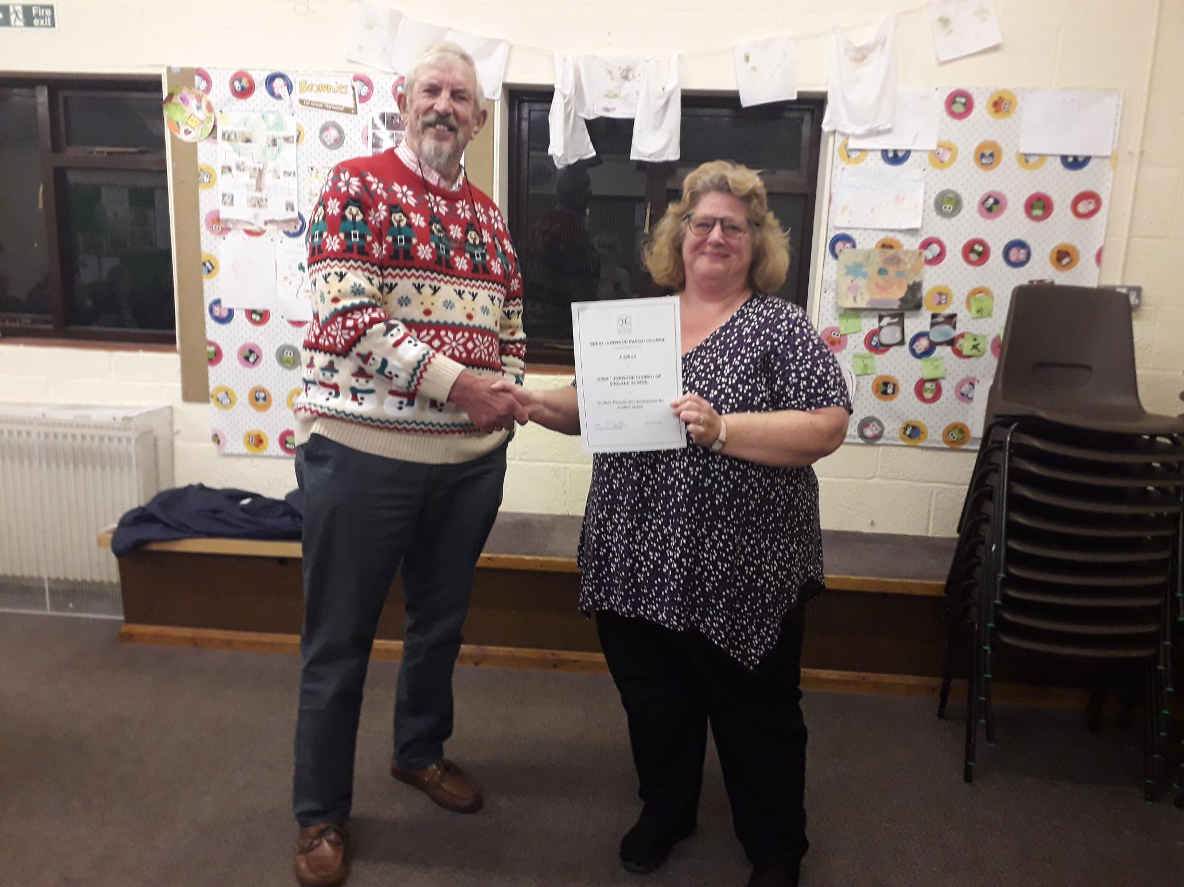
SPEEDWATCH

I still have only had two volunteers come forward to join me in operating the Speedwatch camera. This is the only method that we have for officially recording the speed of vehicles at fixed points in the parish and from which action can be taken by Thames Valley Police with the information that we feedback to them over the internet.
So if you are really concerned about speeding in the village and worried about the dangers to your children and pets there is something you can do about it.
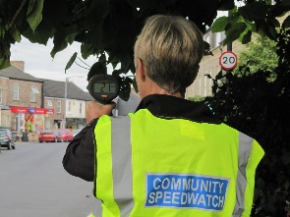
You will need to undertake an online training course and pass the online test at the end of the course. Once up and running the team will monitor speeds of vehicles at certain agreed spots in the parish and report the details direct to Thames Valley Police who will be able to take warning actions against speeding drivers. Cllr. John Gilbey johnwgilbeypc@gmail.com
ALLOTMENTS
There is one plot available on the allotments in Church lane. Please contact Sarah Biswell on clerk@greathorwoodpc.org.uk if you are interested.
WELCOME PACK
If you are new to the village and have not yet received a Welcome pack please email as shown below with your address and I will drop one off to you.
FOCUS ONLINE
Did you know that there is an online edition of Focus with every copy from February 2012?
So, if you have mislaid your copy and can’t find the information you need, just log onto
https://e-voice.org.uk/ghpc/focus-magazine/

NEXT MEETING OF THE PARISH COUNCIL
The next meeting will be held on Tuesday 13th February at 7.30pm in the Scout Hut (this will be our normal venue whilst the Village Hall is being refurbished.)
There is always a public participation period when members of the public can have their say. The Notice of the meeting is advertised on the Great Horwood Facebook page, the Parish Council website and the noticeboard in the High Street.
Minutes of meetings can be found on the noticeboard and the Parish Council website e-voice.org.uk/ghpc/
Cllr. John Gilbey
Chairman of the Council
johnwgilbeypc@gmail.com

