Parish Pump

Local Causes benefit from parish council grants
At the Parish Council meeting in December, the lucky recipients of the Worthy Causes grants were given the opportunity to be presented with their cheques and certificates by Councillor John Gilbey, Chairman of Great Horwood Parish Council. Those that were unable to attend received theirs by post. The successful organisations were – Football Club, WI, Combined School, Winslow and District Community Bus, Scouts & Guides, the Silver Band and the Art & Craft Group. Congratulations to all.
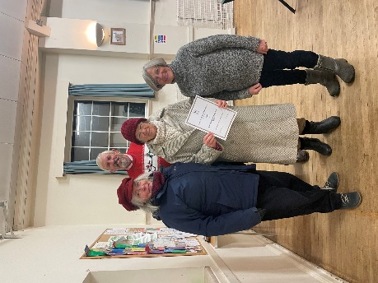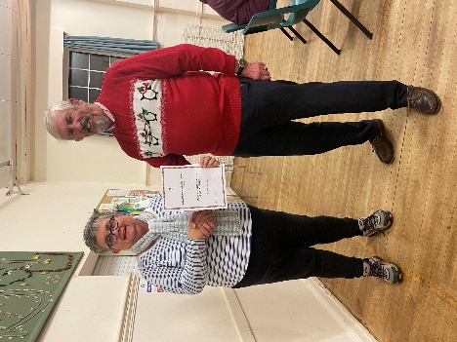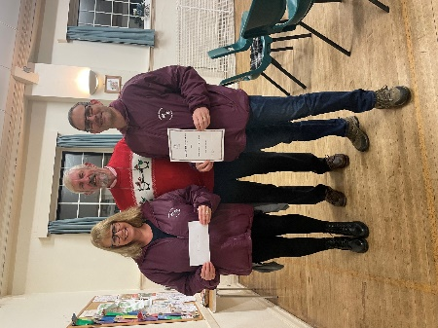

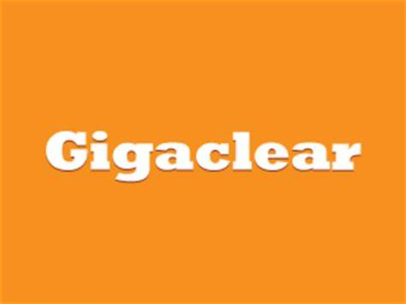
GIGACLEAR WORKS IN GREAT HORWOOD
As many of you are aware, Gigaclear returned to the village in January.
If residents would like to get in touch with Gigaclear, please contact their dedicated Customer Operations team on the details below.
Email: networkbuildqueries@gigaclear.com
Phone: 01865 591131
If and when I receive any updates, they will be published in Focus, which is also available on the Great Horwood Parish Council website e-voice.org.uk/ghpc/, the High Street noticeboard and on the Great Horwood village Facebook page.

NOOK PARK
The Parish Council are aware that there are major ground works going on at Nook Park. We are liaising as closely as possible with representatives of Buckinghamshire Council to try and ensure that the best interests of the current residents are safeguarded. We have also made our local MP Greg Smith aware and we will be following up to ensure that all changes are being made in accordance with the relevant regulations and legislation.

VILLAGE HALL RENOVATIONS
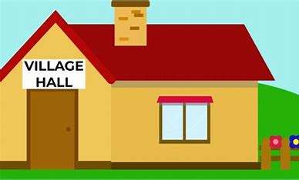
The Village Hall Management Committee are having discussions regarding the renovation of our Village Hall. They would like to see the hall brought up to date so it can be hired out for a wide range of activities and events. If anyone would like to make representations concerning these works, you are welcome to do so during the Public Participation Period of the next Parish Council meeting on Monday 13th February.

FOCUS ONLINE
Did you know that there is an online edition of Focus with every copy from February 2012? So, if you have mislaid your copy and can’t find the information you need, just log onto
https://e-voice.org.uk/ghpc/focus-magazine/

NEXT MEETING OF THE PARISH COUNCIL
The next meeting will be held on Monday 13th February at 7.30pm in the Village Hall. There is always a public participation period when members of the public can have their say. The Notice of the meeting is advertised on the Great Horwood Facebook page, the Parish Council website and the noticeboard in the High Street. Minutes of meetings can be found on the noticeboard and the Parish Council website e-voice.org.uk/ghpc/
Sue Brazier, Clerk to Great Horwood Parish Council
clerk@greathorwoodpc.org.uk

