PARISH PUMP December 2023
FOOTPATHS
A big thank you to the small group of volunteers including Farokh Khorooshi, Alan Biggins, Richard Heeley, Pierre Sacre and Graham Oxford Clay who carried out a great repair job on the footpath that runs behind Pilch Lane.

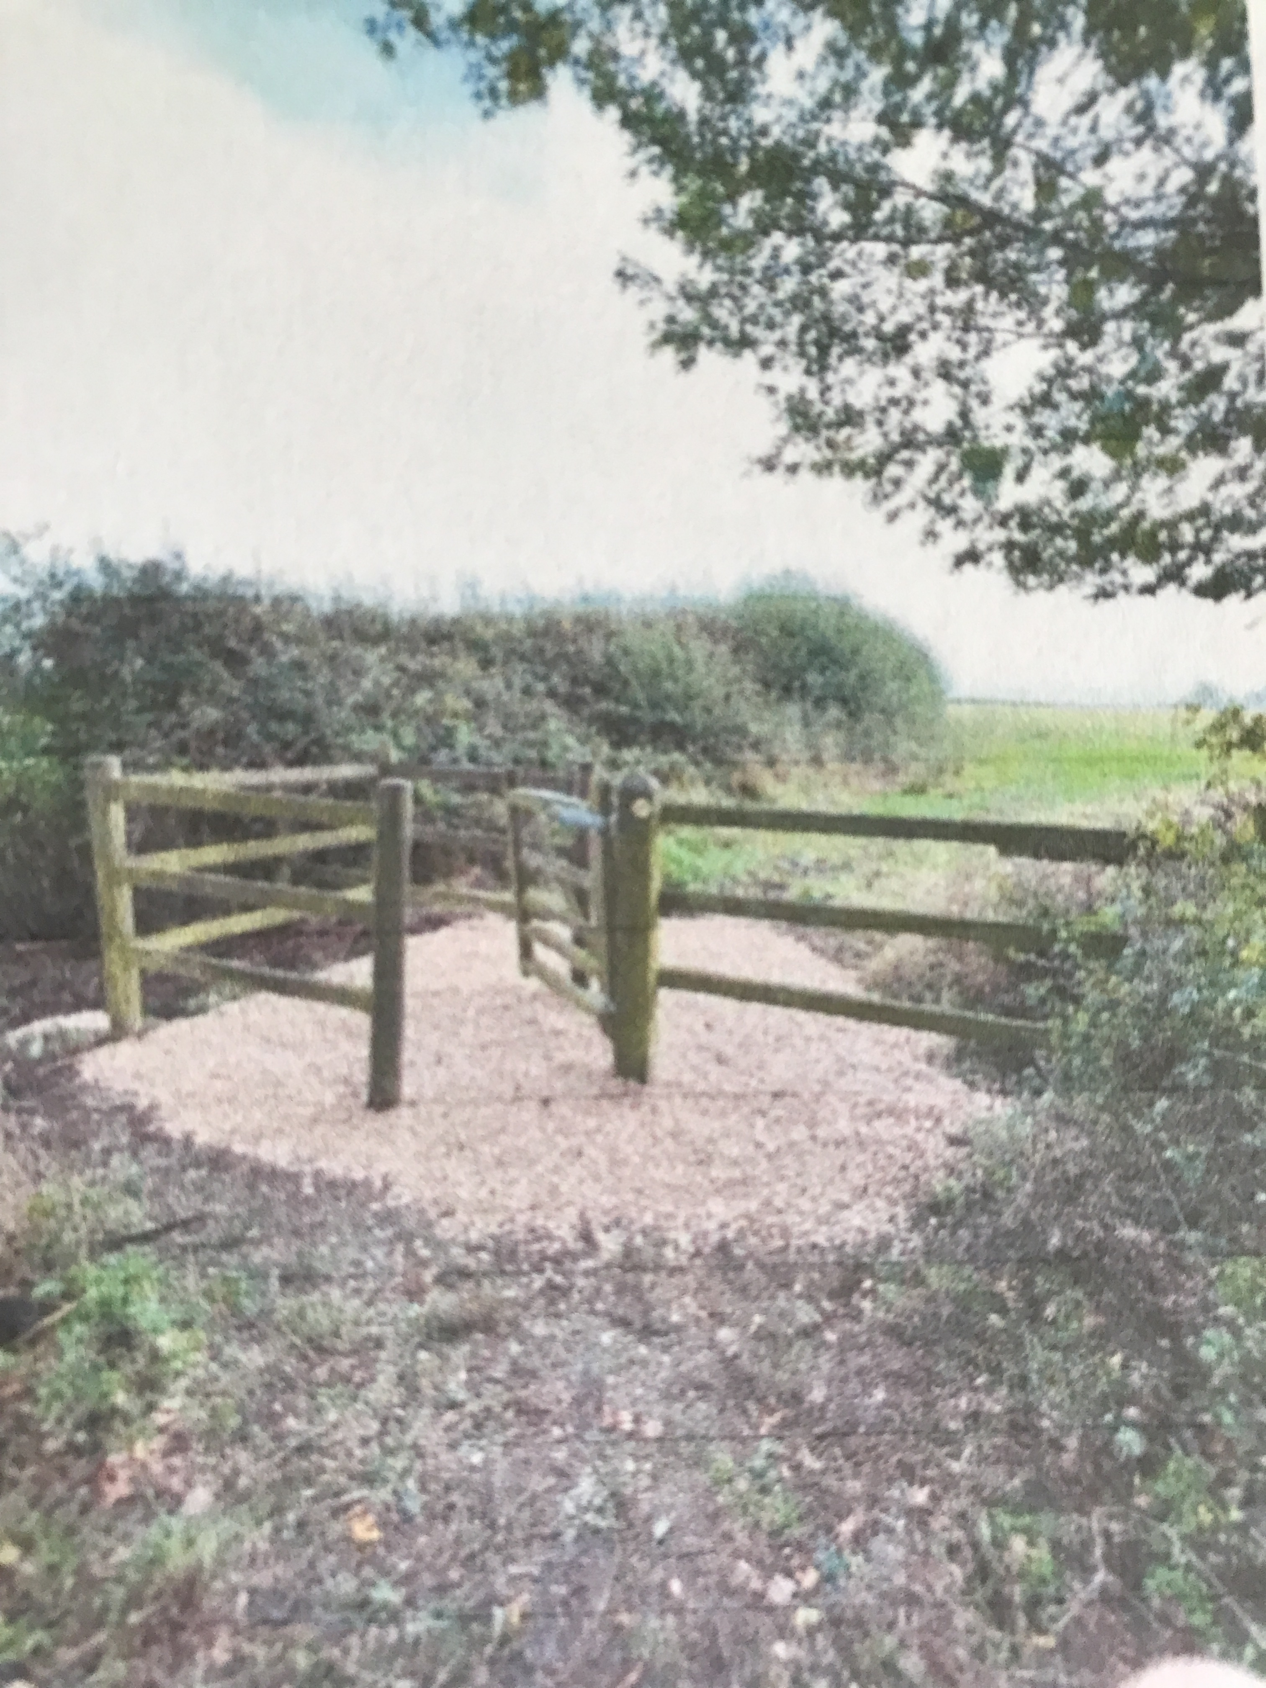

PARISH COUNCILLORS
We still have two vacancies on the council. If you think you might be interested in volunteering to serve your local community in this way please email me and we can arrange to have a chat about the role and see if it is suited to you.
VILLAGE PLANTERS
Since I wrote last month we have had 3 volunteers come forward and so we can look forward to the various planters around the parish being replanted and maintained for the coming year.
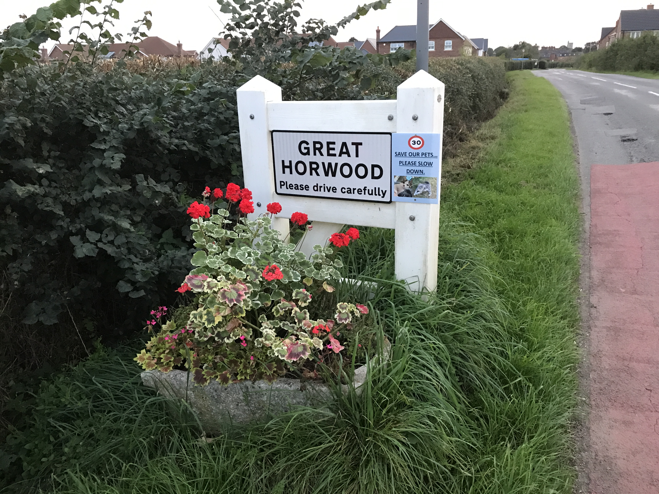

LIDEN PARK
I am sure that you are all pleased to see that two new litter bins have been installed at the eastern and western entrances to the new small park and that a dog bin has also been installed just outside the park on the corner of Liden Way.
FUNDS FOR LOCAL CAUSES

At the Parish Council meeting on 14th November it was agreed to award funding to the following applicants.
- The Football Cub for “Roll on Roll off” goal posts,
- Great Horwood School for an outdoor Pergola,
- Winslow Community Bus for monthly deep cleans and two new tyres,
- Great Horwood Girl Guides for an ice skating trip in December,
- Great Horwood Scouts towards a Bungalow mess tent.
The awards will be made at the Parish Council meeting on 12th December.

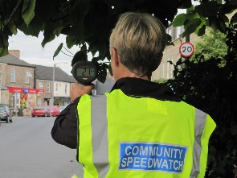
SPEEDWATCH
I still have only had one volunteer come forward to join me in operating the Speedwatch camera. This is the only method that we have for officially recording the speed of vehicles at fixed points in the parish and from which action can be taken by Thames Valley Police with the information that we feedback to them over the internet.
So if you are really concerned about speeding in the village and worried about the dangers to your children and pets there is something you can do about it.
You will need to undertake an online training course and pass the online test at the end of the course. Once up and running the team will monitor speeds of vehicles at certain agreed spots in the parish and report the details direct to Thames Valley Police who will be able to take warning actions against speeding drivers. Cllr. John Gilbey johnwgilbeypc@gmail.com
ALLOTMENTS
There is one plot available on the allotments off Willow Road. Please contact Sarah Biswell on clerk@greathorwoodpc.org.uk if you are interested.
THE CROWN
The Parish Clerk has contacted Buckinghamshire Council Planning Enforcement and the Heritage function a number of times over the last month to try to ensure that the current owner is not allowed The Crown (a listed building) to fall into a state of major disrepair.
WELCOME PACK
If you are new to the village and have not yet received a Welcome pack please email as shown below with your address and I will drop one off to you.
FOCUS ONLINE
Did you know that there is an online edition of Focus with every copy from February 2012?
So, if you have mislaid your copy and can’t find the information you need, just log onto
https://e-voice.org.uk/ghpc/focus-magazine/

NEXT MEETING OF THE PARISH COUNCIL
The next meeting will be held on Tuesday 12th December at 7.30pm in the Scout Hut (this will be our normal venue whilst the Village Hall is being refurbished.)
There is always a public participation period when members of the public can have their say. The Notice of the meeting is advertised on the Great Horwood Facebook page, the Parish Council website and the noticeboard in the High Street.
Minutes of meetings can be found on the noticeboard and the Parish Council website e-voice.org.uk/ghpc/
Cllr. John Gilbey
Chairman of the Council
johnwgilbeypc@gmail.com

