Parish Pump
CASUAL VACANCIES
The Parish Council has 2 casual vacancies and now has permission to co-opt 2 new members.
If you would like to find out more about what being a Parish Councillor involves in serving your local community then please in the first instance contact Cllr. John Gilbey by email at johnwgilbeypc@gmail.com and we can arrange to get together for a chat.

Annual Parish Meeting
The Annual Parish meeting of the Parish Council will take place in the village hall from 7.30pm on Monday 17th April.
All residents are welcome to hear a brief report on the activities of the Parish Council over the last year and to hear from many of the local parish organisations telling us about their own activities and plans for the future.
We will also have presentations on the plans for the Coronation weekend and one on the refurbishment plans for the village hall.

The Parish Council has put aside a small sum in its budget and so any of those organisations or individuals who are planning events or activities for the Monday at the Cricket Club and who need access to some of this funding please apply to the clerk before the next meeting of the Council on 3rd April.
The Parish Council will also be purchasing a supply of red, white and blue bunting and if you are holding a street party on the Sunday and would like to borrow some of the bunting please once again contact the clerk before 3rd April.
CORONATION WEEKEND

NOOK PARK
At last Buckinghamshire Council realised that there was something that they could do and issued a Hedgerow Replacement Notice to the owner of the site. This requires the hedgerow to be replaced by planting to be carried out during the next planting season which is after 1st April.

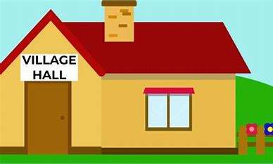
VILLAGE HALL RENOVATIONS The refurbishment project for the village hall is moving forward and a Planning Application has been submitted to Buckinghamshire Council and the committee is currently seeking quotations for the planned works.

FOCUS ONLINE
Did you know that there is an online edition of Focus with every copy from February 2012? So, if you have mislaid your copy and can’t find the information you need, just log onto
https://e-voice.org.uk/ghpc/focus-magazine/

NEXT MEETING OF THE PARISH COUNCIL
The next meeting will be held on Monday 3rd April at 7.30pm in the Village Hall. There is always a public participation period when members of the public can have their say. The Notice of the meeting is advertised on the Great Horwood Facebook page, the Parish Council website and the noticeboard in the High Street. Minutes of meetings can be found on the noticeboard and the Parish Council website e-voice.org.uk/ghpc/
Sue Brazier, Clerk to Great Horwood Parish Council
clerk@greathorwoodpc.org.uk

