PARISH PUMP November 2023
FOOTPATHS
I hope that you all many good use of your Footpaths Map which was included as a loose leaf sheet in the last edition of Focus.

PARISH COUNCILLORS
I am pleased to report that Thomas Lee attended his first meeting as a new Parish Councillor at our October meeting, however Andy Waller has decided that he is not able to devote the time that he would like to his duties as a Parish Councillor and so has resigned from the council. This means that we once again have two vacancies on the council. If you think you might be interested in volunteering to serve your local community in this way please email me and we can arrange to have a chat about the role and see if it is suited to you.
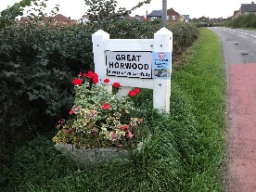
VILLAGE PLANTERS
We have no volunteers come forward in the village to take responsibility for planting and maintaining the 5 planters placed at the entrances to the parish and so we are currently seeking commercial quotations to carry out the work.
FUNDS FOR LOCAL CAUSES
Applications closed for this funding source on 31st October and the decisions on which organisations will receive the money will be made at the parish council meeting on 14th November and payments will be made at the meeting on 12th December.
SPEEDWATCH
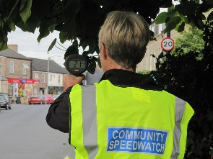
I am still receiving reports of speeding vehicles in the village including along Little Horwood road but unfortunately as I write this I have only had one volunteer come forward to join me in operating the Speedwatch camera. This is the only method that we have for officially recording the speed of vehicles at fixed points in the parish and from which action can be taken by Thames Valley Police with the information that we feedback to them over the internet.
So if you are really concerned about speeding in the village and worried about the dangers to your children and pets there is something you can do about it.
You will need to undertake an online training course and pass the online test at the end of the course. Once up and running the team will monitor speeds of vehicles at certain agreed spots in the parish and report the details direct to Thames Valley Police who will be able to take warning actions against speeding drivers. Cllr. John Gilbey johnwgilbeypc@gmail.com
THE CROWN
The Parish Council has once again contacted Buckinghamshire Council Planning Enforcement and the Heritage function to try to ensure that The Crown (a listed building) is protected from falling into a state of major disrepair.
VILLAGE HALL REFURBISHMENT
The refurbishment of the village hall is now well under way with the process of removing all the asbestos in the hall having already been completed. More than £150,000 is being contributed to the overall cost by the Parish Council with a large part of it coming from the Section 106 agreement for the Neighbourhood Plan development which has been built at East Field and Crabtree Close.
WELCOME PACK
If you are new to the village and have not yet received a Welcome pack please email as shown below with your address and I will drop one off to you.
FOCUS ONLINE
Did you know that there is an online edition of Focus with every copy from February 2012?
So, if you have mislaid your copy and can’t find the information you need, just log onto
https://e-voice.org.uk/ghpc/focus-magazine/

NEXT MEETING OF THE PARISH COUNCIL
The next meeting will be held on Tuesday 14th November at 7.30pm in the Scout Hut (this will be our normal venue whilst the Village Hall is being refurbished.)
There is always a public participation period when members of the public can have their say. The Notice of the meeting is advertised on the Great Horwood Facebook page, the Parish Council website and the noticeboard in the High Street.
Minutes of meetings can be found on the noticeboard and the Parish Council website e-voice.org.uk/ghpc/
Cllr. John Gilbey
Chairman of the Council
johnwgilbeypc@gmail.com

