**PARISH PUMP OCTOBER 2024**

**COUNCILLORS**

As has previously been advised, we currently have 2 vacancies on the Parish Council. If you think you might be interested in volunteering to serve your local community in this way, please get in touch and we can arrange to have a chat about the role and see if it is suited to you johnwgilbeypc@gmail.com

**PARISH COUNCIL “SURGERY”**

As you know, the Parish Council have, for the past few months, set up a drop in point at the Village Hall every 2 weeks. This is held every other Wednesday at 10am when the Village Hall is open for the Post Office/coffee morning. If you are unable to get to the monthly meetings but wish to chat to the Parish Council, this is your opportunity.

Dates for the rest of 2024 are as follows: -

9th and 23rd October

6th and 20th November

4th and 18th December

**FUNDS FOR LOCAL CAUSES**

As in previous years, Great Horwood Parish Council will once again be donating up to £3,000 to local causes. Forms can be obtained from the Parish Clerk, [clerk@greathorwoodpc.org.uk](mailto:clerk@greathorwoodpc.org.uk).

Applicants must be from organisations associated with the village. Winning bids will be announced at the December 2024 Parish Council meeting.

The closing date for applications is 31st October 2024.

**GARDEN TREE GIVEAWAY 2024**

A Garden Tree Giveaway is being run in association with the International Tree Council (ITC). Great Horwood have been invited to join to offer residents to claim 2 free trees. There is a good range of small, medium and large of trees available.

You can view a **tree guide** so you’ll know which are the most suitable trees/shrubs for your garden. Get more information at <https://tinyurl.com/itfcagfreegardentree> or use this QR code.

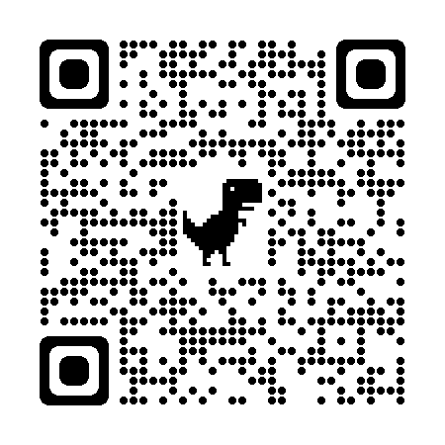

You can request your trees online in early October. The trees will be available for planting in late November/early December.

This giveaway is organised by the International Tree Foundation with financial help from local charities.

If you are interested in this project, please register your interest on the website listed above. Once this initiative is closed (19th October), the Parish Council will receive a list of who has been registered to receive the trees and an email from the ITC to arrange collection will follow.

Details of this are on the GHPC Facebook page and a poster is in the Noticeboard.

**BUCKINGHAMSHIRE LOCAL CYCLING AND WALKING INFRASTRUCTURE PLAN (LCWIP)**

Buckinghamshire Council (Transport Strategy) are having a consultation on the draft Buckinghamshire Local Cycling and Walking Infrastructure Plan (LCWIP). The draft Buckinghamshire LCWIP suggests a future network of new and improved connections for walking, cycling and wheeling between towns and villages across Buckinghamshire. Feedback is now being invited on the draft LCWIP.

The consultation is running until 13th October 2024 and can be accessed at [www.buckinghamshire.gov.uk/LCWIP](http://www.buckinghamshire.gov.uk/LCWIP). The online survey is available at this link, alongside a printable version of the survey, contact email address and information about events taking place.

Details of this are on the GHPC Facebook page and a poster is in the Noticeboard.

**FIX MY STREET**



Just a reminder to everyone that “FixMyStreet” is an online facility where anyone can make a public report for things like graffiti, fly tipping, broken pavings slabs, and potholes that they see in the Village. This information gets passed to Buckinghamshire Council for them to action. The website address is <https://www.fixmystreet.com>

**DOG WASTE**

I am sure that you will have seen the various posts on the Great Horwood Facebook page concerning the amount of dog litter around in the village that is being left and not picked up.

As I am sure we are all aware, not only is this unsightly but it presents a health hazard to everyone.

There are 8 dog waste bins within the village – please remember if you are taking your dog for a walk, please pick up after them and place the waste in the designated bin – thank you.

**LIDEN PARK (CHERRY LEAS)**

It is hoped that over the next few weeks that the Parish Council will take on the responsibility of the Open Space for the above development. It was originally hoped that this would be a play park for the children at this end of the Village, however, the funding for this has changed since the original plan was set up. It would be of great help to the Parish Council if they could receive your views on what you would like this Open Space to look like/what would be of most benefit to the whole village. Please do comment on what you would wish to see in this area. An email to the Clerk with your views on the usual email address would be appreciated – thank you.

**WELCOME PACK**

If you are new to the village and have not yet received a Welcome pack, please email Cllr Gilbey with your address and one will be delivered to you johnwgilbeypc@gmail.com

**FOCUS ONLINE**

Did you know that there is an online edition of Focus. If you have mislaid your copy and can’t find the information you need – just log onto the Parish Council website.

<https://e-voice.org.uk/ghpc/focus-magazine/>

**NEXT MEETING OF THE PARISH COUNCIL**

The next meeting will be held on Monday 14th October 2024 at 7.30pm in the Village Hall.

There is always a public participation period when members of the public can have their say – please feel free to attend. The Notice of the meeting is advertised on the Parish Council website and the noticeboard in the High Street.

Minutes of meetings can be found on the noticeboard and the Parish Council website.

e-voice.org.uk/ghpc/