PARISH PUMP May 2024

PARISH COUNCILLORS
We have two vacancies on the Council. If you think you might be interested in volunteering to serve your local community in this way, please email and we can arrange to have a chat about the role and see if it is suited to you johnwgilbeypc@gmail.com

FACEBOOK PAGE
The Parish Council have now decided to have their own page on the social media platform, Facebook. It is simply called Great Horwood Parish Council. If you are familiar with this platform, could you please like the page? Going forward we will be posting more information about various things that residents might be interested/get involved in.

LITTER PICK
The annual Litter Pick took place on 17th March 2024, which although started off very damp (with an occasional short rain burst), we had a great turn out from the Scouts, Cubs and Beavers. Those helping included a few residents of the village and two Parish Councillors - a large amount of rubbish has been cleared from the streets and ditches of the Village.

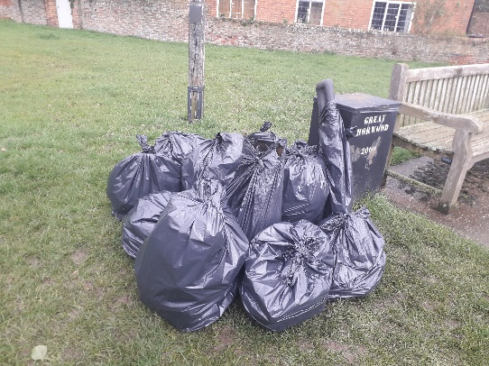

FIX MY STREET
Just a reminder to everyone that “FixMyStreet” is an online facility where anyone can make a public report for things like graffiti, fly tipping, broken pavings slabs, and potholes that they see in the Village. This information gets passed to Buckinghamshire Council for them to action. The website address is https://www.fixmystreet.com

DOG WASTE
Another reminder that if you are taking your dog(s) for a walk in the village please remember to pick up after them. With the warmer weather on its way more people will be out and about in the various green spaces in the village - please remember to pick up as you go. Thank you.

THE CROWN
Ongoing discussions between the Parish Council and Buckinghamshire Council and further updates will be given when they become available. Don’t forget to check the minutes of the Parish Council meetings to see the latest information.

WELCOME PACK
If you are new to the village and have not yet received a Welcome pack, please email Cllr Gilbey with your address and one will be delivered to you johnwgilbeypc@gmail.com

FOCUS ONLINE
Did you know that there is an online edition of Focus. If you have mislaid your copy and can’t find the information you need – just log onto the Parish Council website.
https://e-voice.org.uk/ghpc/focus-magazine/

INFORMATION SHARING GROUP
This is a good way of communicating useful information to villagers. If you would like to receive information first hand, such as Thames Valley Police info, roadworks updates and other ad hoc information, please contact Sarah Biswell on clerk@greathorwoodpc.org.uk if you are interested and you can be added to the email group.

NEXT MEETING OF THE PARISH COUNCIL
The next meeting will be held on Monday 13th May 2024 at 7.30pm in the Village Hall.
There is always a public participation period when members of the public can have their say – please feel free to attend. The Notice of the meeting is advertised on the Parish Council website and the noticeboard in the High Street.
Minutes of meetings can be found on the noticeboard and the Parish Council website.
e-voice.org.uk/ghpc/

