 | Great Horwood Parish Council
 | Minutes of the Ordinary Parish Council Meeting held on 11 September 2023 at 7.30pm in the Village Hall, Great Horwood

Present: Cllr John Gilbey (JWG) Chairman, Cllr Caroline Cousin (CC) Vice Chairman, Cllr Andy Waller (AW), Cllr Jonathan Evans (JE), Cllr Jackie Goss (JG), Bucks Cllr John Chilver, Mandy Cliffe (MC), Sarah Biswell (SB Clerk) and eight members of the public.

Please note, to comply with Data Protection rules, names (other than councillors or persons who have previously given their permission) will not be used in Great Horwood Parish Council Minutes.

To receive apologies for absence
Bucks Councillor Sir Beville Stanier Bt., Thomas Lee
Resolution to co-opt Thomas Lee as a Parish Councillor
JWG proposed to co-opt Thomas Lee. CC seconded. The Parish Council resolved to co-opt Thomas Lee onto the Parish Council.
To receive declarations of interest
AW – Items 7 & 19
Confirmation of the Minutes of the Parish Council meeting held on 10th July 2023
The minutes were agreed as a true record and were signed by JWG at the meeting.
To consider matters arising from the Minutes of the last meeting

The issue of Hemlock near the Cricket Club was discussed, it seems that this has now died down for this year, which appears to have alleviated the problem for the time being. but could come back next year, will need to revisit this area.

The abandoned car on the Nash Road is still in situ and is due to be inspected tomorrow by BCC (12th September 2023) and its removal will take place next week.

Nash Road development. The vision swathe to the north of the site is partly obscured by greenery which makes it difficult to see oncoming traffic when leaving the site. JWG wrote to the landowner again but the response was not positive. It was agreed that we would leave the matter until Lodge Park Homes have completed their S278 works, which will include clearing the vision swathe, and see if any more action was needed then.

Public Participation Period

One resident advised the Parish Council that a villager had posted on social media (comments and a picture) about a lake in Great Horwood and caused a lot of people to ask where this location was. The PC were advised that this was NOT open to the public, it is on private land. No disclosure of where this is was mentioned at the meeting. It was agreed something could be put in the Focus magazine showing where the public footpaths are in the village (Action Cllr Gilbey).

Another individual asked if any further action was taken with the resident who had been shouting at individuals from their garden and seen to be harassing walkers on a public footpath by declaring it was private property. The footpath in question connects the bottom of Spring Lane (near the Pece) to the Winslow Rd. Walkers were moving across the last field, adjacent to 21 Winslow Rd, when this interaction took place. They were advised that the footpath goes around the perimeter of the field, which is not the case. There has been no permission sought to change this. Cllr Gilbey has walked this route with the Footpath Monitor and has not reported seeing anyone.

Report from Buckinghamshire Councillors
Suggested topics:

- Update on Nook Park
Cllr Chilver reiterated the points in the email that had been circulated to the residents of Nook Park and copied in JWG and all Councillors. This has been on the instructions of Martin Tett.

AW was asked if there was any additional information that Cllr Chilver could take back to Buckinghamshire Council.
CC asked if it was possible to get a copy of the current planning approvals that are in place as they are not on the Bucks Website
Cllr Chilver agreed to take these questions back and will feedback to the Parish Council in due course.

- New Sports Centre in Winslow

There are consultations/discussions/plans to develop the previous site of the Sir Thomas Freemantle School – the Department of Education need to “deregister” this site as a School, this is in hand. The new development will include part housing, part care home, new library and community facilities.
There are plans for a new sporting space by the A413 which would include pitches for football, rugby and a potential MUGA. A full planning application is due to be submitted in Spring 2024 when more detail will be available.

Horwode Pece Management Committee Report

The report from the Horwode Pece Management Committee is attached to and forms part of these minutes. The Parish Council acknowledged the monitoring that had been ongoing. CC asked that the budget for next year be requested for consideration at the next PC meeting. Clerk to email the Management committee to ask for this. (Action: Clerk)

Footpaths Report

No report received.

A request for around £250.00 was put forward for gravel to put in the very muddy gateway and an additional handrail on the bridge to improve the footpath No 2 adjacent to Bywater Meadow.

It was resolved to approve the funding but CC questioned whether a second hand rail was needed. In addition only one post could be on Bywater Meadows and the other would have to be on land belonging to another landowner, whose permission would be needed.

JWG would take this matter up with the Footpath Monitor. (Action: Cllr Gilbey)

Roads Report

No Report received.
JWG reiterated the issue in August 2023 with the work undertaken on the A421 and the impact this had on the village at the time. However, the work by Anglian Water was completed quicker than proposed and the A421 was opened earlier meaning there was less traffic using Great Horwood as a diversion.

Parish Maintenance

The installation of 2 additional dog refuse bins has been ongoing for some time. JWG has now been advised that Buckinghamshire Council no longer use a viable contractor for this service so the timescale for this installation is currently outstanding.

JWG advised that the Parishioner who maintained the planters round the village has now moved away from the area and a new person is needed to take this on. It is understood that this item is on the agenda for the upcoming WI Meeting to ask for a possible volunteer. CC suggested that this be put in the next issue of Focus (Parish Pump) as well. (Action: Cllr Gilbey)
12. | Planning Report  CC advised that since the last meeting 9 applications had been determined and 1 withdrawn after negative comments from Heritage.  Nash Park had an appeal allowed in July to increase the number of pitches from 11 to 12. As a result of that appeal two further applications were allowed. They were 21/03776/APP, which allowed second static homes on 4 of the pitches and 23/01384APP which allowed the land earmarked as amenity space to be used as a pitch.  CC also noted that the outline application for 3 houses off the Little Horwood Road had been refused as it contravened the Great Horwood Neighbourhood Plan.
13. | Issues arising from the Planning Report  CC reminded Councillors that she had commented at the July meeting that the planning application for the 4 houses on the site of the former garage had been approved, but that a condition of the approval was that Building Regulation Part M(4)2 should be applied. This would mean that all four houses, including the three small terraced houses, would have to be built to a Lifetimes Homes standard.  The PC had subsequently been consulted on an application by the developer to have this condition removed.  CC had contacted Bucks Planning to see if it was now policy to apply this condition to all new dwellings, and the reply was that it was.  Given that, the Parish Council cannot influence the decision, they followed the policy and objected to the application.
14. | Other Planning Matters  The Crown  It was noted that the matter had been raised with Bucks Heritage department previously that the Parish Council were concerned that this building should be on the buildings at risk register if no further work is being undertaken. Nothing further has been heard so it was agreed that this item be chased up on progress. An update from Heritage will be sought (Action: Clerk)  CC said that the outstanding planning application included putting rooflights in the roof. Heritage had responded that if the roof is to be used as a habitable space a new planning application would be required. If it is purely a storage facility, then no rooflights would be allowed. The application does not appear to have progressed beyond this.  Nash Road Site  JWG commented that it was a condition of the Planning permission that no houses were to be occupied until the road crossing had been constructed in accordance with the S278 plans, yet nearly all the houses were now occupied.  CC commented that Lodge Park Homes were aware of this. She suggested that as Buckinghamshire Council had taken an inordinately long time to approve the S278 plan they simply could not afford to have their money tied up in unsold houses as a result of the Council’s very slow response.  The S278 plans have finally been approved, and Lodge Park Homes are now instructing their Groundworks team to complete the site works. CC commented that the front of the development looked untidy and currently the fencing is incomplete.  CC reported that she had spoken to Roger Jefcoate and he has agreed to plant some Black Poplar trees in the amenity space once it is seeded.  Shenley Park SPD Consultation  CC attended the consultation. The proposed number of new houses in Shenley Park were quoted as 1150. On the new estate being built in Tattenhoe they are building 1300 with 1900 being put in place in Newton Longville.  The A421  There will be a meeting at the Swan pool building in Buckingham on 12 September to consult on improving the A421. This could have significant implications for not only Castlefields North of the A421 but also for the Cricket Club. CC will attend this meeting. (Action Cllr Cousin)
15. | Earmarked Reserves.  It was proposed to increase the earmarked reserve for the Village Hall refurbishment to £42,000 with the expectation that the Council Reserves would be replenished with the additional £22k as soon as the funds are received from the Solar Farm.  CC presented a revised Earmarked Reserves policy document, and the Parish Council resolved to accept the revised document.
16. | Report from the MVAS and Speedwatch  No information was available at the time of the meeting on the MVAS. This is to follow shortly.  JWG confirmed that he has been liaising with Thames Valley Policy and that the Great Horwood Speedwatch has now been set up. JWG has undertaken and passed the training along with one other volunteer. In order for this to be a viable venture it needs further volunteers to come forward, and this has been encouraged by the Parish Council. Several people have previously come forward but not yet signed up and taken the training – this needs to be followed up (Action; Clerk)  One new volunteer has written to the Parish Council today and Cllr Gilbey will be following this up (Action: Cllr Gilbey).  Sites have to be defined as the most acceptable within the village with the first one due to be in place on the grass in front of The Close entrance. This equipment needs to be linked up and JWG asked Mandy Cliffe (Clerk for Little Horwood Parish Council) if she could pass the equipment back to Great Horwood (Action: Clerk)
17. | Winslow and Villages Community Board  £15,000 is being sought from the Winslow and Villages Community Board to assist with the funding of a disabled toilet as part of the refurbishment of the Village Hall. CC reported that the work is due to start on 25th September 2023. Potential completion date is 2nd February, but this is subject to change. A new kitchen and fittings have been gifted to the Village Hall by IKEA. CC confirmed that the Post Office which visits once a week will not be available during this time.
18. | To receive a report from any meetings attended  18 July – CC – Planning Services update  19 July – CC - Community Board Meeting  21 July – CC – Village Hall Meeting  25 August – CC – Village Hall Meeting  6 September – CC & JWG – meeting with Contractor for Village Hall  6 September – CC – Shenley Park SPD Consultation
19. | Report on Developments at Nook Park  Update from AW  The site owner must put back one pitch that has been altered – and has been given 21 days to do so.
19. | Update on Fox Covert Solar Farm Ltd  JWG has been in touch with the company developing the solar farm who are hoping to get this energised by the end of September 2023 and payment to the Parish Council should follows shortly after. This is when, the Parish Council understand, that the first energy will be delivered to the Grid.
20. | Worthy Causes  This has been published in the latest Focus magazine. Chase up all previous applicants to see if they wish to put in an application this year (Action: Clerk)
22. | Update on EV Charging Points  CC reported that an email had been received from Buckinghamshire Council – they have chosen a framework and are currently going through the T&C’s. They have prepared a business case and the bid for funding which is hopefully submitted by them at the end of November 2023. They will be sending out letters shortly to the Parish Council explaining what is required to give permission for work to be undertaken by Distribution Network Operators who supply the electricity to the site and the ChargePoint installer/operator. Installation in Great Horwood is set for April 2024 “but this is by no means set in stone”.
23. | To receive and note correspondence  Nothing to report.
24. | Finance  a). To review the bank reconciliation  b). To agree payments that require authorising and note funds received  It was resolved to carry out the payments as indicated on the schedule.  c). RFO to present statement of receipts and payments to date under each budget heading  It was resolved to receive the statement of payments to date.
  Great Horwood Parish Council Receipts and Payments 11th September 2023 (as at 6th September 2023)
  Payments TA | Payee | Type | Payment £ | VAT | Ledger £ | Date Paid/Recd | Notes
  Balance B/F | 10 July 2023 |  |  |  | 4092.20
  Payments TA
  GH 23.029 | nPower Rererence: A0009233279001 | DD | 43.80 |  |  | 26/07/2023 | Streetlighting  power
  GH 23.030 | nPower Rererence: A0009233279001 | DD | 44.65 |  |  | 24/08/2023 | Streetlighting  power
  GH 23.031 | Walker Grounds Care inv. 719 | FPO | 585.50 |  |  | 27/08/2023 | Devolution Grass Cutting
  GH 23.032 | Barclaycard Dropbox renewal | DD | 95.88 |  |  | 31/07/2023 | Dropbox
  GH 23.033 | Barclaycard 123 email acct renewal | DD | 100.66 |  |  | 13/07/2023 | 123 Reg
  GH 23.034 | Walker Grounds Care inv. 727 | FPO | 585.50 |  |  | 01/09/2023 | Devolution Grass Cutting
  GH 23.035 | Harlequin Focus printing September 2023 | FPO | 367.00 |  |  | 30/08/2023 | Other
   | Subtotal / Ledger balance Treasurer's account |  | 1822.99 |  | 2269.21
   | Actual expenditure minus transfers |  | 1822.49
  Receipts TA
  GHR 23.06 | Remittance | BGC | 61.55 |  |  | 11/08/2023
   | Ledger balance Treasurer's account |  |  |  | 2330.76
  Reconciliation Bank to Ledger 6th September 2023 Treasurer's Acct |  |  |  | 3283.26
  Add outstanding receipts |  |  |  | 0.00
  Minus September 2023 unpaid invoices payments |  |  |  | -952.50
  Ledger Total |  |  |  | 2330.76
  Horwode Pece B/F |  |  |  |  | 7,975.43
  Payments HP
  HP 23.06 | Walker Grounds Care inv. 720 | FPO | 150.00 |  | 7,825.43
  HP 23.07 | Walker Grounds Care inv. 721 | FPO | 150.00 |  | 7,675.43
  Sub Total |  |  | 300.00 |  | 7,675.43
  Receipts HP | Nil
   | Total / Ledger balance Horwode Pece Acct |  |  |  | 7675.43
   | Nil |  | 0.00
  Business Instant Access B/F |  |  |  |  | 54811.36
  Receipts BIA
   | Jul interest |  | 40.38 |  | 54851.74
   | Aug interest |  | 0.00 |  | 54851.74
   | Sep interest |  | 0.00 |  | 54851.74
   | Total in BIA account |  | 40.38 |  | 54851.74
25. | Items for the next meeting  Handover from Mandy Cliffe to Sarah Biswell  Worthy Causes  Finance – bank mandate changed to allow clerk access to accounts.  Horwode Pece Budgetary figures for 24/25 to be considered and agreed  Review Clerk’s contract of employment
25. | Confirmation of date and time of the next meeting  Tuesday 10th October 2023 in the Scout Hut

The meeting closed at 8.42pm.

After the meeting closed Cllr Gilbey advised that a token of appreciation (in the form of a small gift) was to be given to John Nicholls on behalf of the Parish Council for his assistance in securing the two new seating benches in the new playpark on Little Horwood Road.

Signed Date 10th October 2023

Chairman

Horwode Pece Management Committee - Report to Parish Council
September 2023

Back in July, I reported that the Rec. looked in good condition. We had recently received the RoSPA report and this had confirmed the general good state of the equipment and that all the equipment was safe, offering acceptable risk commensurate with adventurous play.

At the beginning of August, Mike Hotard offered to dispose of a wasp nest located just past the corner of the fencing towards the top of the field. I would like to thank Mike for doing this and can report that all is now safe in this respect. Then, later in August, part of the old willow tree blew down and landed across the Toddler area. Luckily is did not do any damage, narrowly missing the Navigator piece of equipment, but now it blocked our footpath access for to the Rec (see picture).

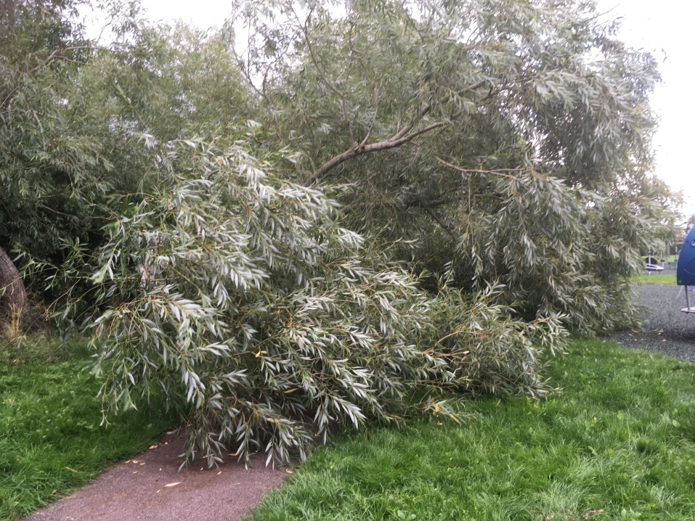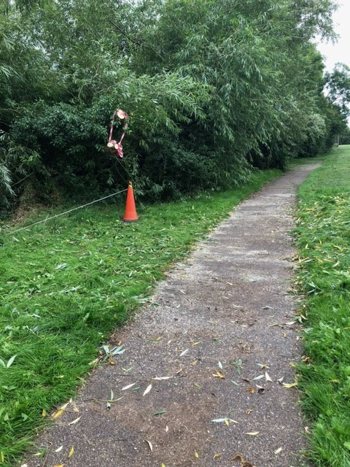

We looked for someone to remove this fallen part of the willow tree, to open up access. Rick Bond volunteered, saving us the cost of a professional tree surgeon. Many thanks, Rick, for your hard work. The results are outstanding, as can be seen in the second attached photograph.

Otherwise, the Rec. is in good condition, bar minor work and repairs, such as ‘cleaning bird poo of the swing seats’, ‘rebonding’ the underlay where it has been kicked up and exposed’. But, such is the on-going tasks of keeping the Rec. in good condition. My thanks, to our regular team of Rec. checkers for this valuable work.

I have noticed, over the summer, some items of minor malicious damage; where caps have been removed from bolts securing equipment. New caps have to be purchased to make good these repairs. These items are not being safety critical and will be rectified at the next working party.

In summary, jobs outstanding for the Autumn working party.

- The underlay inside the SuperNova roundabout is torn in places and will need rebonding.
- Two of the timbers on the far goal are rotting and will need replacing; all the timbers for both goals should be treated against rot. Some screws need replacing on the near goal.
- The wood surrounds of both toddler and teenage need to be replaced. This is the major work activity this Autumn.
- The seat and table to the far S.E. corner is in poor condition and should be removed. It could be replaced if funds permit, but the donated VW/Audi bench now provides good seating at the top of the Rec.

Lastly, I must express my thanks to the work of Jane Holland. She was a long-standing member of the Rec. management committee, regularly looking after the planted areas, with her ambition to naturalise parts of the Rec. with meadow flowers, in the more shady areas that are not used for play. She has now moved home to Lincolnshire and we have space on the Rec. committee for new enthusiastic members, who think the Rec. is a great asset to our village and would like to help maintain it.

John Nicholls - Chairman
10/09/2023
Planning Committee Report - for meeting on 11 September 2023 (as at 11 Sept 2023)
Below are current and recent Planning Applications. The Parish Council is invited to ratify the comments made to Buckinghamshire Council on behalf of the Planning Committee since the last meeting.
CURRENT PLANNING APPLICATIONS
Date Received |  | Application Number |  | Applicant |  |  | Site Address |  | Details of Application |  | Parish Council Response |  | BC Decision
Determined
23/09/2021 | 21/03776/APP  Karen Fossett  21/10/2021 |  |  |  | Messrs Corcoran, Cawley and Nevin |  | Plots 2,4,6 & 7 Nash Park, Nash Road, Great Horwood  MK17 0PD |  | Change of use of land to use as a residential gypsy and traveller site, including an increase in the number of caravans to a total of 15 of which no more than 8 shall be static caravans/mobile homes occupied for residential purposes, together with retention of existing ancillary building |  | Objection |  | Approved  24/8/23
14/10/2022 | 22/03413/APP  Emma Mumby  11/11/2022 |  |  |  | Mrs & Mrs H Elliott |  | 28 Spring Lane,  Great Horwood  MK17 0QW |  | Demolition of the existing dwelling and the erection of a detached dwelling with access, parking and amenity space |  | No objection |  | Approved  14/7/23
4/5/23 | 23/01384/APP  31/5/23 |  |  |  | J Cawley |  | Nash Park  MK17 0FD |  | Change of use of amenity space to 2 pitch site |  | Object |  | Approved  22/08/23
5/5/23 | 23/01432/APP  Naim Poptami  2/6/23 |  |  |  | J B Pro Ltd |  | Old Dean Farmhouse Singleborough Lane MK17 0RF |  | Householder application for demolition of rear sheds and erection of rear extensions |  | No objection |  | Approved 3/8/23
16/5/23 | 23/01530/APP  13/6/23 |  |  |  | Stuart Parker |  | Paddock View, 15c Litle Horwood Road  MK17 0RA |  | Householder application for first floor side extension |  | No objection |  | Withdrawn  11/7/23
6/6/23 | 23/01698/APP  Naim Poptami  3/7/23 |  |  |  | Mr & Mrs I Wilson |  | The Cottage Singleborough Lane Singleborough Great Horwood Buckinghamshire MK17 0QY |  | Householder application for construction of carport, alteration/reconfiguration of hard and soft landscaped areas, including French drains |  | No objection |  | Approved  10/8/23
16/6/23 | 23/01775/AGN  Shelley Ghazi  26/6/23 |  |  |  | Mr I Watts |  | Land South Of Little Horwood Road Great Horwood Milton Keynes MK17 0FT |  | Erection of agricultural building |  | No objection |  | Approved  7/7/23
13/6/23 | 23/01783/VRC  11/7/23 |  |  |  | James Gunn |  | 4 Little Horwood Road  MK17 0QE |  | Variation of condition 2 (Approved Plans) attached to planning planning permission 22/03926/APP |  | No Objection |  | Approved  9/8/23
14/6/23 | 23/01810/APP  Naim Poptami  12/7/23 |  |  |  | Mr & Mrs Daymond |  | 2 High St MK17 0QL |  | Householder application for replacement of windows and doors |  | No Objection |  | Approved 3/8/23
19/6/23 | 23/01844/AOP  Tom Ansell  17/7/23 |  |  |  | Mr P West |  | Land off Little Horwood Read |  | Outline application for a residential development to provide up to 3 dwellings and access only onto Little Horwood Road, & all other matters reserved |  | Object |  | Refused  11/8/23 | 19/6/23
05/02/2020 | 20/00409/APP  Alice Culver  05/03/2020 |  |  |  | Ms M McCarthy |  | Land off Little Horwood Road, Nash MK17 0EJ |  | Variation of condition 2 – change condition to permanent planning permission/consent relating to application 14/00107/APP (allowed on appeal) |  | Objection |  | Awaiting decision
01/09/2020 | 20/02755/APP  Philippa Jarvis  08/02/2023 |  |  |  | Mr T Reilly c/o Agent Ruston Planning Ltd |  | Land at Nash Park, Nash Road, Great Horwood, Bucks |  | Change of use of land to 6 Gypsy/traveller pitches with associated works including 6 no. mobiles homes, 6 no. touring caravans, 6 no. day rooms and 6 no. cesspits incorporating detailed landscape scheme. |  | Objection |  | Awaiting decision
21/01/2021 | 21/00221/APP  Kirsty Elliott  18/02/2021 |  |  |  | J Hanson & Son |  | Home Farm, 4 Winslow Road, Great Horwood MK17 0QN |  | Erection of 16 new residential dwellings and the refurbishment and extension of the existing farmhouse, with associated access landscape and parking |  | Objection |  | Awaiting decision
21/01/2021 | 21/00222/ALB  Kirsty Elliott  18/02/2021 |  |  |  | J Hanson & Son |  | Home Farm, 4 Winslow Road, Great Horwood MK17 0QN |  | Erection of 16 new residential dwellings and the refurbishment and extension of the existing farmhouse, with associated access landscape and parking |  | Objection |  | Awaiting decision
07/06/2022 | 22/01776/APP  Catherine Dickson  05/07/2022 |  |  |  | Ms S Isseyegh |  | The Farmhouse,  Fair Winter Farm, Singleborough Lane, Singleborough, Great Horwood MK17 0RB |  | Erection of a replacement dwelling together with associated development |  | No objection |  | Awaiting decision
09/08/2022 | 22/02490/APP  Emma Mumby  06/09/2022 |  |  |  | Mr F Engel |  | The Crown Public House, 1 The Green, Great Horwood  MK17 0RH |  | Householder application for the erection of a single storey rear glazed link extension, reinstatement of window of the front elevation, reinstatement of the attic timber casement window in the northern gable and the insertion of two conservation rooflights to the west facing roof slope. |  | Objection |  | Awaiting decision
09/08/2022 | 22/02491/ALB  Emma Mumby  06/09/2022 |  |  |  | Mr F Engel |  | The Crown Public House, 1 The Green,  Great Horwood  MK17 0RH |  | Listed building application for the erection of a single storey rear glazed link extension, reinstatement of window of the front elevation, reinstatement of the attic timber casement window in the northern gable and the insertion of two conservation rooflights to the west facing roof slope. Internal alterations to include removal of partitions and alterations to internal layout, installation of staircase, ensuite at first floor level and new fixture and fittings. |  | Objection |  | Awaiting decision
07/09/2022 | 22/03046/APP  Kerby MacInnis  05/10/2022 |  |  |  | Mr D Grainge |  | Eastfield Farm,  Little Horwood Road,  Great Horwood  MK17 0NZ |  | Construction of bund |  | No objection |  | Awaiting decision
01/11/2022 | 22/03218/APP  Emma Mumby  29/11/2022 |  |  |  | Mr O Negrea  Sub Blue Ltd  Grange Park  Northampton |  | Land to rear of Vine Cottage, 3 Little Horwood Road, Great Horwood MK17 0QE |  | Erection of 3 dwellings |  | No objection |  | Awaiting decision
1/8/23 | 23/02296/APP  Naim Poptani  29/8/23 |  |  |  | J B Pro Ltd |  | Old Dean Farmhouse Singleborough Lane Singleborough Great Horwood  Buckinghamshire MK17 0RF |  | Householder application for replacement windows |  | No objection |  | Awaiting decision
4/8/23 | 23/02342/APP  Faye Hudson  1/9/23 |  |  |  | Miss J Taylor |  | Land Off Singleborough Lane Singleborough Great Horwood  Buckinghamshire |  | Proposed alterations to existing menage, welfare accommodation and replacement stables (amendment to approval 22/02042/APP) |  | No objection |  | Awaiting decision
11/8/23 | 23/02417/VRC  Kerby MacInnis  8/9/23 |  |  |  | Ian Sutton |  | Great Horwood Service Station High Street Great Horwood Buckinghamshire  MK17 0QL |  | Removal of Condition 20 (fitted to comply with building regulations) relating to  application 22/02114/APP (Demolition of existing service station buildings and  erection of 4 dwellings) |  | Objection |  | Awaiting decision
21/8/23 | 23/02484/APP  18/9/23 |  |  |  | Mr and Mrs A Barratt |  | Croft Farm 33 Nash Road Great Horwood Buckinghamshire MK17 0RA |  | Change of use of section of paddock to garden land |  | No objection |  | Awaiting decision
6/9/23 | 23/02678/APP  4/10/23 |  |  |  | Ms S Isseyegh |  | Fair Winter Farm Singleborough Lane Singleborough Great Horwood  Buckinghamshire MK17 0RB |  | Construction of a welfare and handling facility building |  | No Objection |  | Awaiting decision

Key –
Colours
Green = applications determined since last report
Orange = applications received in 2020
Light blue = applications received in 2021
Yellow = applications received in 2022
Pink = applications received in 2023
Names are those of the AVDC application case officer
Dates are when the application was received (column 1) and by when comments must be made (column 2).

