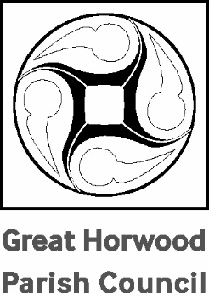

Great Horwood Parish Council
Annual Parish Meeting

TO BE HELD IN THE GREAT HORWOOD AND SINGLEBOROUGH VILLAGE HALL ON MONDAY 28TH APRIL 2025

AGENDA

- Apologies for absence

- Approval of the Minutes of the 2024 APM held on 29th April 2024

- Chairman’s Report – Cllr. John Gilbey

- Report from Bucks Councillor John Chilver

- Report from Bucks Councillor Sir. Beville Stanier

- Brief reports from village organisations – in no particular order: Football Club, Rainbows, Brownies, Scouts and Guides, WI, Winslow and District Community Bus, St James Church, Focus, Great Horwood School, Arts and Craft Club, Horwode Pece, Silver Band, Cricket Club.

- Open Forum

John Gilbey
Chairman of Great Horwood Parish Council 22nd April 2025

