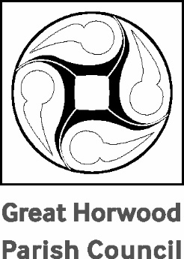

**Great Horwood**

**Annual Parish Meeting**

Monday 29th April at 7.30pm IN THE VILLAGE HALL

**AGENDA**

1. Apologies for absence.
2. Approval of the Minutes of the 2023 APM held on 17th April 2023.
3. Chairman’s Report – Cllr. John Gilbey.
4. Brief reports from village organisations – in no particular order: Football Club, Scouts & Guides, WI, Village Hall, St James’ Church, Focus, Winslow Bus, Great Horwood School, Horwode Pece, Silver Band, Cricket Club.
5. Open forum.

John Gilbey

Chairman of Great Horwood Parish Council 23th April 2024