Great Horwood Parish Council
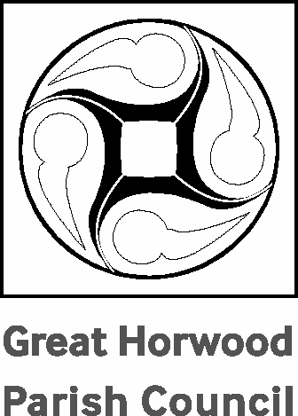

ORDINARY PARISH COUNCIL MEETING
Summons to all Members of Great Horwood Parish Council
You are required to attend the Annual Meeting of the Parish Council on Monday 10th June 2024 commencing at 7.30 pm.

Date: 4th June 2024
AGENDA

1. | To receive apologies for absence
2. | To receive declarations of interest
3. | Confirmation of the Minutes of the Parish Council meeting held on 13th May 2024
4. | To consider matters arising from the Minutes of the last meeting (not otherwise included in the agenda)
5. | Public participation period
6. | Report from Buckinghamshire Councillors
7. | Horwode Pece Management Committee Report  To receive the Management Committee Report
8. | Footpaths Report  To receive the Footpaths Report.
9. | Roads Report
10. | Parish maintenance
11. | Planning Report  To receive and note the Planning Report.
12. | Issues arising from the Planning Report
13. | Other Planning Matters  The Crown – update  Nash Road – update
14. | Report from the MVAS and Speedwatch
15. | Winslow and Villages Community Board
16. | To receive a report from any meetings attended
17. | Unity Trust Bank – update
18. | Report on developments at Nook Park – update from appeal/ongoing actions
19. | Update on EV charging points
20. | To receive and note correspondence.
21. | Finance.  - To approve schedule of payments requiring authorisation  - RFO to present statement of receipts and payments to date under each head of budget  - AGAR – including Governance Statement to be presented to Council for formal approval 2023/2024  - Presentation of the Annual Return by RFO  - Written report of internal auditor  - Review of Financial Regulations document  - To approve transfer of underspend from 2023/2024 Budget to Reserves Account  - To approve the setting up of 2 new UTB Savings Accounts – Shorts Field and Liden Park
22. | Items for the next meeting  To approve schedule of payments requiring authorisation  Worthy Causes for 2024
23. | Confirmation of date and time of the next meeting  Monday 8th July 2024 at 7.30pm in the Village Hall

Signed 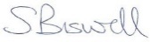
Sarah Biswell - Clerk to the Council

