 | Great Horwood Parish Council
 | DRAFT
 | Minutes of the Ordinary Parish Council Meeting held on Monday 13th October 2025 at 7.30pm in the Great Horwood and Singleborough Village Hall, Great Horwood

Present: Cllr Caroline Cousin (CC) Chairman, Cllr Thomas Lee (TL) Vice Chairman, Cllr Jonathan Evans (JJ), Cllr Jackie Goss (JG), Cllr Mary Saunders (MS), Sarah Biswell (SB) Clerk, and 5 members of the public.

Please note, to comply with Data Protection rules, names (other than councillors or persons who have previously given their permission) will not be used in Great Horwood Parish Council Minutes.

1. | To receive apologies for absence  None
2. | To receive declarations of interest  None.
3. | Confirmation of the Minutes of the Parish Council meeting held on 11th August 2025  The minutes were agreed as a true record and were signed and initialled by Cllr Cousin at the meeting.
4. | To consider matters arising from the Minutes of the last meeting (not otherwise included in the Agenda)  Path kerbstones to be put in place in front of residence in Spring Lane by BC (Clerk to continue to monitor with the LAT).  Cityfibre to reseed following infrastructure installation (Clerk to continue to monitor).  The Give Way sign in Singleborough has now been fixed but the 30mph sign in Little Horwood Road is still in the verge, this has been reported – (Clerk to continue to monitor).  3 Oak Saplings situated on Little Horwood Road – 2 have been removed – Cllr Goss volunteered to look into the remaining one for its removal and replanting (Action: Cllr Goss).  Lamp Post on Nash Road has been repaired – as this belongs to the Parish Council an insurance claim has been submitted to the Insurers (Clerk to monitor and feedback on the claim).  The Clerk contacted the owner of the field where the MVAS point is – referred to Cllr Goss to get in touch to with them to clear the overgrown hedge to allow the MVAS point to be put in place down Winslow Road (Cllr Goss).  Document outlining the uses of The Green has been distributed – matter resolved.  Revised Salary set up for Clerk has been actioned – matter resolved.
5 | Public Participation Period  A member of the public raised the matter of a complaint received by a third party regarding a breach of the allotment agreement. The matter was resolved and the complainant will be informed. It was agreed that a sign previously installed by the Parish Council will be taken down.
6. | Report from Buckinghamshire Councillor – John Chilver  No report was received prior to the meeting.
7. | Horwode Pece Management Committee Report  Report received.  The Chairman of the HP Committee will liaise with the Parish Clerk concerning the matter of a damaged Parallel bar at Horwode Pece - to put together an email to submit to the grass cutting contractor for comment/recompense for damage incurred.  The rubber chippings invoice is still outstanding for the Parish Clerk to order for further works to be  undertaken. The Chairman of the HP Committee is aware of this.
8. | Footpaths Report  Email from the Footpath Monitor received prior to the meeting.  Cllr Evans will contact the Footpath Monitor to discuss the North Bucks Way questions raised in that email. (Action: Cllr Evans).
9. | Parish Maintenance  Nothing to report in this section that is not contained in the main Agenda.
10. | Planning Report  Report received.
11. | Issues arising from the Planning Report  There have been 5 applications determined and 2 withdrawn.
12 | Neighbourhood Plan  The Consultation was issued as planned and the consultation closed 13.10.2025.  Responses received 48 online to date and around 23 on paper by 23/9.  Next steps are to upload paper responses on line and then analyse all the responses.  Call for sites  10 sites received. They include the Weston Road site and also a slightly slimmed down Croudace (50-70). Steering Group to advise Buckinghamshire Council of findings by deadline of 29 October 2025.  The next step will be site assessment.  Contract for support  5 invitations to tender were issued and two tenders received. They were assessed by the Chairman and Secretary of the Neighbourhood Plan Steering Group (NPSG) and they recommended that ONH's tender be accepted. This was accepted at the NPSG meeting on 23 September, and it was agreed that a recommendation should be made to the Parish Council that ONH's tender be accepted. The Parish Council resolved to accept this recommendation.  Additional funding may be required at later stages and it was resolved to close down the Horwode Pece earmarked reserves and add it to the NP earmarked reserve.  Contract award and tender refusal documents will be issued this week by the Parish Clerk. (Action: Clerk to issue contract award and tender refusal letter).
13. | Draft Local Plan – Buckinghamshire Council  The Buckinghamshire Local Plan Regulation 18 Consultation Is underway with a closing date of 29 October. Cllr Cousin urged all Councillors to respond as this will be the only opportunity to make input.  Buckinghamshire Council are legally required to comply with the Statement of Community Involvement. Their plan not to consult on the final draft Local Plan was contrary to that, so at the Cabinet meeting of 9 September 2025 they amended it to remove the commitment to consult on the Plan in its entirety. It was hoped that there would be “focused consultation” prior to publication - The deadline is 29 October 2025.
14. | Website and email  Update  4 companies were considered on site content, storage, email and cost. Example of other parish websites already set up were provided to show the difference between the 4 companies.  Decision  Further information was required on website storage and content transfer (Action: Clerk to investigate and advise)  Next Steps  Clerk to report back at next meeting with above information to enable PC to make a decision as to the chosen website provider. (Action: Clerk)  Assessment of the Eyelid proposal (Action: Cllr Cousin).
15. | Report from the MVAS  Report received and discussed. Report uploaded to Dropbox.  The MVAS continued to monitor traffic in Singleborough in August and September. The maximum speed recorded for the two months was 60 mph. The MVAS was moved on 5 October to monitor incoming traffic into Great Horwood on Nash Road.
16. | To approve letter for Change.org traffic survey to be sent to Buckinghamshire Council  Letter was resolved to be accepted – Cllr Cousin to provide a detailed map from Parishes Online Mapping Service website before sending off the letter by email. (Action: Clerk to send letter to BC once new map received from Cllr Cousin).
17. | Allotments – Church Lane  Report prepared by Clerk was reviewed.  Items from one plot are to be removed before the PC take over the plot – Clerk to contact existing tenant.  One plot will need a lot of work undertaken before it can be available to a new tenant – it was agreed to contact a Contractor to get a quote for removal of brambles/foliage currently on one plot.  It was resolved that plots that are not taken should be covered to prevent any weed growth. Any new plots taken on must be in a clean and clear state beforehand so this matter does not arise in the future and to avoid PC funds being used to deal with overgrowth. (Action: Clerk to action as above).
18. | Grounds Maintenance contract  Approval of invitation to Tender  8 ground maintenance contractors have been identified to invite to tender, including the current provider. Cllr Cousin presented a draft invitation to tender package and it was resolved that it should be issued to the 8 contractors. It was further resolved that the deadline for tenders would be 4 weeks from the date of issue of the invitations to tender. It was agreed that Cllrs Cousin, Evans and Lee would evaluate the tenders and make a recommendation to the next meeting. (Action: Clerk to issue tenders. Cllrs Cousin, Evans and Lee to conduct assessment).
19. | Request for a Flag Pole on The Green  A resident emailed the Parish Clerk to ascertain if a Flag Pole on The Green would be considered, as the Church flagpole has not been used in recent months. Various options were looked at, but it was resolved that the Parish Council do not wish to have flag pole on The Green. (Action: Clerk to contact resident to advise).
20. | To receive a report from any meetings attended  Cllr Cousin  NBPPC - Local Plan Webinar – online – 8.10.2025  Town and Parish Planning Forum – 25.9.2025  Cllr Saunders  NBPPC - Local Plan Webinar – online – 8.10.2025
21. | Liden Park – update  The bench has been commission to be cemented in by G S Groundworks on 26th October 2025 (weather permitting).  It was resolved to postpone purchasing the picnic benches until the next financial year.
22. | Transfer of Shorts Field to the PC – update  A plan has been received for the landscape buffer that included the ransom land that had previously been omitted. This now accords with the S106 agreement and the transfer was proceeding on the basis of that plan.  Cllr Cousin reported that she had contacted Lodge Park Homes to request that the grass in both areas be cut before the transfer took place.
23. | Update on EV Charging Points  Nothing further to report at this meeting.
24. | Policies to be approved  Code of Conduct – this has been amended to show the correct address for Buckinghamshire Council – this was resolved to be adopted at this meeting and the dates will need to be amended. (Action: Clerk to amend document and republish on website).  IT Policy – although this is a template from the SAPPP it needs to reflect how it fits to GHPC – Cllr Cousin to review and bring back to next meeting for approval (Action: Cllr Cousin).
25. | Correspondence received  GHPC have received an email from the Community Safety Officers for Buckinghamshire Fire and Rescue Service. They are looking to advertise their FREE 'Home fire safety visit' by displaying a postcard in the village. This is in the Noticeboard and also published on the GHPC Facebook page as well. It has been included as a notice in the Parish Pump for November 2025.  Email received from 1st Great Horwood Scout Group – The Councillors have been invited to take the salute for the St Georges Day Parade at St James Church on Sunday 26th April 2026 – it was agreed to bring this back to the March 2026 meeting to discuss (Action: Clerk to bring forward to the March 2026 Agenda).  External auditor signed off the 2024/2025 accounts and the notice was advertised in the noticeboard for 2 weeks.
26. | Finance  To approve schedule of payments requiring authorisation - see listed below.  Horwode Pece 2026/2027 Budget requirements to be considered and agreed  Budget received – further information is required to finalise the actual budget figure.  Update of Employers NI  Awaiting HMRC response for an Employee PAYE reference number and Accounts Office Reference to set up on Basic Tools application. (Action: Clerk to continue to deal/request).  Barclaycard – update  3rd Barclaycard has still not been received – awaiting a further 4 weeks before reporting to ensure card is received. (Action: Clerk to continue to monitor).  Worthy Causes Grants  As of the meeting date only 2 applications have been received – deadline 31.10.2025 (Action: Clerk to monitor and bring all applications to next meeting).  SLCC membership  Membership due November 2025, annual rate applicable will be related to Clerk’s salary – awaiting invoice from SLCC. PC resolved to fund this for another 12 months.  Subscription to Parish Online Mapping Service  Cllr Cousin (CC) has been utilising a 3-month free trial of this service, it has proved an extremely beneficial tool for the Parish Council – not only for use on the Neighbourhood Planning – it was resolve to fund this for a further 12 months (Action: Clerk to arrange payment of the invoice when the free trial has ended).  Metro Bank  Monthly charge  This bank account is set up by the Great Horwood Recreation Ground Trustees to receive the quarterly income from GH Cricket Club. Metro Bank have announced that this account will be subject to a monthly £3.00 charge from December 2025. It was felt that an alternative provider be sourced.  Alternative Bank  Various providers were considered but after further research the Charity and Community Bank Account with The Co-operative Bank was chosen as this has no monthly fee, no joining fee and reduced charges for transactions. It was resolved to set up a new bank account for the Great Horwood Recreation Ground Trustees with The Co-operative Bank and make a balance transfer from Metro Bank (Action: Clerk to arrange).
27 | Items for the next meeting  - To approve schedule of payments requiring authorisation  - Agree funds to be allocated from Worthy Causes Budget  - Consider first draft of Budget  - Report on verification of bank reconciliations  - 2nd Quarter Budget Actuals
28. | Confirmation of date and time of the next meeting  Monday 24th November 2025 at 7.30pm in the Great Horwood and Singleborough Village Hall.

SCHEDULE OF PAYMENTS

Great Horwood Parish Council Receipts and Payments up to 13th October 2025
Payments | Payee | Type | Payment £ | VAT
GH 25.056 | Grass cutting payment to St James as per budget | FPO | 250.00 | 0.00
GH 25.057 | Harlequin Press - one edition of Focus (1st tranche) | FPO | 343.00 | 0.00
GH 25.058 | Harlequin Press - printing of the Consultation document for the revision of the NP | FPO | 330.00 | 0.00
GH 25.059 | Clerks’ salary and backpay to 1.4.2025 | SO | 989.04 | 0.00
GH 25.060 | N Power - Feb to July 2025 | DD | 441.44 | 21.02
GH 25.061 | Unity Trust Bank - August 2025 fee | DD | 6.00 | 0.00
GH 25.062 | May Election Recharge from Buckinghamshire Council | FPO | 358.00 | 0.00
GH 25.063 | PFK Littlejohn - External auditor fee | FPO | 378.00 | 63.00
GH 25.064 | Walker Grounds Care - Liden Park - invoice 836 | FPO | 164.00 | 0.00
GH 25.065 | Walker Grounds Care - GH Grass cutting - invoice 837 | FPO | 625.85 | 0.00
GH 25.066 | Walker Grounds Care - Horwode Pece - invoice 838 | FPO | 161.50 | 0.00
GH 25.067 | Harlequin Press - second edition of Focus (2nd tranche) | FPO | 343.00 | 0.00
GH 25.068 | Clerks’ salary | SO | 878.80 | 0.00
GH 25.069 | EON Parishes - street lighting maintenance | FPO | 288.00 | 48.00
GH 25.070 | N Power - IN13960634 - August 2025 | DD | 70.77 | 3.37
GH 25.071 | Village Hall - NP Steering Group | FPO | 16.00 | 0.00
GH 25.072 | Walker Grounds Care - GH Grass cutting - invoice 845 | FPO | 625.85 | 0.00
GH 25.073 | Walker Grounds Care - Horwode Pece - invoice 846 | FPO | 161.50 | 0.00
GH 25.074 | Unity Trust Bank - September 2025 fee | DD | 6.00 | 0.00
GH 25.075 | Cardiaid Defibrillator maintenance - (paid every 2 years) | FPO | 358.80 | 59.80
GH 25.076 | NBPPC - Draft Local Plan Webinar | FPO | 30.00 | 0.00
Receipts
Transfer | Transfer from Liden Park account to T1 account to pay grass cutting under GH25.064 | Transfer | 164.00
Transfer | Transfer from Horwode Pece account to T1 account to pay grass cutting under GH25.066 | Transfer | 161.50
Transfer | Transfer from Horwode Pece account to T1 account to pay grass cutting under GH25.073 | Transfer | 161.50
Receipt | Transfer from Reserves to T1 Current Account to pay GH25.058 |  | 330.00
Receipts
GHR 25.008 | Precept - second tranche - 2025/2026 |  | 17,000.00
 | Total of T1 Current Account as of 9th October 2025 |  | 19,629.30
 | (excluding above payments to be made, items marked where payment has been made)
Horwode Pece | Account number 20500962
Receipts/Transfers
Transfer | Transfer from Horwode Pece account to T1 account to pay grass cutting under GH25.066 | Transfer | 161.50
Transfer | Transfer from Horwode Pece account to T1 account to pay grass cutting under GH25.073 | Transfer | 161.50
Income/Interest | Quarterly interest from Unity Trust Bank - 30.9.2025 |  | 20.85
 | Total of Horwode Pece Account as of 9th October 2025 |  | 3,848.81
 | (excluding above payments to be made, items marked where payment has been made)
Reserves Account | Account number 20500959
Receipts/Transfers
Transfer | Transfer to T1 account for payment of Consultation Doc from EM Reserves - GH 25.058 |  | 330.00
Income/Interest | Quarterly interest from Unity Trust Bank - 30.9.2025 |  | 267.76
 | Total in Reserves Account as of 9th October 2025 |  | 48,210.56
 | (excluding above payments to be made, items marked where payment has been made)
Liden Park Account | Account number 20508922
Receipts/Transfers
Transfer | Transfer from Liden Park account to T1 account to pay grass cutting under GH25.064 | Transfer | 164.00
Income/interest | Quarterly interest from Unity Trust Bank - 30.9.2025 |  | 98.27
 | Total in Liden Park Account as of 9th October 2025 |  | 27,390.27
 | (excluding above payments to be made, items marked where payment has been made)

The meeting closed at 9.12pm

Signed Date

Chairman

Horwode Pece Management Committee - Report to Parish Council
October 2025

The major issue this month was the damage reported to the ‘Parallel Bars’. I was contacted by Sarah over this at the beginning of the month: Ian Walker had rung her to say that he has been mowing the Pece earlier that day and noticed that ‘while mowing round one of the parallel bars it was "rotten from three quarters of the way down to the bottom". He said he had touched it and it went over and is now on the ground, so he rang to let us know’. Following this notice, I went down to inspect on the Saturday morning, with my wife, Liz.

This is what we found. It was evident that the outer of the parallel bars had been damaged. It was not on the ground, as Ian Walker had said, but was clearly in an unsafe condition. On closer inspection, it looks like the parallel bar post has been hit by one of Ian Walker's lawn mowers (please see the attached picture showing the imprint of a tyre tread on one of the parallel bar’s uprights).

We have known that the surface timbers were starting to rot at ground level, this was raised in the RoSPA report, but during our weekly inspections it has been assessed and shown to be strong, secure and safe. I can confirm, it is now broken at ground level, but when we found it it was still secured by the metal bar to its partner post, so Ian's report ‘that he touched it and it went over and is now on the ground' cannot be true.

My inspection and belief is that it was hit by a tractor or mower, which felled the upright. This is the only way we can get the tyre print on the side of the post. This impact must have been quite heavy, first to leave the tyre imprint, second to break the post off at ground level and third to bend one of the parallel bar's retaining bolts (picture 2). We found this bent bolt when stripping the broken parallel bar down so that it is safe.

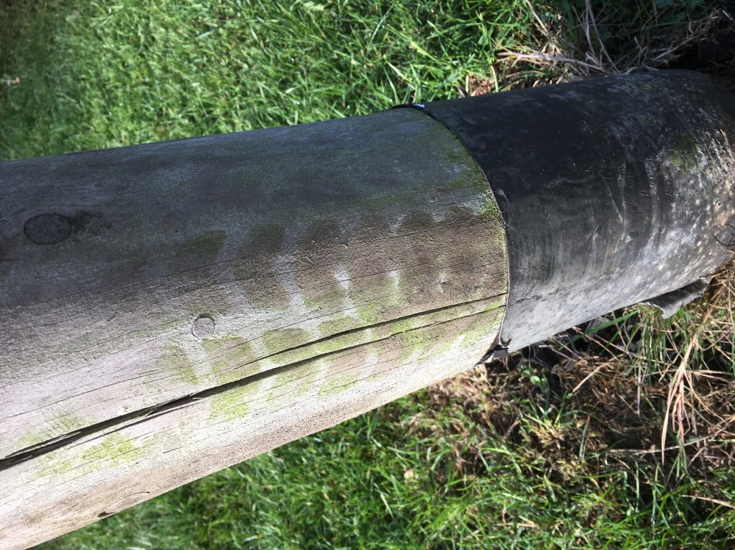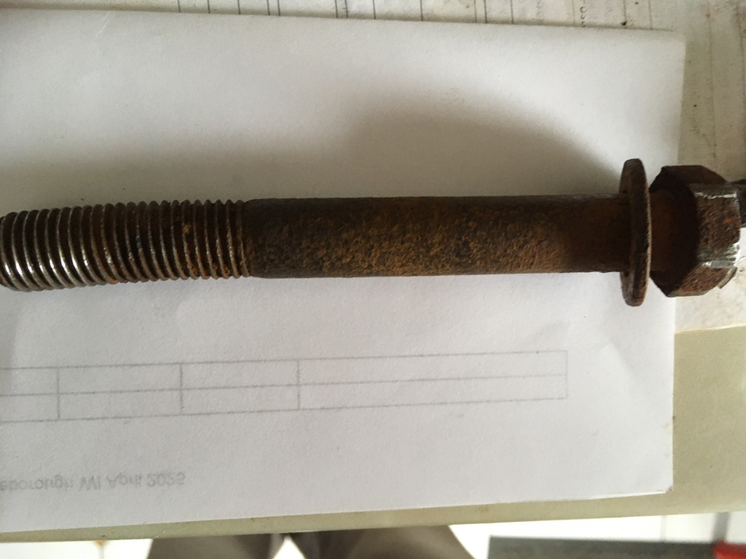

To make the area safe, Liz and I, plus two others from the village, dismantled the post and parallel bar pole. These are at my house and can be inspected by any insurer, should they wish.
Since, I have inspected the post in more detail, and can confirm ‘the post is not rotten half way up’. When you look at the post, there is a strim-guard that is just above ground level (see picture above). The post has broken below this. I have tested the penetration depth using a method similar to that illustrated in the RoSPA report, and found that above the strim-guard, I was only able to make small holes with a sharp point, between 2-3mm deep. So, I do not believe the wooden post is rotten at this height. Below the strim strip, I penetrated 1 or 2 cm in one place, but then only to a depth less than 5mm in two other places, so some local wood rot at ground level, and this is as reported by RoSPA.

Given the evidence above, can we claim off of Ian Walker's third party insurance? I think we should.

Clearly, it now looks like we will need to replace this piece of equipment next year if we are unable to make an insurance claim. I have included this in next year’s budget.

Outstanding work to note for the Autumn work-party includes:

- Repairing the wooden slats to the goals, again rotten.
- Bond the underlay around the ‘Super-Nova’ before the replacement rubber chippings are laid.
- Topping-up of the rubber chippings to both the Toddler and Teenage areas.
- The rubber coverings on the Pollux look to have deteriorated. They are over 15 years old. We need to investigate the repair of these joints. My inspection of this damage shows that it is cosmetic and does not affect the Pollux joint safety.

Finally, find attached a draft budget for the Rec. for the 2026/2027 financial year. This includes the cost of replacing the damaged exercise equipment. The exact degree of funding will depend on the remaining reserve funds, plus the costs of professional help to install the Teenage equipment. In the proposed budget I have provided my estimate of the costs of this work, for planning purposes. We will have to wait and see what quote prices we receive.

John Nicholls - Chairman
12/10/2025

Pictures of Equipment from CostcuttersUK.com
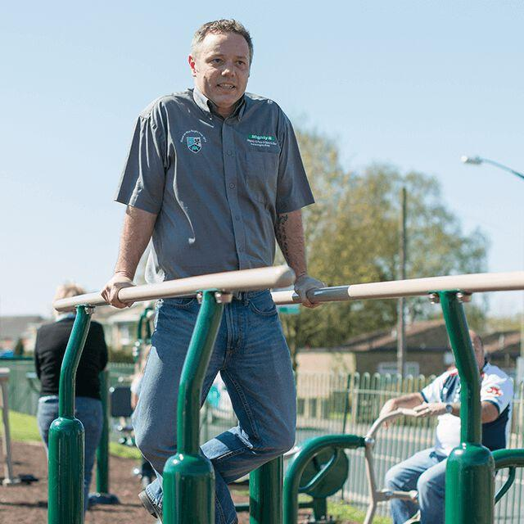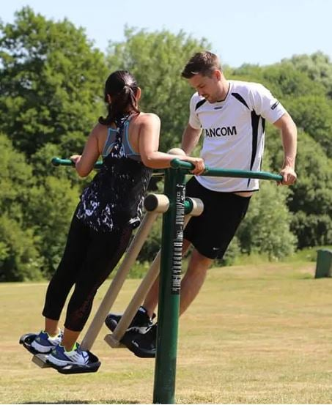

Planning Committee Report - for meeting on 13 October 2025 (as at 9 October 2025)
Below are current and recent Planning Applications. The Parish Council is invited to ratify the comments made to Buckinghamshire Council
on behalf of the Planning Committee since the last meeting.
CURRENT PLANNING APPLICATIONS
Date Received |  | Application Number |  | Applicant |  |  | Site Address |  | Details of Application |  | Parish Council Response
19/6/25 | 25/01824/APP  Emma Mumby |  |  |  | Ms H Hedges |  | Hillside Bletchley Road Great Horwood Buckinghamshire MK17 0RB |  | Demolition of existing dwelling and erection of new dwelling |  | No objection
2/7/25 | 25/01773/APP  Anna Souter |  |  |  | Beaver |  | Wigwell Spring Lane Great Horwood Buckinghamshire MK17 0QW |  | Householder application for the replacement of existing windows to the front,  rear and side elevations |  | No objection
18/8/25 | PL/25/2796/PIP  Anna Shah |  |  |  | Ms Lucy Goodey |  | Land Rear Of, Ashwell House, Singleborough Lane, Singleborough, Great Horwood,  Buckinghamshire, MK17 0RF, |  | Permission in Principle for a minimum of one and maximum of one dwelling |  | Objection
2/1/2025 | 24/03870/APP |  |  |  | Mr And Mrs H Elliott |  | Spring Cottage 28 Spring Lane Great Horwood Buckinghamshire MK17 0QW |  | Erection of dwelling with access and amenity space together with the  conversion and alterations of existing dwelling to form ancillary  accommodation/outbuilding (part retrospective) |  | Objection
23/4/25 | 25/01025/APP  Dipanwita Chatterjee |  |  |  | Mr Pithers |  | Greenway Business Park 7 Winslow Road Great Horwood Buckinghamshire  MK17 0NP |  | Erection of two storey modular building to be used as office facilities |  | No objection
25/4/25 | 25/01262/VRC |  |  |  | Mr and Mrs P Pearce |  | Spring Hill Farm Little Horwood Road Great Horwood Buckinghamshire  MK17 0NZ |  | Removal of condition 3 (agricultural occupancy condition) 4 (private  residential accommodation) relating to application 78/01811/AV (Erection of a  farmhouse) |  | No objection
24/7/25 | 25/01953/ALB  Faye Hudson |  |  |  | Mr Simon Joynes |  | Rushmere 9 Little Horwood Road Great Horwood Buckinghamshire MK17  0QE |  | Internal remedial works - oil line failure beneath the floor structure in the snug  at the juncture of the dining room and kitchen |  | No comments made as works complete
21/01/2021 | 21/00221/APP  Kirsty Elliott |  |  |  | J Hanson & Son |  | Home Farm, 4 Winslow Road, Great Horwood MK17 0QN |  | Demolition of existing agricultural buildings; erection of 15 residential dwellings with associated access, parking and landscaping; extension and refurbishment of existing listed farmhouse. |  | Objection
21/01/2021 | 21/00222/ALB  Kirsty Elliott |  |  |  | J Hanson & Son |  | Home Farm, 4 Winslow Road, Great Horwood MK17 0QN |  | Demolition of existing agricultural buildings; erection of 15 residential dwellings with associated access, parking and landscaping; extension and refurbishment of existing listed farmhouse. |  | Objection
12/1/24 | 22/03218/APP  Emma Mumby |  |  |  | Mr Octavian Negrea |  | Land To Rear Of Vine Cottage 3 Little Horwood Road Great Horwood  Buckinghamshire MK17 0QE |  | Erection of 3 dwellings |  | Objection
4/4/24 | 24/00952/APP  Emma Mumby |  |  |  | Mr Connors |  | 3 Nash Park Winslow Road Nash Buckinghamshire  MK17 0FD |  | Change of use of land from a 1 pitch Caravan Site to a 2 pitch Caravan Site (2  Static Caravans & 2 Touring Caravans) alongside the retention and  conversion of Stables to Dayroom |  | No objection
18/06/24 | 24/01794/APP  Danika Hird |  |  |  | Mr William McDonaugh |  | Plot 1 Nash Park Winslow Road Nash Buckinghamshire MK17 0FD |  | Creation of a 2nd pitch on an existing 1 pitch caravan site to provide 2 static  caravans and 2 touring caravans and erection of a dayroom |  | Objection
23/7/24 | 24/02148/APP  Danika Hird |  |  |  | Mr Nigel Denne |  | The Hedgerows Nash Road Great Horwood Buckinghamshire MK17 0EJ |  | Change of use of land from agricultural to B8 (Storage and distribution) E(a)  (Sales / Display of goods other than hot food) E(g)(i) (Offices). New dropped  kerb/access. Erection of building and yard area |  | Objection
4/10/24 | 24/03004/APP  Faye Hudson |  |  |  | Hennigan Building and Civil Engineering Ltd |  | Land Between Nash Road And Cross Roads Kennels Nash Road Great  Horwood Buckinghamshire |  | Hybrid application for the redevelopment of the site comprising outline  planning permission, with all matters reserved except access, for a drive thru  restaurant (Use Class E(b)/Sui Generis) and EV charging hub and full  planning permission for an office building (Use Class E(g)(ii)) and a day  nursery (Use Class E(f)) with associated landscaping, parking and access  arrangements |  | Objection
20/11/24 | 24/03472/APP  Danika Hird |  |  |  | Mortlake 17 Llp |  | Land To The East Side Of Winslow Road Winslow Road Great Horwood  MK17 0NP |  | Four no. commercial stables, ancillary facilities, parking, landscaping and  internal road |  | Objection
2/12/24 | 24/03513/APP |  |  |  | Andrew Marshall |  | Faccenda Chicken Thornhill Poultry Farm Pilch Lane Great Horwood  Buckinghamshire MK17 0NX |  | Temporary change of use for 3 years of land and dwelling to allow use as a  lorry park and offices (retrospective) |  | Objection
12/3/25 | 25/00518/ADM |  |  |  | Chris Lewis-Evans |  | Unit A At Land Adjacent To Cakeford Little Horwood Road Great Horwood Buckinghamshire |  | Prior notification application (Part 11, Class B) for demolition of building |  | No objection
4/3/25 | 25/00425/APP |  |  |  | Mr And Mrs H Elliott |  | Spring Cottage 28 Spring Lane Great Horwood Buckinghamshire MK17 0QW |  | Householder application for construction of detached car port |  | No objection
2/6/25 | 25/01623/APP |  |  |  | Tim Northey  (Abbeymill Homes) |  | Land South Of Weston Road Great Horwood Buckinghamshire |  | Erection of 35 detached and semi-detached 2 storey dwellings with new access off Weston Road, footpaths, garaging, parking, landscaping and all enabling works |  | Objection
23/6/25 | 25/01910/APP  Anna Souter |  |  |  | Mr Robert Webb |  | Home Farm Pilch Lane Great Horwood Buckinghamshire MK17 0QN |  | Erection of agricultural storage building |  | No objection
9/7/25 | 25/01964/APP |  |  |  | Mr Robert Webb |  | Home Farm Pilch Lane Great Horwood Buckinghamshire MK17 0QN |  | Proposed Grain Store |  | No objection
29/9/25 | PL/25/4148/AGN  Anna Souter |  |  |  | Mr John Matthews |  | Field To West Of Singleborough , Off Singleborough Lane, Singleborough, Great  Horwood, Buckinghamshire, |  | Erection of agricultural building, associated agricultural access track leading to  building and associated hardstanding 500 square metres to the east and south of the  barn
2/10/25 | PL/25/4181/PIP  Faye Hudson |  |  |  | Mr R George |  | Land Adjacent To, The Ridings, Singleborough Lane, Singleborough, Great Horwood,  Buckinghamshire, MK17 0RF, |  | Application for permission in principle for the erection of minimum of 1 and a  maximum of 1 detached dwelling

