About Building Resilience Together
Building Resilience Together is a three-year pilot. The project team has initially begun working with four Local Resilience Forums (LRFs) and one Local Authority, and hubs in these areas will be launched later in 2023 and into 2024. The project will also be looking to expand to work with additional LRFs in 2024 and the years to come.
Our Vision
Through this programme, Groundwork and the British Red Cross will work with local people to develop community-led solutions. These solutions will help the communities involved to build the skills, knowledge and resources that are needed to grow local and national resilience to emergencies, including climate change and extreme weather events. We will share our learnings and insights with national resilience networks such as the VCSEP and NCSR+, and other LRF partners, to support a whole-of-society approach to resilience and an iterative cycle of constructive feedback.
What will a Resilience Hub offer?
The resilience hubs will act as spaces to coordinate resources before, during and after an emergency. They will bring together individual volunteers, community groups, voluntary organisations, local authorities, businesses and community resilience professionals in local and regional networks, enabling more joined up and effective approaches to community resilience that better utilise local assets and better manage local risks.
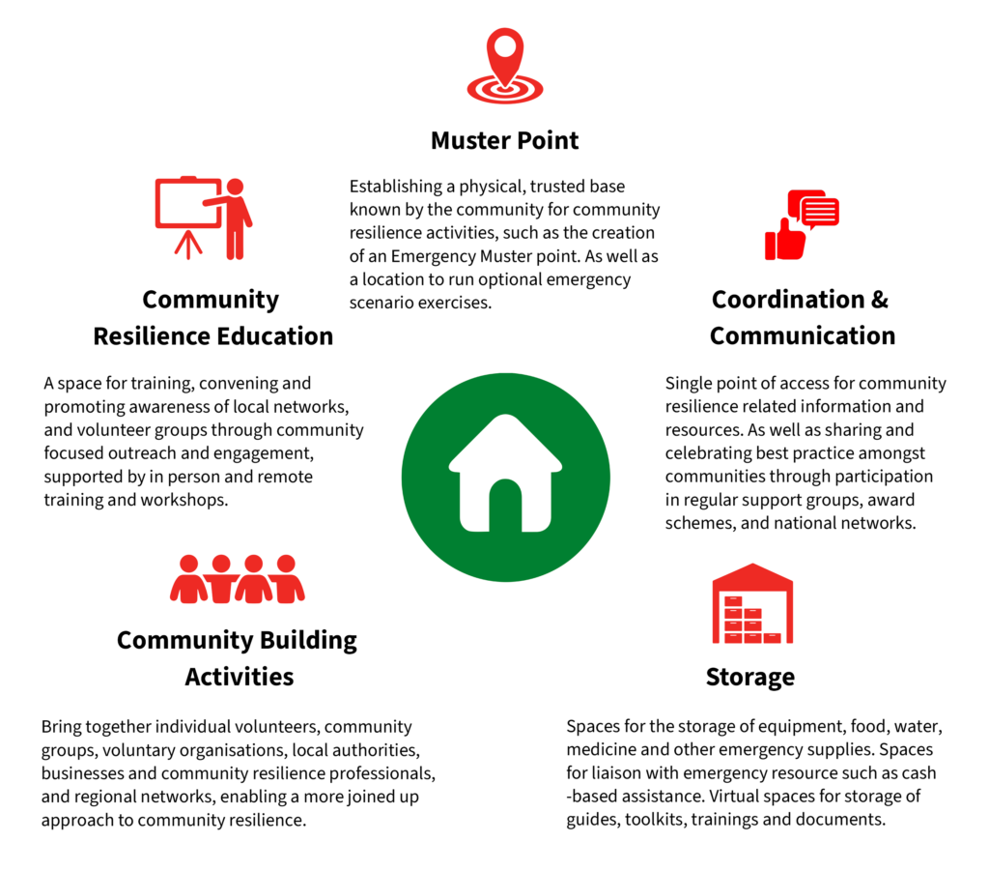
By setting a well-known/trusted location as a community resilience hub in advance, appropriate equipment can be stored there, and access arrangements can be set up to ensure it is available 24/7 when needed. Training can be delivered to local people, and the hub location can also be regularly publicised throughout the community, encouraging additional volunteer responders who wish to be part of their community response.
Our Partnership
At Aviva, they understand just how traumatic events like fires and floods can be. They want to go beyond simply paying out claims to fix any damage in the aftermath. They also want to help their customers and the communities prepare for and respond quickly to such crises when they happen. As far as possible they want to help limit or prevent damage from happening in the first place. Aviva’s partnership with the British Red Cross and Groundwork allows them to do just that.
Communities Prepared is a Groundwork project which equips Community Emergency Volunteer and Flood Warden groups with the knowledge and confidence to prepare for, respond to, and recover from a range of emergencies, from flooding and severe weather incidents to pandemics.
Communities Prepared supports the development of multi-role volunteer groups that have the confidence and skills to manage a range of emergencies – building their community’s long-term resilience. They do this through a combination of training and tailored support, recognising the particular needs of, and challenges faced by, the communities they are working with.
Groundwork is a federation of charities mobilising practical community action on poverty and the environment across the UK. They help people gain confidence and skills, get into training and work, protect and improve green spaces, lead more active lives and overcome significant challenges such as poverty, isolation, low skills and poor health.
The British Red Cross’s mission is to mobilise the power of humanity so that individuals and communities can prepare for, deal with, and recover from crises. Their vision is a world where everyone gets the help they need in a crisis, and they promise to be the movement that connects human kindness with human crisis.

